William Hall & Co.
CHARTERED SURVEYORS, LAND AGENTS, VALUERS,
AUCTIONEERS, AND ESTATE AGENTS
Regulated by RICS
The Estate Office, Hawarden, Flintshire, CH5 3NX
Telephone: 01244 531547 Fax: 01244 536160 enquiries@williamhallandco.com
 |  | 

Photographic Survey

Subject: | Gardener’s Cottage & Barn, Castle Grounds, Hawarden, Flintshire
Date: | Monday, 30 March 2009
Author: | Anthony Hall B.Eng. (Hons) M.Sc. MRICS
Note: | High Resolution Digital Photograph Files on Attached CD

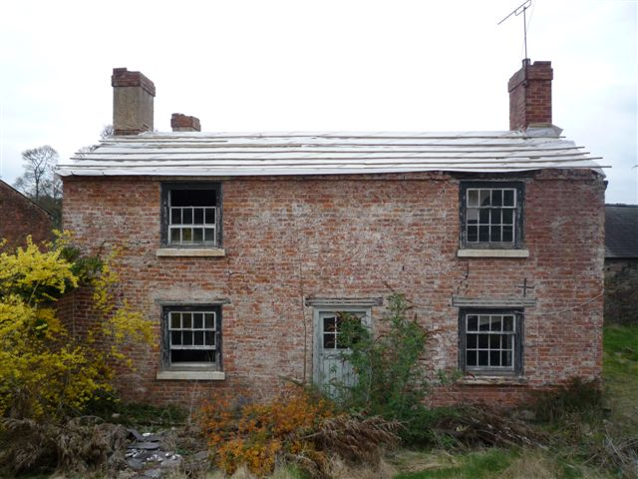

Site Plan – Location & Orientation of Photographs

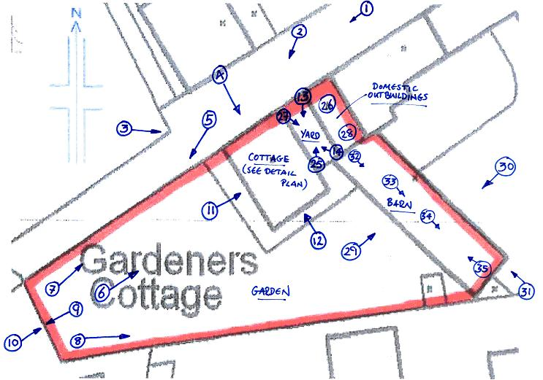
Crown Copyright – All Rights Reserved – OS Licence No 10005433 - For Identification Only – Not to Scale

Ground Floor | First Floor

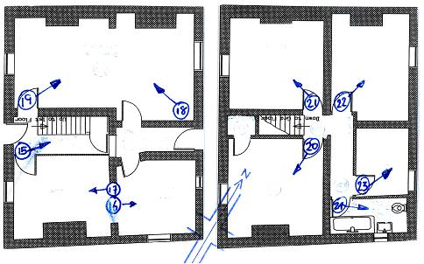

Picture 1  Unmade Access Road Into Site From North East | 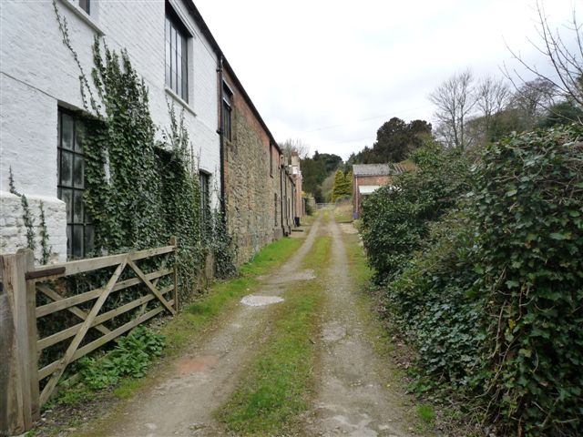
Picture 2  North Western Elevation | 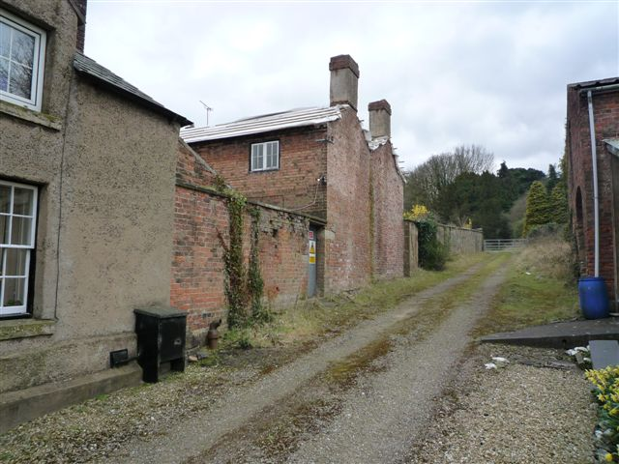
Picture 3  North Western Elevation | 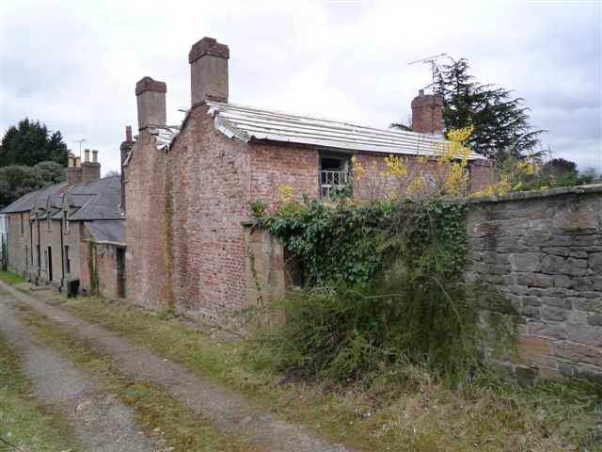
Picture 4  North Western Elevation | 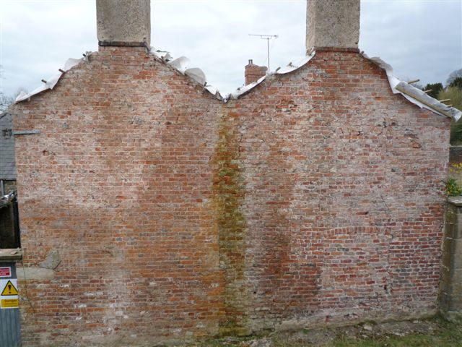
Picture 5  North Western Boundary Wall & Cottage Abutment | 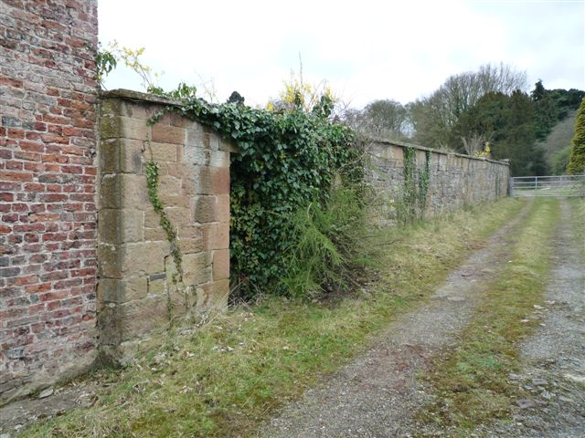
Picture 6  South Western Elevation & Garden | 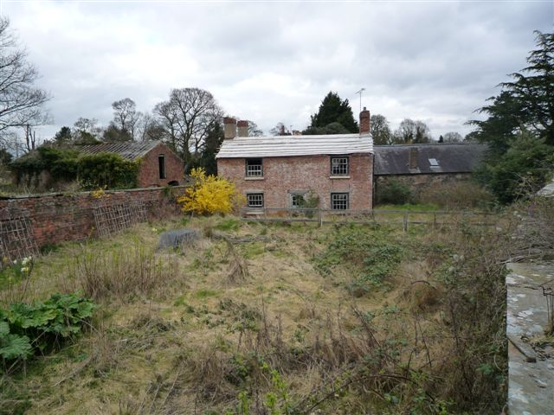
Picture 7  North Western Boundary Wall | 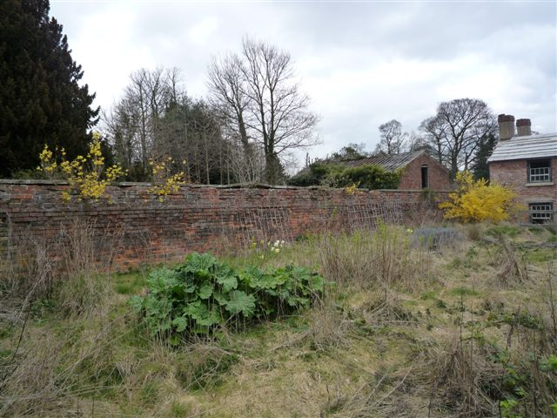
Picture 8  Southern Boundary Wall | 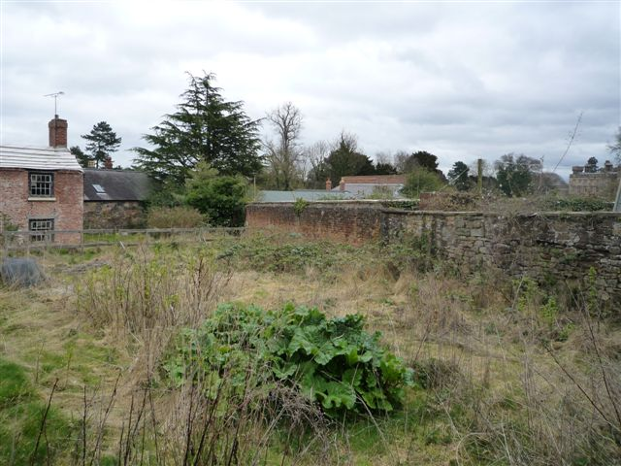
Picture 9  Western Boundary Wall | 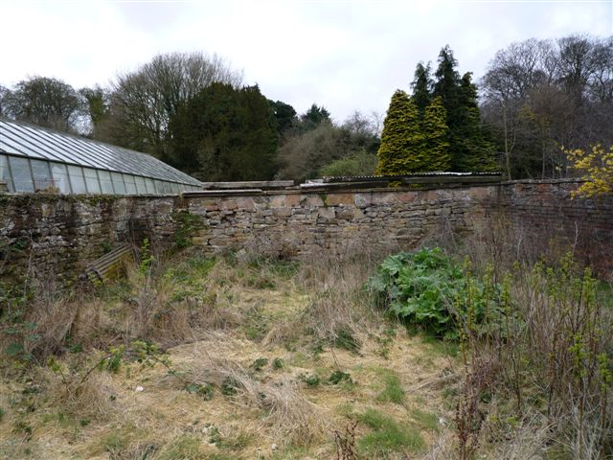
Picture 10  Western Boundary Wall | 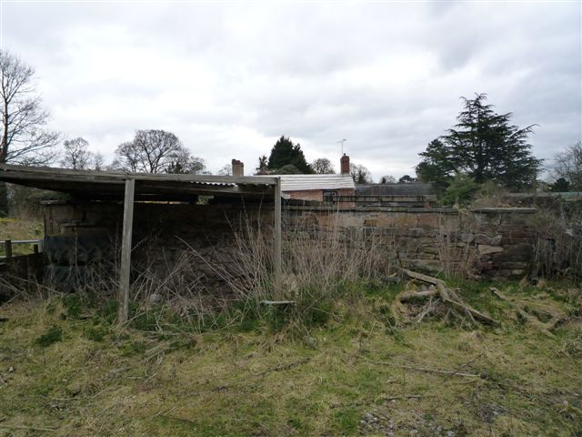
Picture 11

South Western Elevation

Picture 12  South Eastern Elevation | 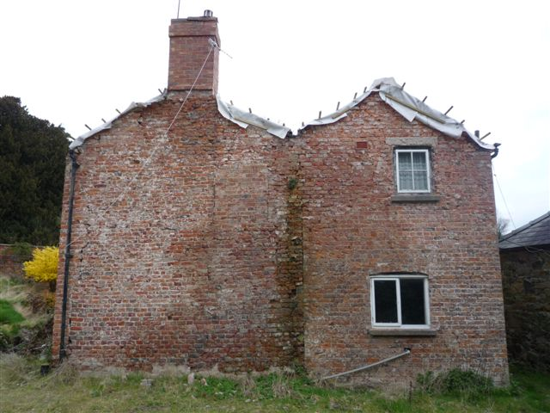
Picture 13  North Eastern Elevation | 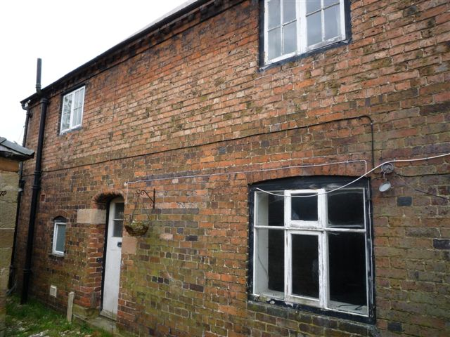
Picture 14  North Eastern Elevation | 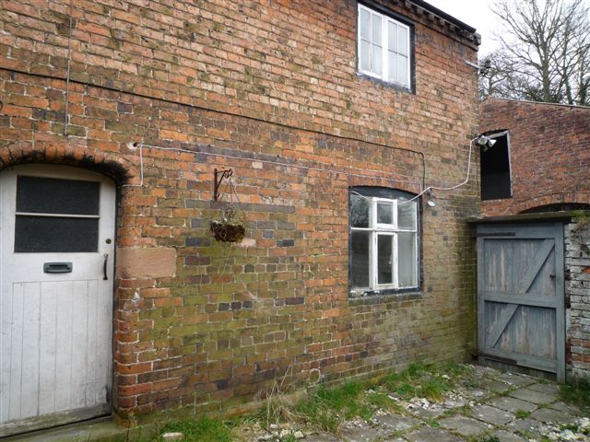
Picture 15  Entrance Hall & Staircase | 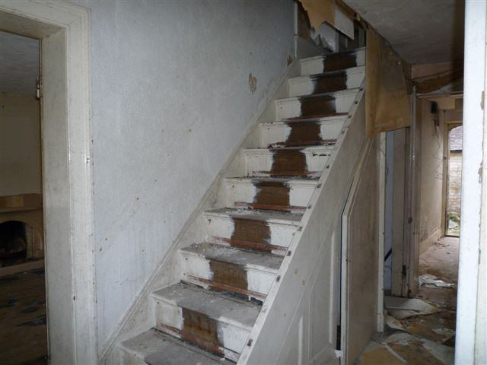
Picture 16  Kitchen | 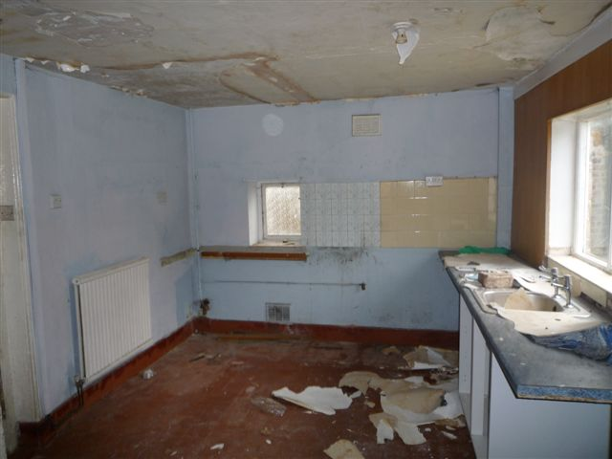
Picture 17  Dining Room | 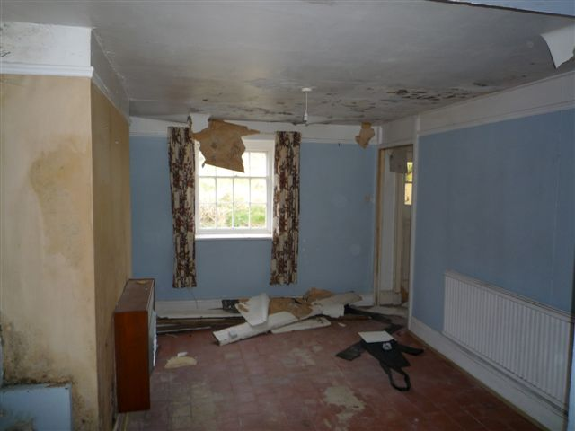
Picture 18  Living Room | 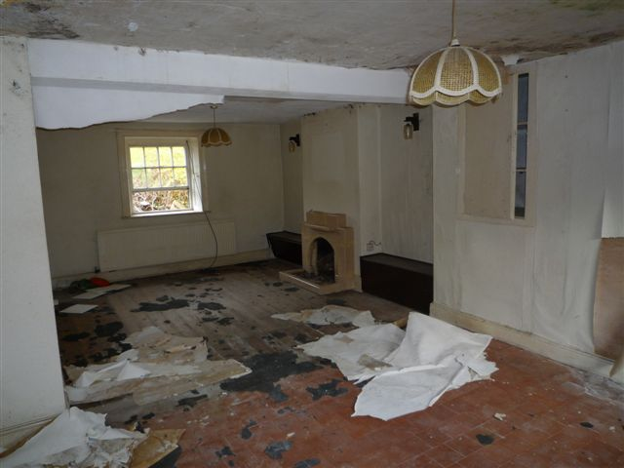
Picture 19  Living Room | 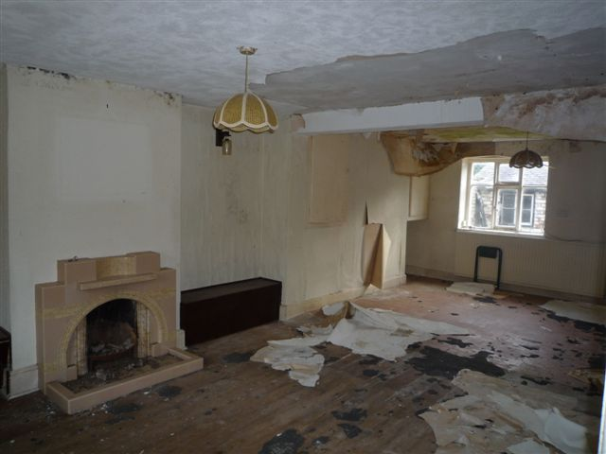
Picture 20  Bedroom 1 | 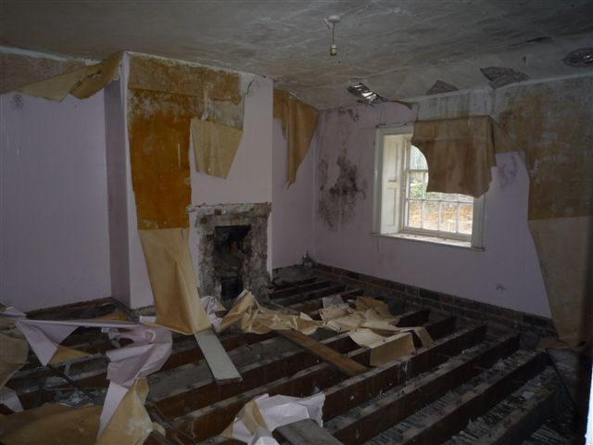
Picture 21  Bedroom 2 | 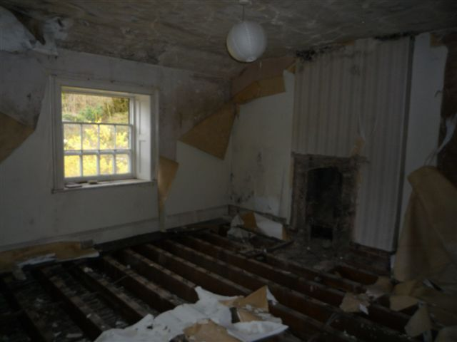
Picture 22  Bedroom 3 | 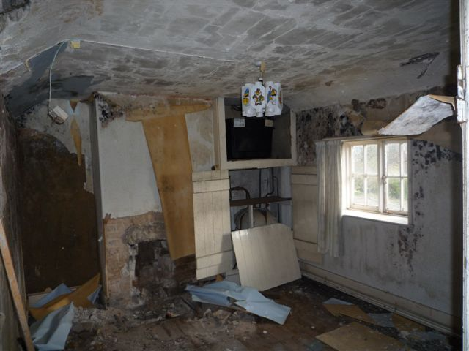
Picture 23  Bedroom 4 | 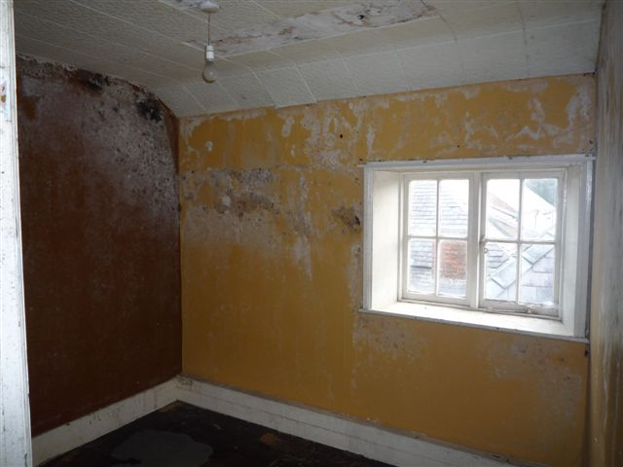
Picture 24  Bathroom | 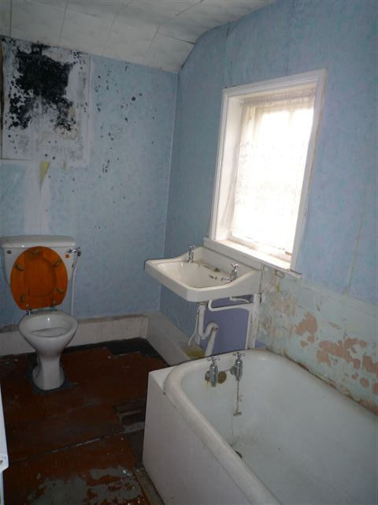
Picture 25  Yard & Domestic Outbuildings | 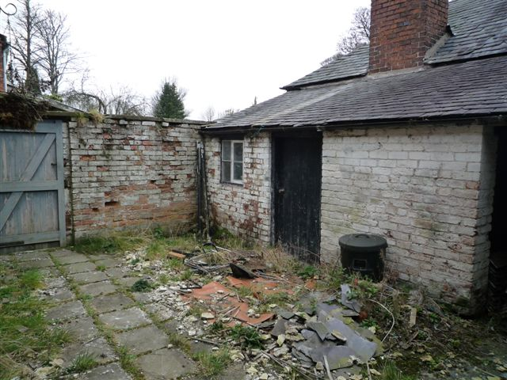
Picture 26  Inside Domestic Outbuilding | 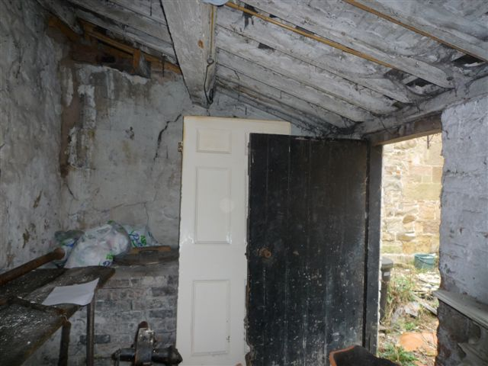
Picture 27  Yard & Domestic Outbuildings  including  Barn – North Western Elevation | 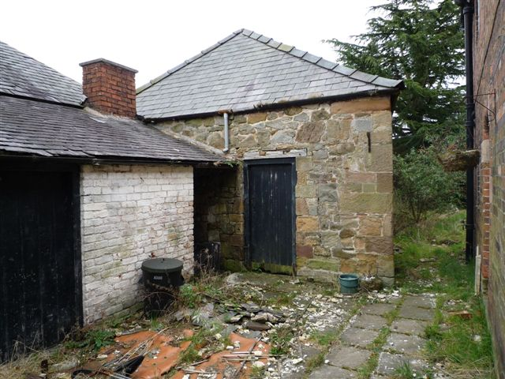
Picture 28  Inside Domestic Outbuilding | 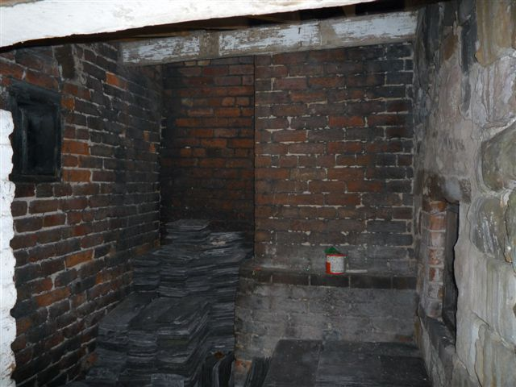
Picture 29  Barn - South Western Elevation | 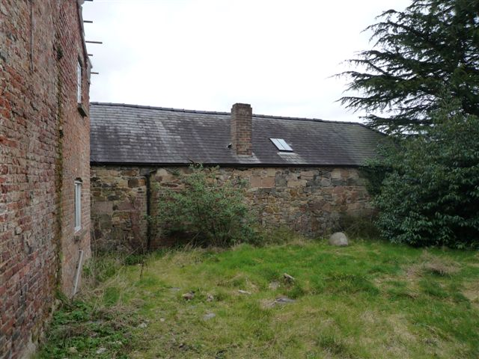
Picture 30  Barn - North Eastern Elevation | 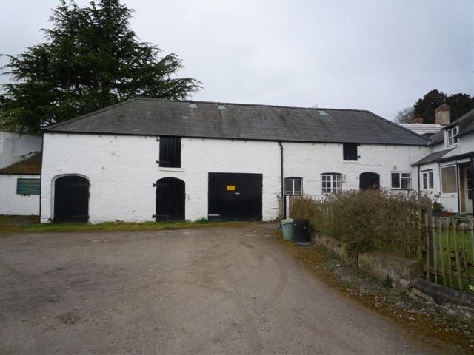
Picture 31  Barn - South Eastern Elevation | 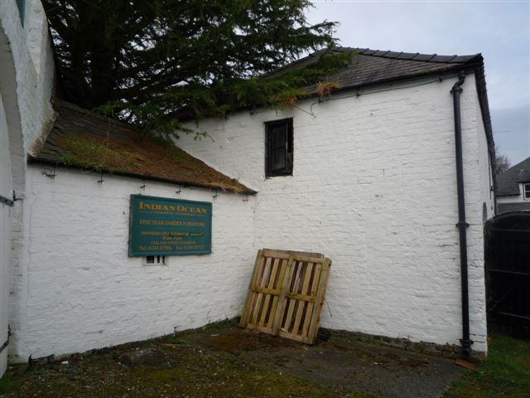
Picture 32  Barn – Ground Floor Accessed From Yard | 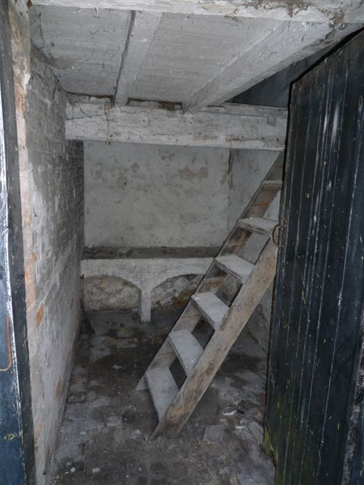
Picture 33  Barn - First Floor From North West End | 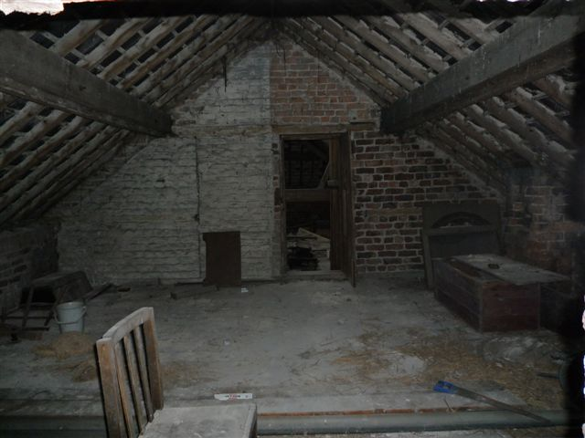
Picture 34  Barn – First Floor From Centre Looking South East | 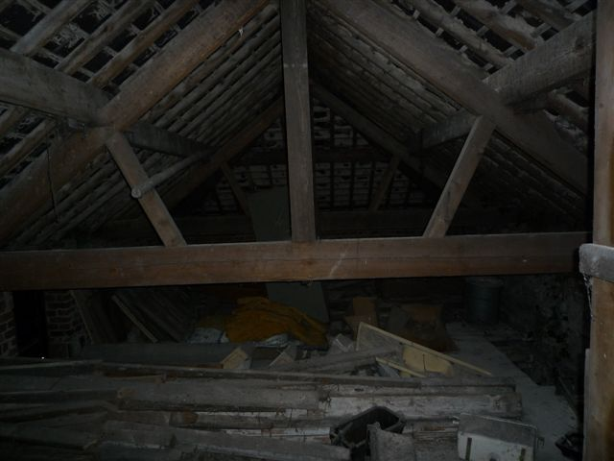
Picture 35  Barn – First Floor From South Eastern End | 