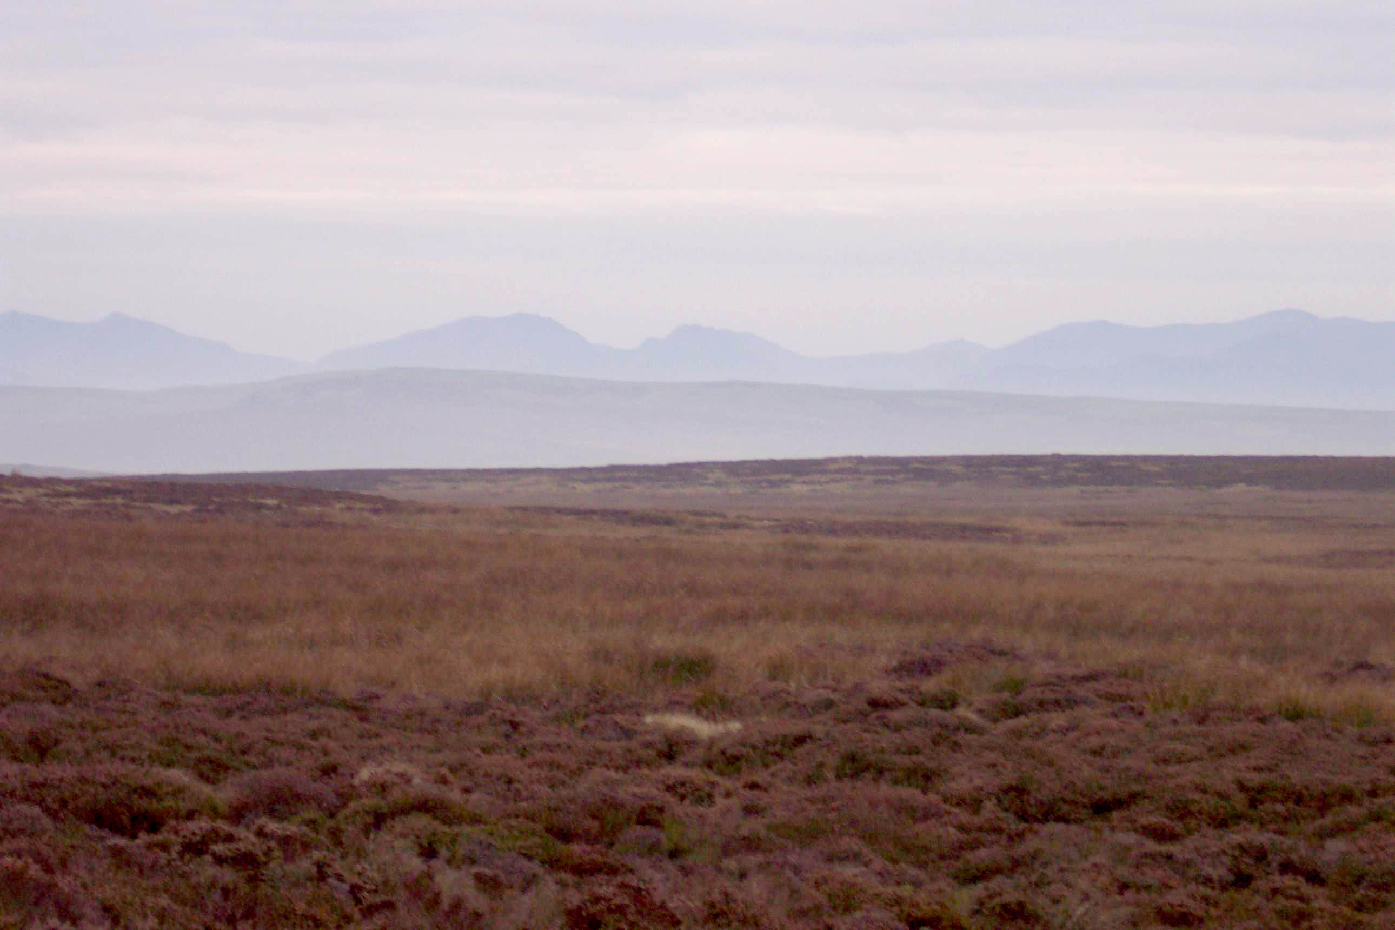

Plate 1: General view across the Hiraethog Moors

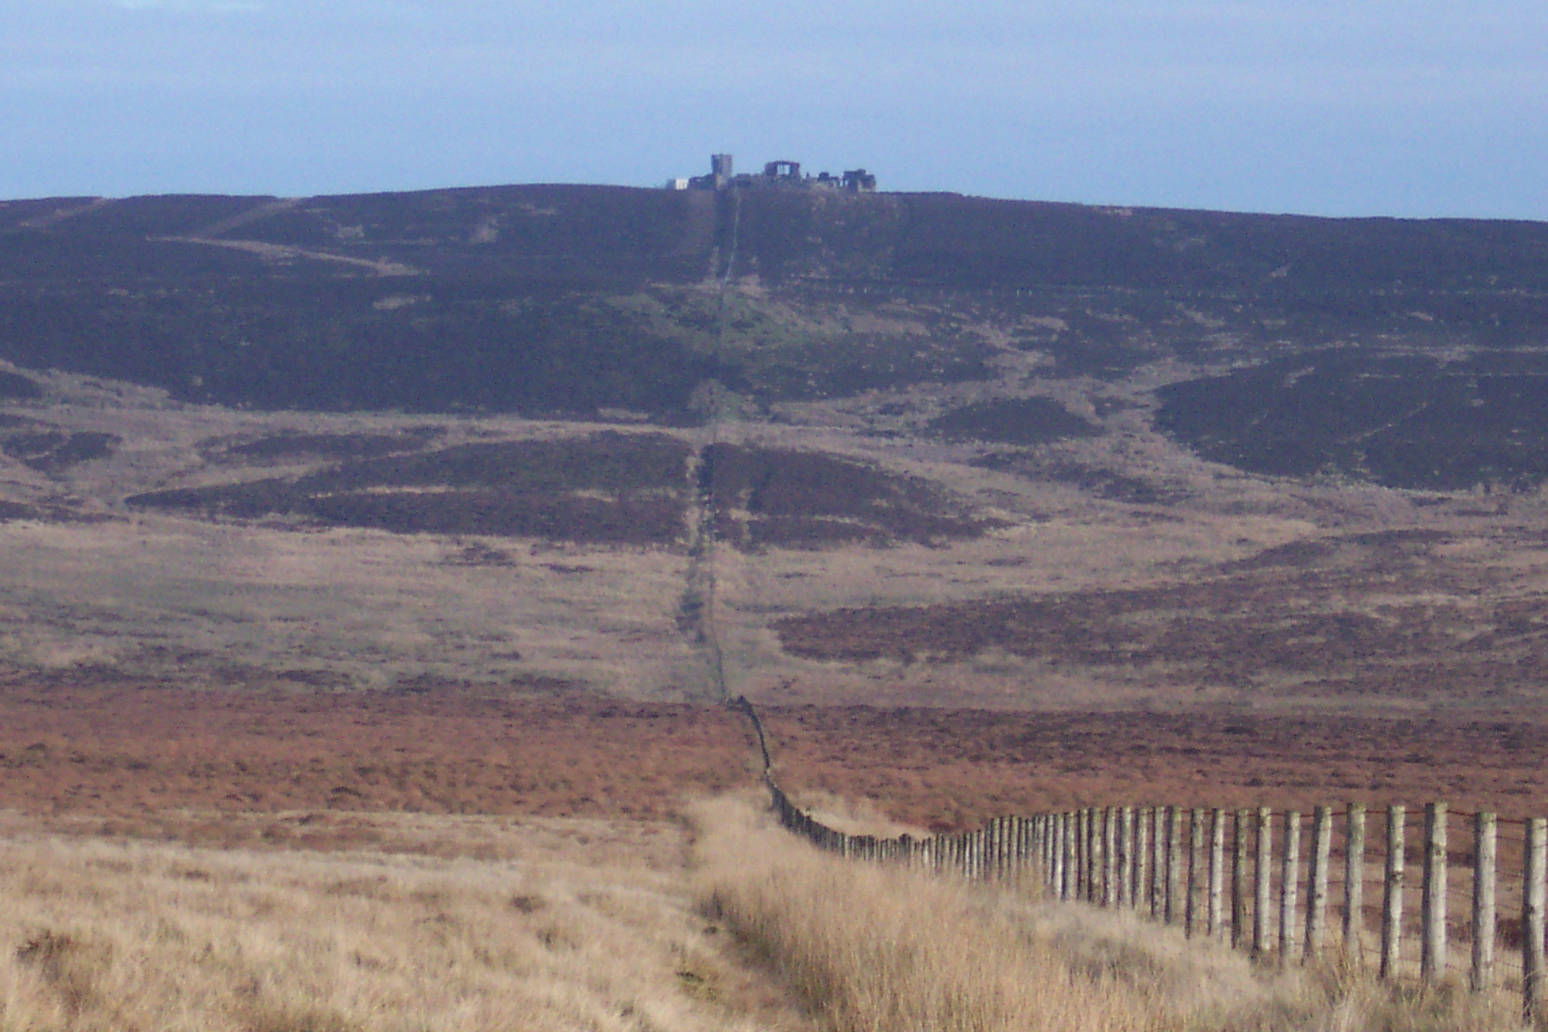

Plate 2: View up the Llansannan/Henllan parish boundary towards Gwylfa
Hiraethog shooting lodge

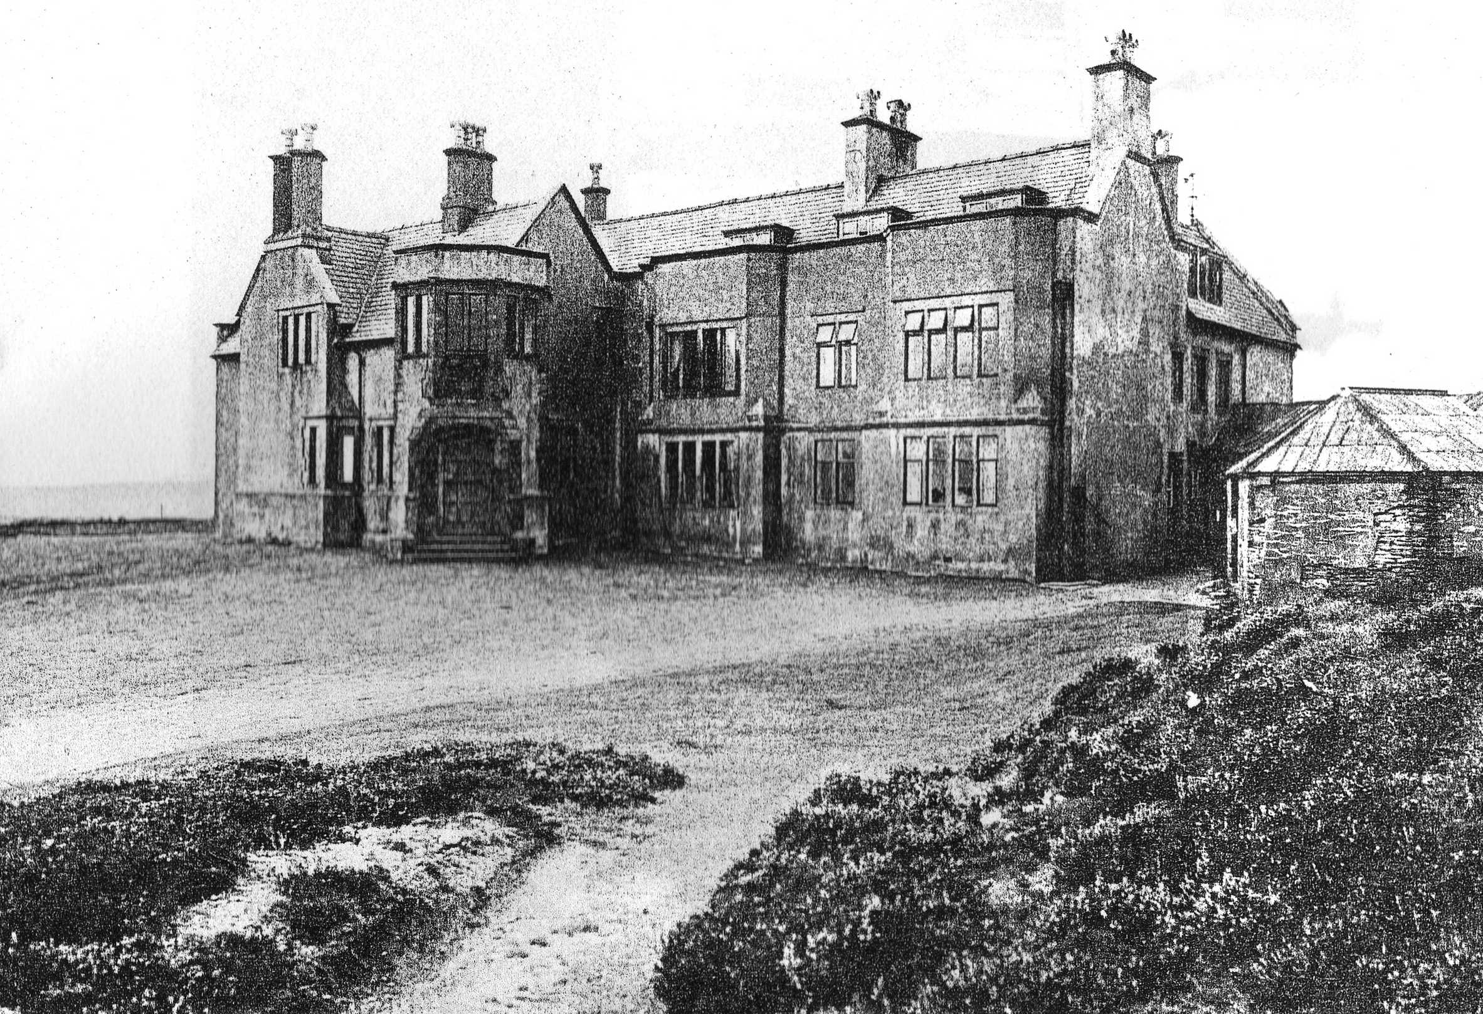
Plate 3: Photograph of Gwylfa Hiraethog shooting lodge c1913 (NMR 23045)

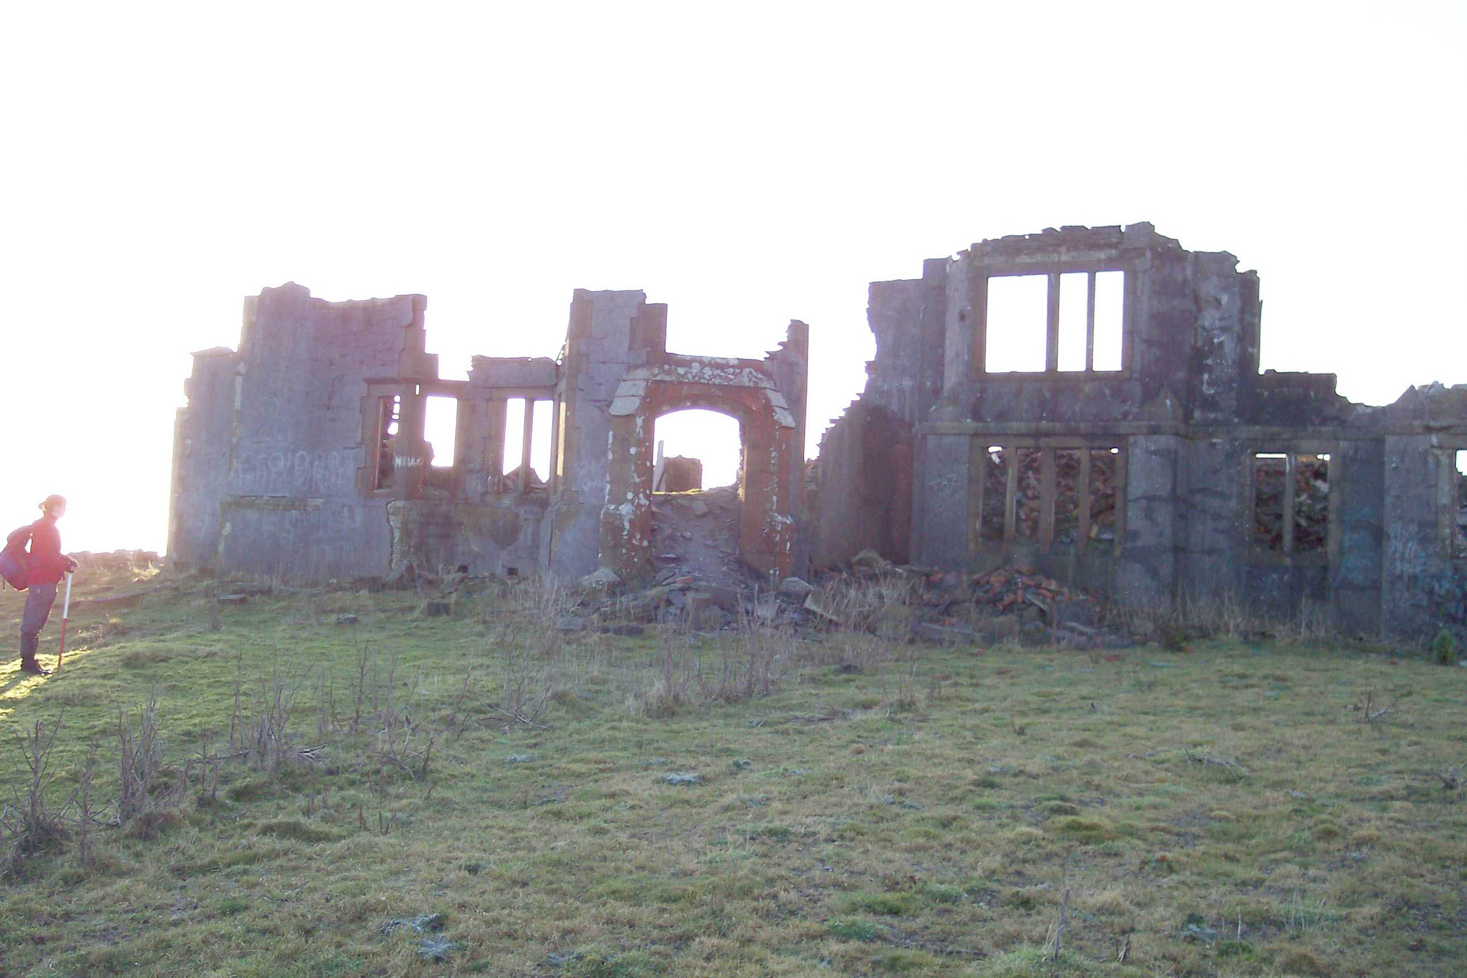
Plate 4: Gwylfa Hiraethog shooting lodge (NMR 23045)

