Croft House

SN 13230078 Sheet XLI 11 Tenby

Today the house is used as Court and Council offices.
The EB Hughes map of 1849 shows a formal garden at the ( west, Norton ) front with steps down to the road. To the east side was another formal plot which is now a small public garden (Margaret Davies says that one of the Richards family gave it to the town.) and two more sqares to the north on one of which the County Club was later built: the other has become a car park. There was apparently a wooded, more informal, area to the south side reaching from Norton to Croft.
At the opposite side of the Norton and running down Windpipe Lane was a double walled garden with a probable coach-house at the end. This was presumeably the walled kitchen garden of Croft House.

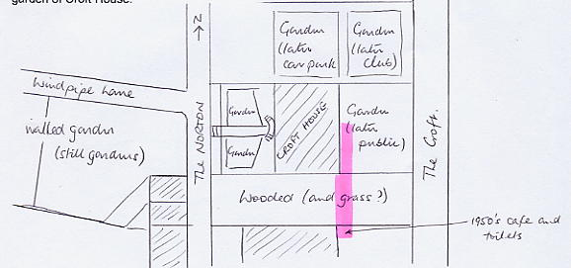

The following people were connected with the place:
1811 - 1826 Jacob Richards mayor many times. Had made a fortune in India.
Very powerful figure in Tenby politics at this time and a supporter of Owen of Orielton for parliament. There is a story that when he leased the enclosure called Croft he attempted to close the footpath to Waterwinch which was re-opened after a bitter dispute with Charles Norris who produced a lampoon etching ( of William Richards? ).
1850 William Richards son of above, High Sheriff 1850, mayor 1835 - 1854. Both are buried in the Scotsborough vault of Tenby church where they had bought the right. by puchasing the ruined site.
William Henry Richards JP born 1844, nephew of above, was High Sheriff in 1878. He died in 1895; his widow, a daughter of Stokes of St Botolphs died in 1914.
1901 (Jeffrey J? Allen, Indian Civil Servant retired, was living at Croft Lodge)
1914 Miss Harvey
1920 ditto
1929-1938 Extensive litigation to establish ownership of various claimed sites including cliff
gardens along Croft Terrace.

Gazetteer:
Council offices. Gardens almost completely replaced by car parking. Small formal rear garden with railings from the demolished boat pier.

(Croft House, Tenby)

Gazetteer

Magistrates Court.. Small public garden.
1

