DINEFWR PARK EAST DRIVE

ARCHAEOLOGICAL EVALUATION AHEAD OF PROPOSED FOOTPATH

MARCH 2006

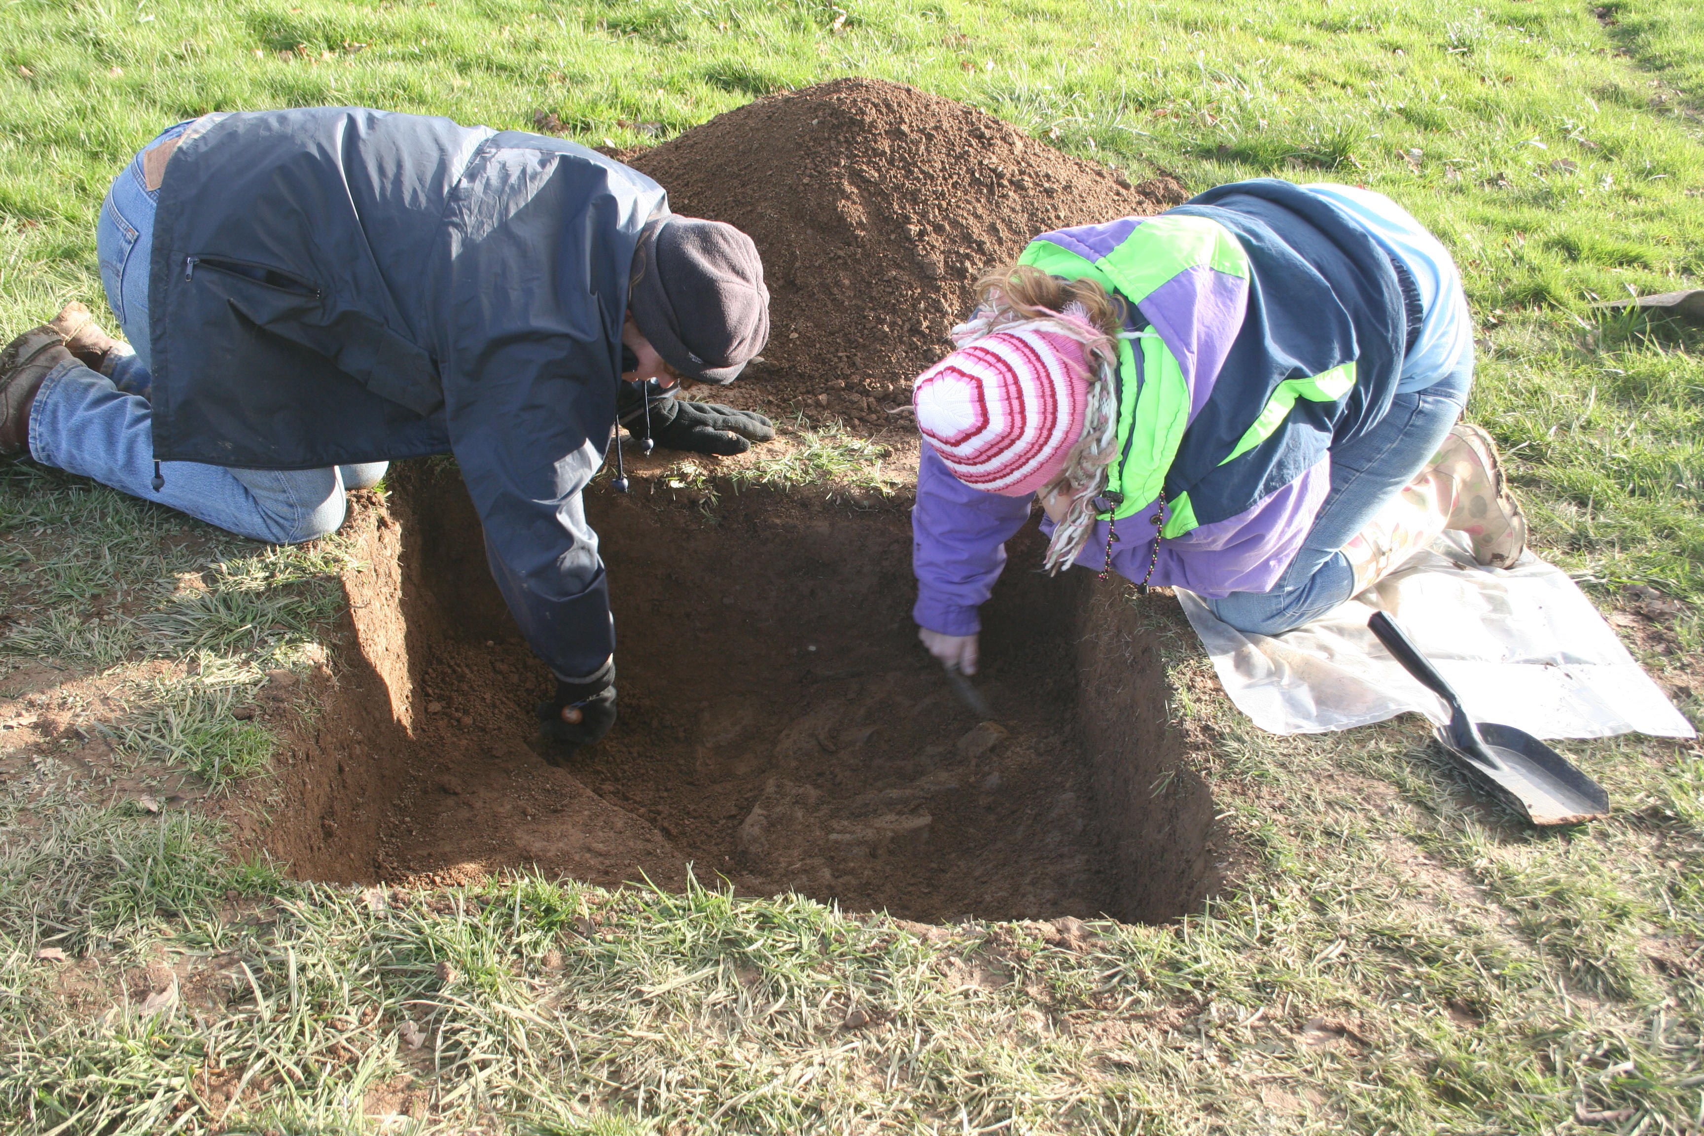




Prepared by Cambria Archaeology
For The National Trust

ARCHAEOLEG CAMBRIA ARCHAEOLOGY

RHIF YR ADRODDIAD / REPORT NO. 2007/15
RHIF Y PROSIECT / PROJECT RECORD NO. 62655

Mawrth 2006
March 2006

DINEFWR PARK EAST DRIVE
ARCHAEOLOGICAL EVALUATION AHEAD OF PROPOSED FOOTPATH

Gan / By

Marion Page

Archaeoleg Cambria yw enw marchnata Ymddiriedolaeth Archaeolegol Dyfed Cyfyngedig.
Cambria Archaeology is the marketing name of the Dyfed Archaeological Trust Limited.

Paratowyd yr adroddiad yma at ddefnydd y cwsmer yn unig. Ni dderbynnir cyfrifoldeb gan Archaeoleg Cambria am ei ddefnyddio gan unrhyw berson na phersonau eraill a fydd yn ei ddarllen neu ddibynnu ar y gwybodaeth y mae’n ei gynnwys

The report has been prepared for the specific use of the client. Cambria Archaeology can accept no responsibility for its use by any other person or persons who may read it or rely on the information it contains.



ARCHAEOLEG CAMBRIA
Ymddiriedolaeth Archaeolegol Dyfed Cyf
Neuadd y Sir, Stryd Caerfyrddin, Llandeilo, Sir Gaerfyrddin SA19 6AF
Ffon: Ymholiadau Cyffredinol 01558 823121
Adran Rheoli Treftadaeth 01558 823131
Ffacs: 01558 823133
Ebost: cambria@cambria.org.uk
Gwefan: www.cambria.org.uk

CAMBRIA ARCHAEOLOGY
Dyfed Archaeological Trust Limited
The Shire Hall, Carmarthen Street, Llandeilo, Carmarthenshire SA19 6AF
Tel: General Enquiries 01558 823121
Heritage Management Section 01558 823131
Fax: 01558 823133
Email: cambria@cambria.org.uk
Website: www.cambria.org.uk

Cwmni cyfyngedig (1198990) ynghyd ag elusen gofrestredig (504616) yw’r Ymddiriedolaeth. The Trust is both a Limited Company (No. 1198990) and a Registered Charity (No. 504616)

CADEIRYDD CHAIRMAN: C R MUSSON MBE B Arch FSA MIFA. CYFARWYDDWR DIRECTOR: E G HUGHES BA FSA MIFA

CONTENTS

SUMMARY 4

INTRODUCTION 5

METHODOLOGY 5

RESULTS 6

DISCUSSION 7
RECOMMENDATIONS 7

ACKNOWLEDGEMENTS 8

SOURCES 8
ARCHIVE DEPOSITION 8

PLATES 10

APPENDICES 12

Dinefwr Park East Drive

Archaeological evaluation, March 2006

SUMMARY

Cambria Archaeology undertook an archaeological evaluation to assess the potential impact of a proposed footpath parallel to the East Drive in Dinefwr Park, a National Trust property in Llandeilo. The Park contains an extensive Roman landscape, which is a scheduled ancient monument including two overlapping Roman forts. The evaluation was requested by Cadw as part of scheduled monument consent for the footpath.

Seven test pits were hand-excavated along the line of the proposed footpath in order to determine the depth of any archaeological deposits. A feature, possibly part of the defensive ditch system of the earlier fort, was revealed in Test Area 6. A possible post-hole, defined by an oval stone setting, was revealed in the top of the ditch fill. Other than this no features of archaeological significance were encountered.
4
INTRODUCTION

In response to an application for scheduled monument consent for a proposed footpath parallel to the East Drive in Dinefwr Park, Llandeilo, Cambria Archaeology (acting on behalf of the National Trust) carried out an evaluation to establish the depth of any surviving archaeological deposits. The line of the proposed footpath traverses the southern corner of the older of two Roman forts in the Park. The forts were discovered as a result of a geophysical survey carried out in 2003 (Stratascan 2003) and were characterised through excavation in 2005 (Hughes 2006).

METHODOLOGY

The evaluation was carried out through test pitting along the route of the path. A total of seven 1 metre square test areas were hand-excavated (Fig. 2). Each test area was excavated either to the top of surviving archaeological deposits, or to the top of the natural subsoil.
5
RESULTS

Test Areas 1-5 and Test Area 7 revealed no archaeological deposits. In each of these the excavation continued to the top of the natural subsoil, a dark yellow-brown silty clay containing frequent small pieces of shattered shale. The topsoil, a dark yellow-brown silty loam with occasional small angular stones, varied between 0.2m.-0.3m. in depth in each of these test areas. In Test Area 5, on the top of a low rise in the topography, the topsoil was only 0.1m. deep and directly overlay the natural shale bedrock. A few small finds were recovered from the topsoil in Test Areas 3 and 4. Mostly these were Post-Medieval in date, but two possible fragments of Samian ware and some possible pieces of daub were found in the topsoil of Test Area 3. A rim fragment of possible Roman date was recovered from the topsoil of Test Area 4. Further details of all test areas are given in Appendix 1.

In Test Area 6 a rock-cut feature (602) was revealed in the bedrock (Fig.1). The cut was steep-sided (c.45°). Since the intention was to do no more than establish the presence and depth of surviving archaeology this feature was not excavated to its full depth and therefore its profile was not established. The feature appeared to be oriented northwest-southeast, turning to run north-northeast, and extended beyond the test area in all directions. The fill (601) was a silty clay loam containing frequent (c.40%) angular shattered shale fragments. Also present in the fill were occasional charcoal flecks and tiny pieces of burnt stone/brick/tile. Tiny fragments of burnt bone were also present in the fill, but these represented substantially less than 1% of the deposit.

Inserted in the top of the fill of feature 602 was a possible post-hole (603), defined by an oval setting of stones measuring approximately 20x30cm. The fill of the post-hole (604) was a silty clay loam c.0.18m. deep which contained no small finds.
Figure 1. Plan of Test Area 6
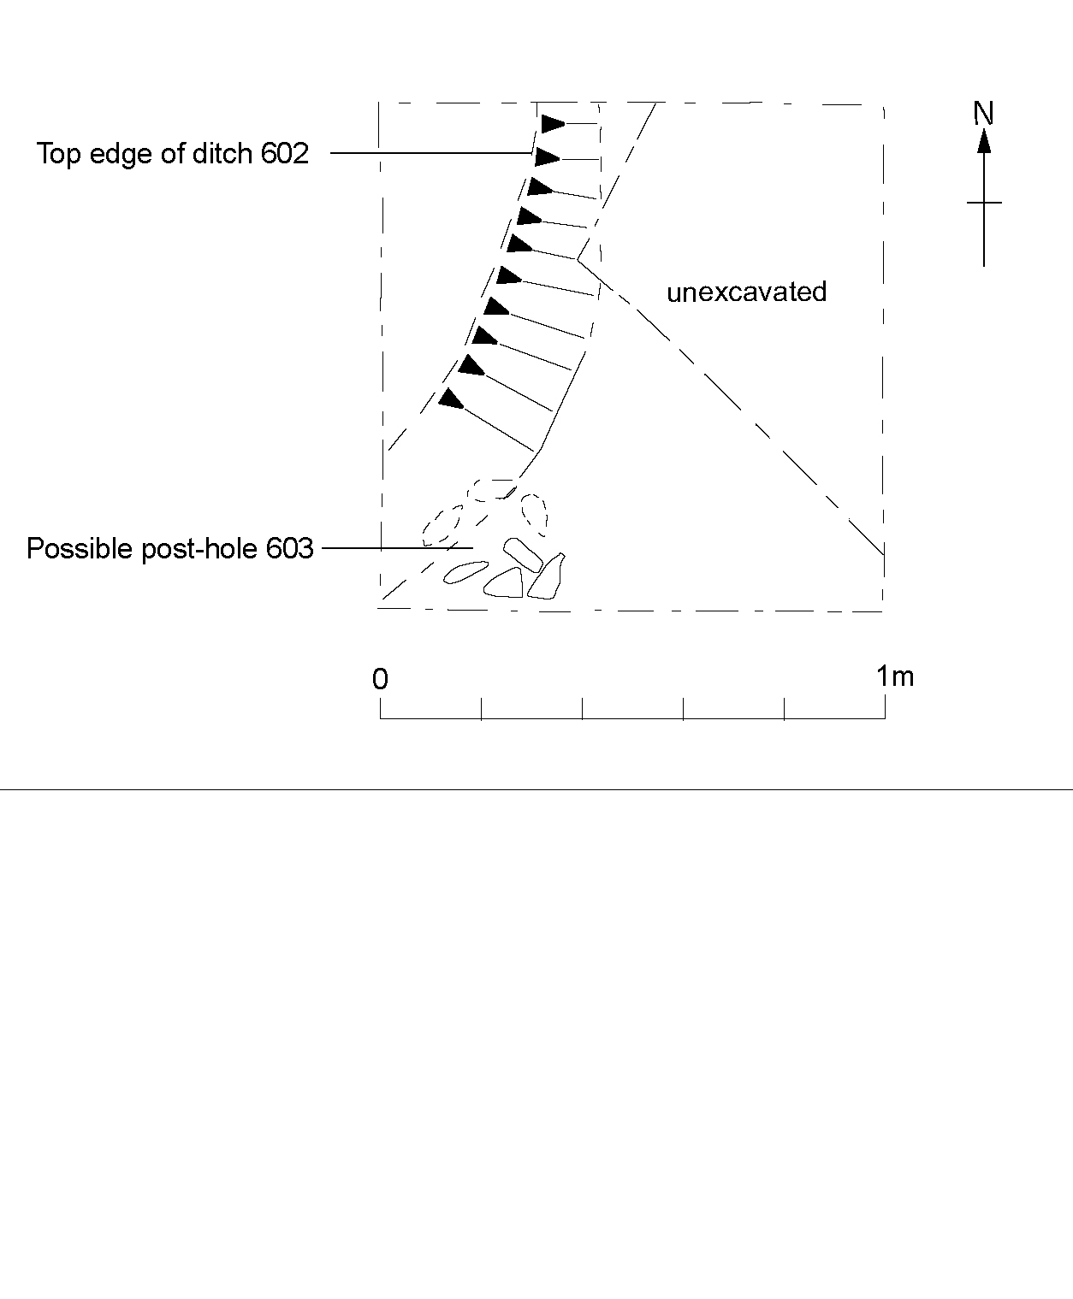
6
DISCUSSION

It is unsurprising that no archaeological deposits were encountered in most of the test areas, since the geophysical survey results suggest that any surviving features are more likely to be found further to the north.

The rock-cut feature in Test Area 6 is almost certainly associated with the southwestern corner of the defensive ditches of the earlier fort. These ditches, along with a number of smaller features, were first revealed in Trench 1 of the 2005 season in the area of the southwestern entrance to the fort. The occurrence of occasional charcoal flecks, burnt stone/clay and burnt bone in the fill is not unexpected: the most common context for the occurrence of burnt clay in the 2005 excavations was from ditch fill or from the fills of structural features. It was suggested in 2005 that the presence of the burnt material was suggestive of the destruction of buildings. Unlike the 2005 excavation this evaluation has not recovered any burnt daub.

The interpretation of the oval setting of stones as possible packing material surrounding a later post-hole cut into the top of ditch fill is tentative: the fill appeared to be the same as that of the probable ditch and it was not possible to identify a distinct cut for the smaller feature. Post-holes with stone packing cut into earlier ditch fills were, however, identified during excavations on the site of the neighbouring Roman fort at Llanfair-ar-y-Bryn (Cook 2006).

RECOMMENDATIONS

Apart from those in Test Area 6 no archaeological features were identified during the evaluation. This suggests that the proposed footpath will have a minimal impact on archaeological deposits. It is entirely possible that archaeological features survive elsewhere along the route of the footpath. The test areas have given an indication of the depth of overlying topsoil in various locations along the route and this can be used as a guide during the footpath construction. It is recommended that the footpath avoids the southwest corner of the earlier fort (the area of Test Area 6), as this is the only location where archaeological features are known to survive. This can be achieved by slightly altering the route of the path to run further to the south. It is important to note that the topsoil in Test Area 6 was 0.25m deep and this gives an indication of the depth of ground disturbance that would impact on archaeology in this area.
7
ACKNOWLEDGEMENTS

Thanks to Nikki Cook, Gwilym Hughes, Chris Nicholls, and Will Steele of Cambria Archaeology for assistance with the excavation and to Hubert Wilson for the illustrations.

SOURCES

Cook, N. 2006 Llanfair-ar-y-Bryn archaeological field evaluation, June-July 2006 (unpublished Cambria Archaeology report no. 2006/89, copy held in Cambria Archaeology HER)

Hughes, G. 2006 The Llandeilo Roman Forts: archaeological investigations 2003-2005, Draft in progress (unpublished Cambria Archaeology report no. 2006/38, copy held by Cambria Archaeology)

Stratascan 2003 Geophysical survey at Dynevor Park, Llandeilo (unpublished report, copy held in Cambria Archaeology HER)

ARCHIVE DEPOSITION

The evaluation archive will be integrated with the final archive for Llandeilo Roman Fort. In the short term it will be held by Cambria Archaeology.
8
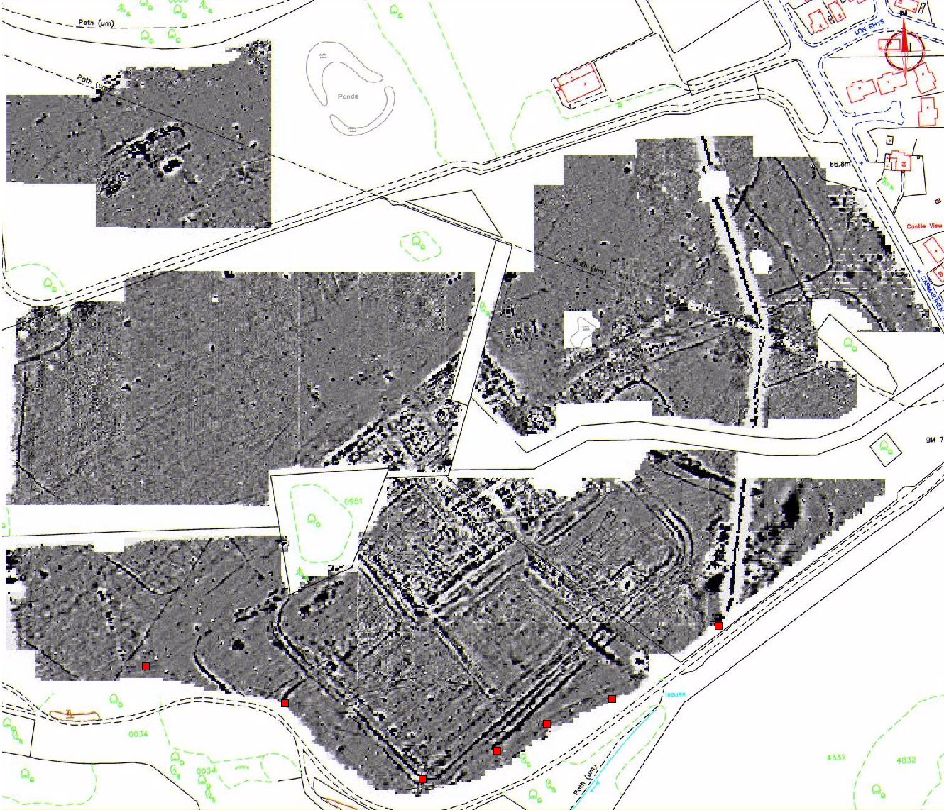
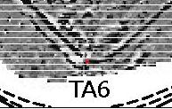

TA2
TA7
TA5
TA4
TA3
TA1
TA6

Figure 2. Test Areas plotted over geophysical survey results.
9
PLATES

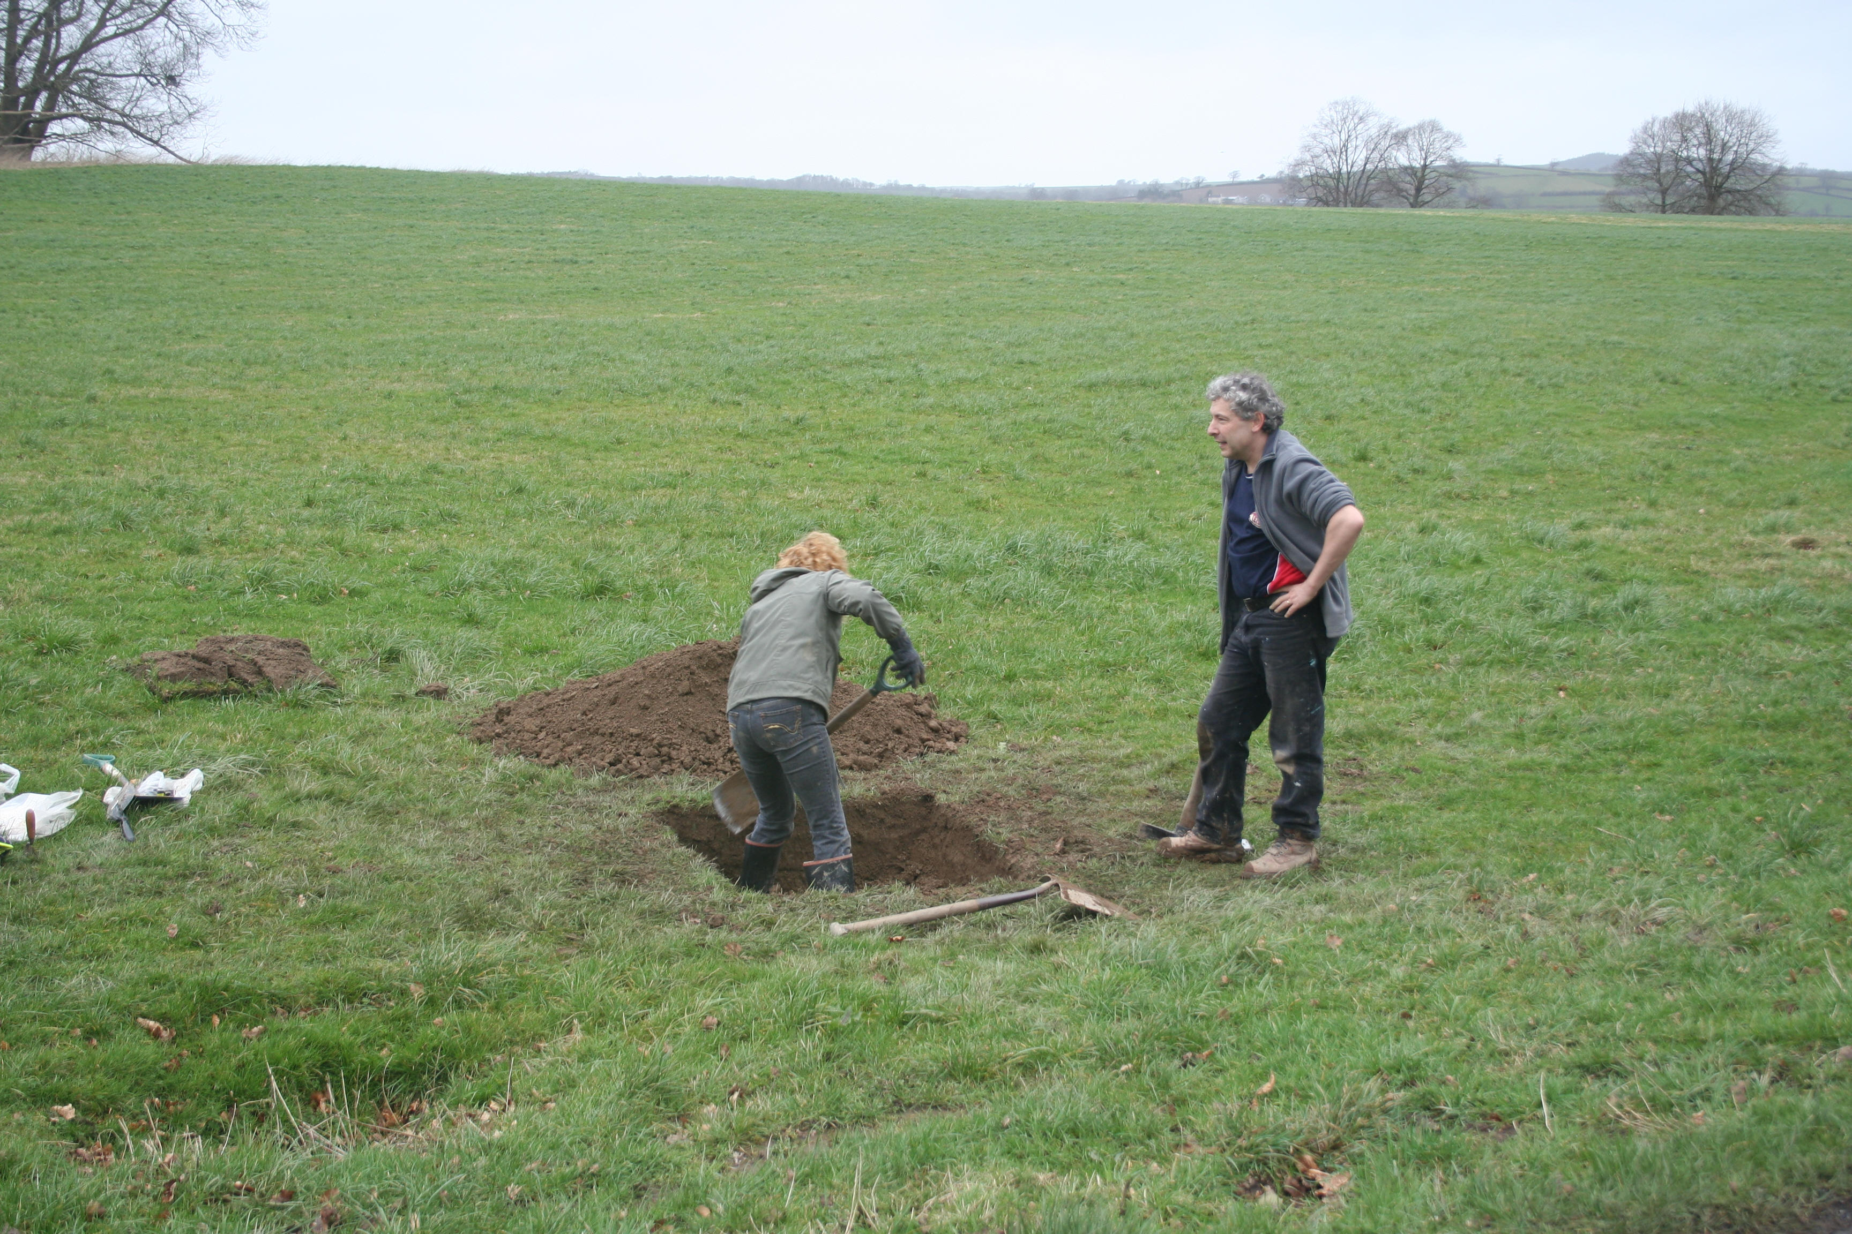
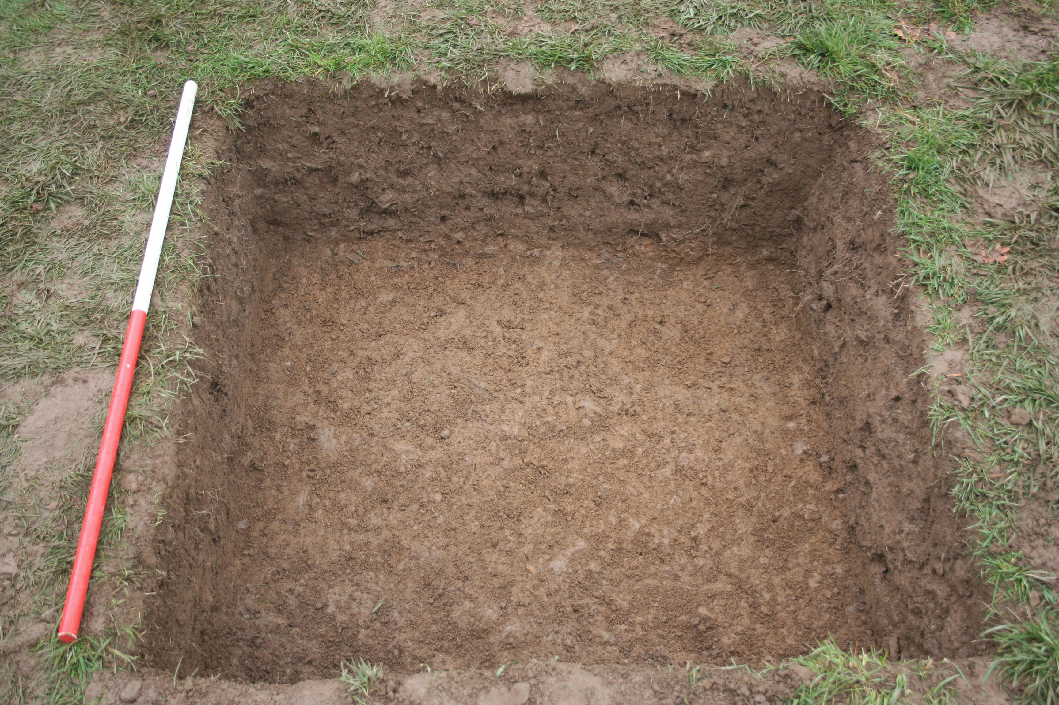

Plate 1.Excavation in Test Area 1 Plate 2. Test Area 3 after excavation
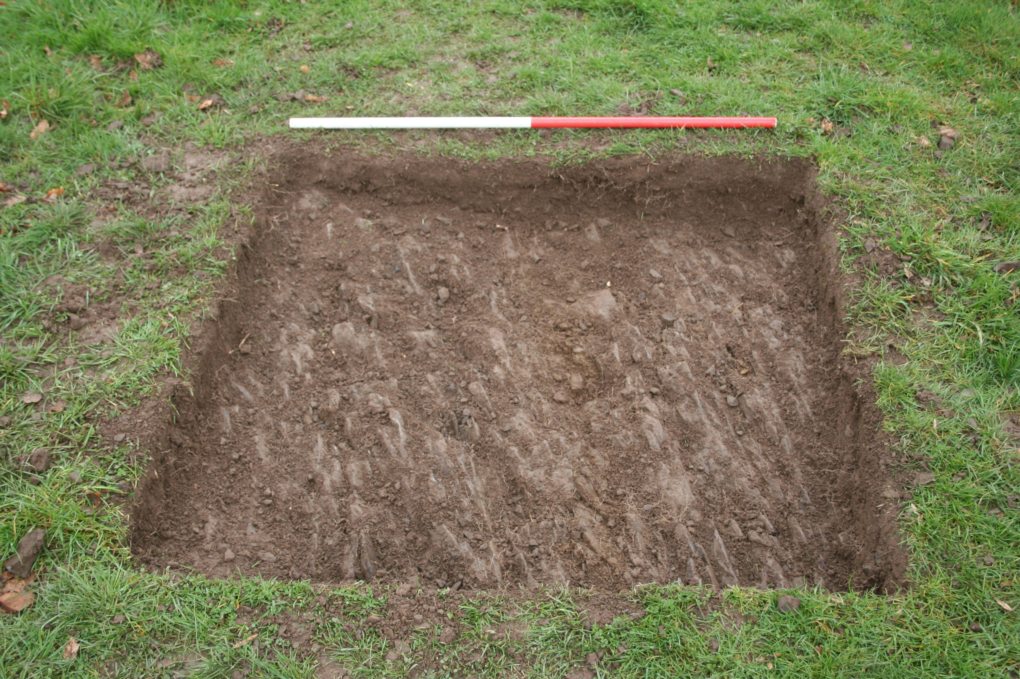
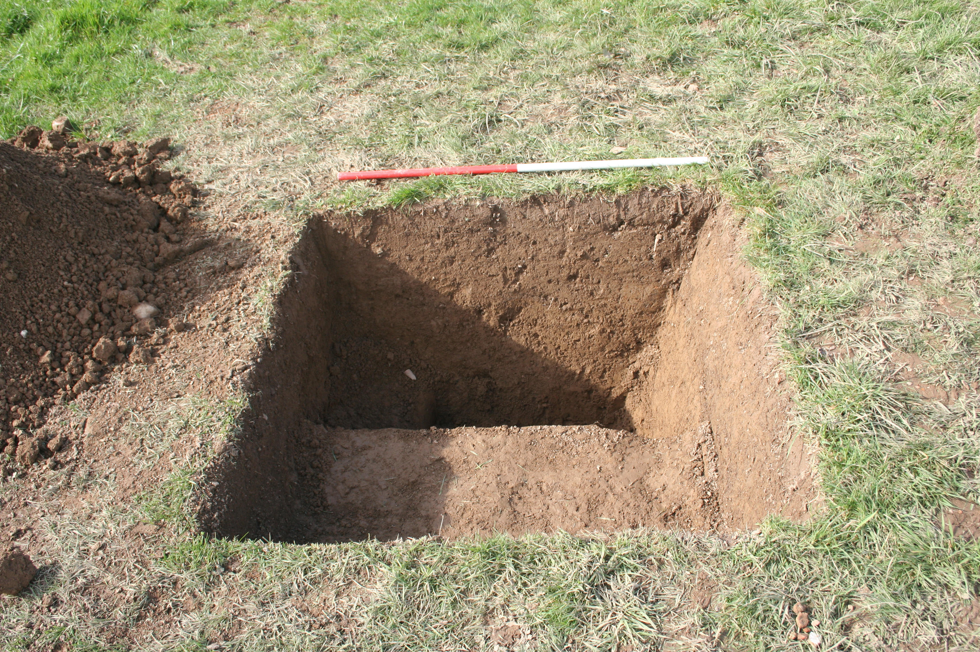

Plate 3. Test Area 5 after excavation Plate 4. Test Area 7 after excavation.
10

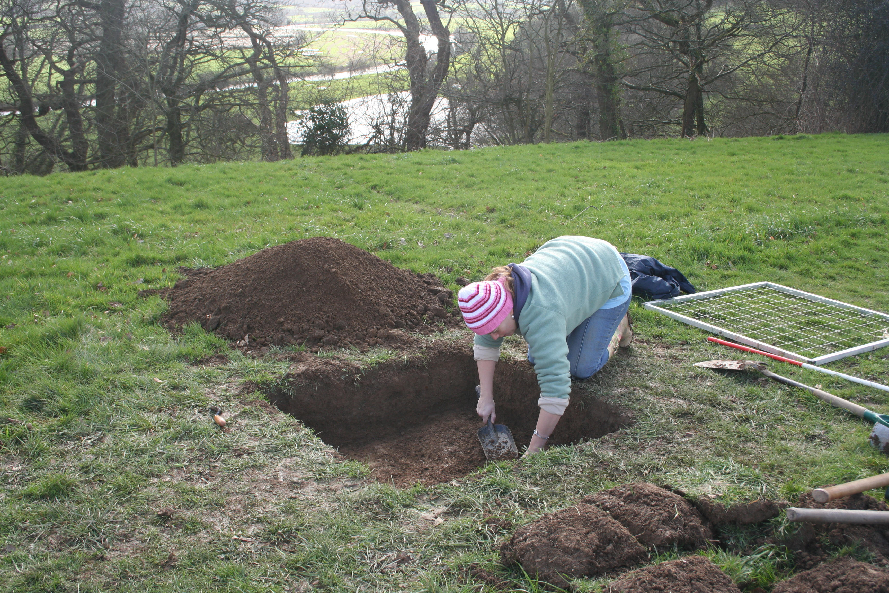
Plate 5. Initial excavation in Test Area 6.
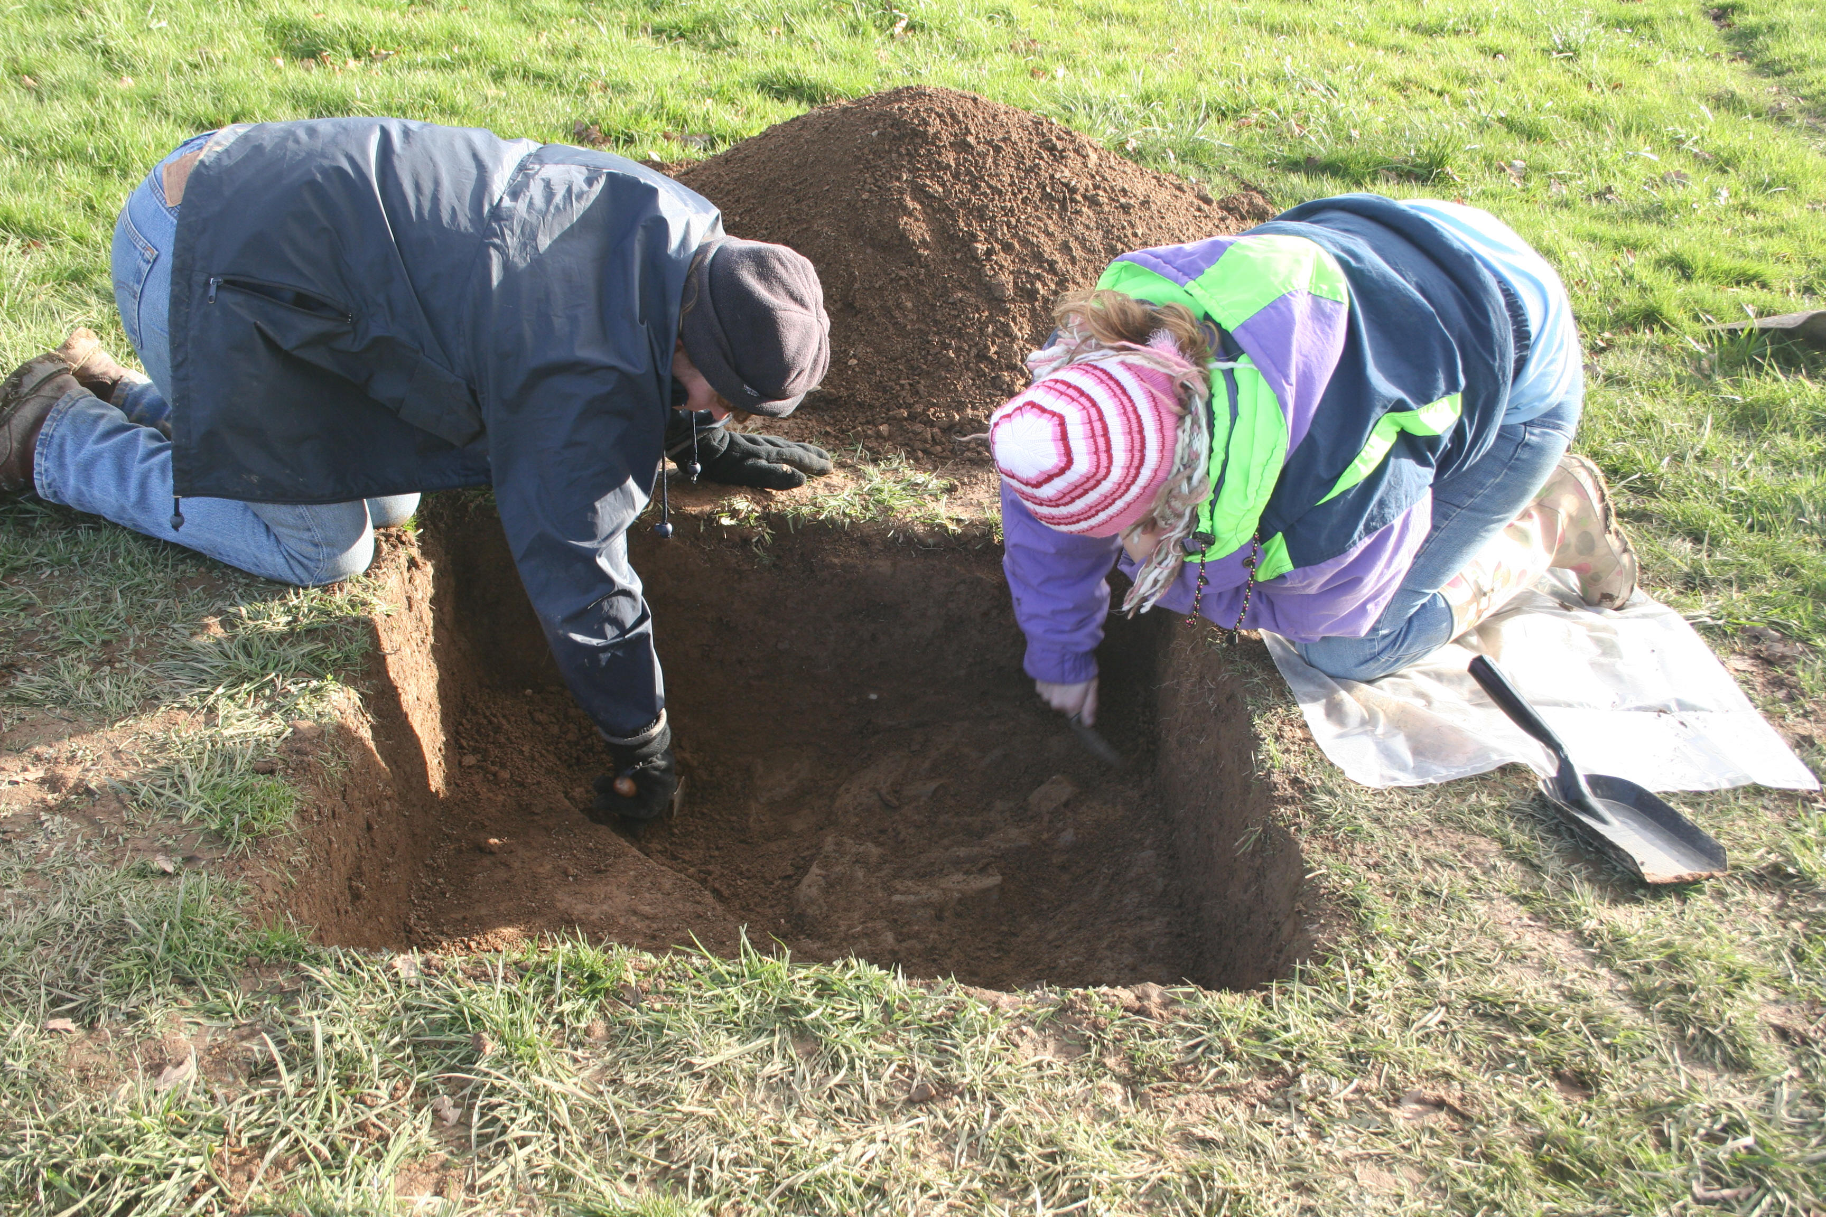
Plate 6. Test Area 6 showing possible post-hole 603.
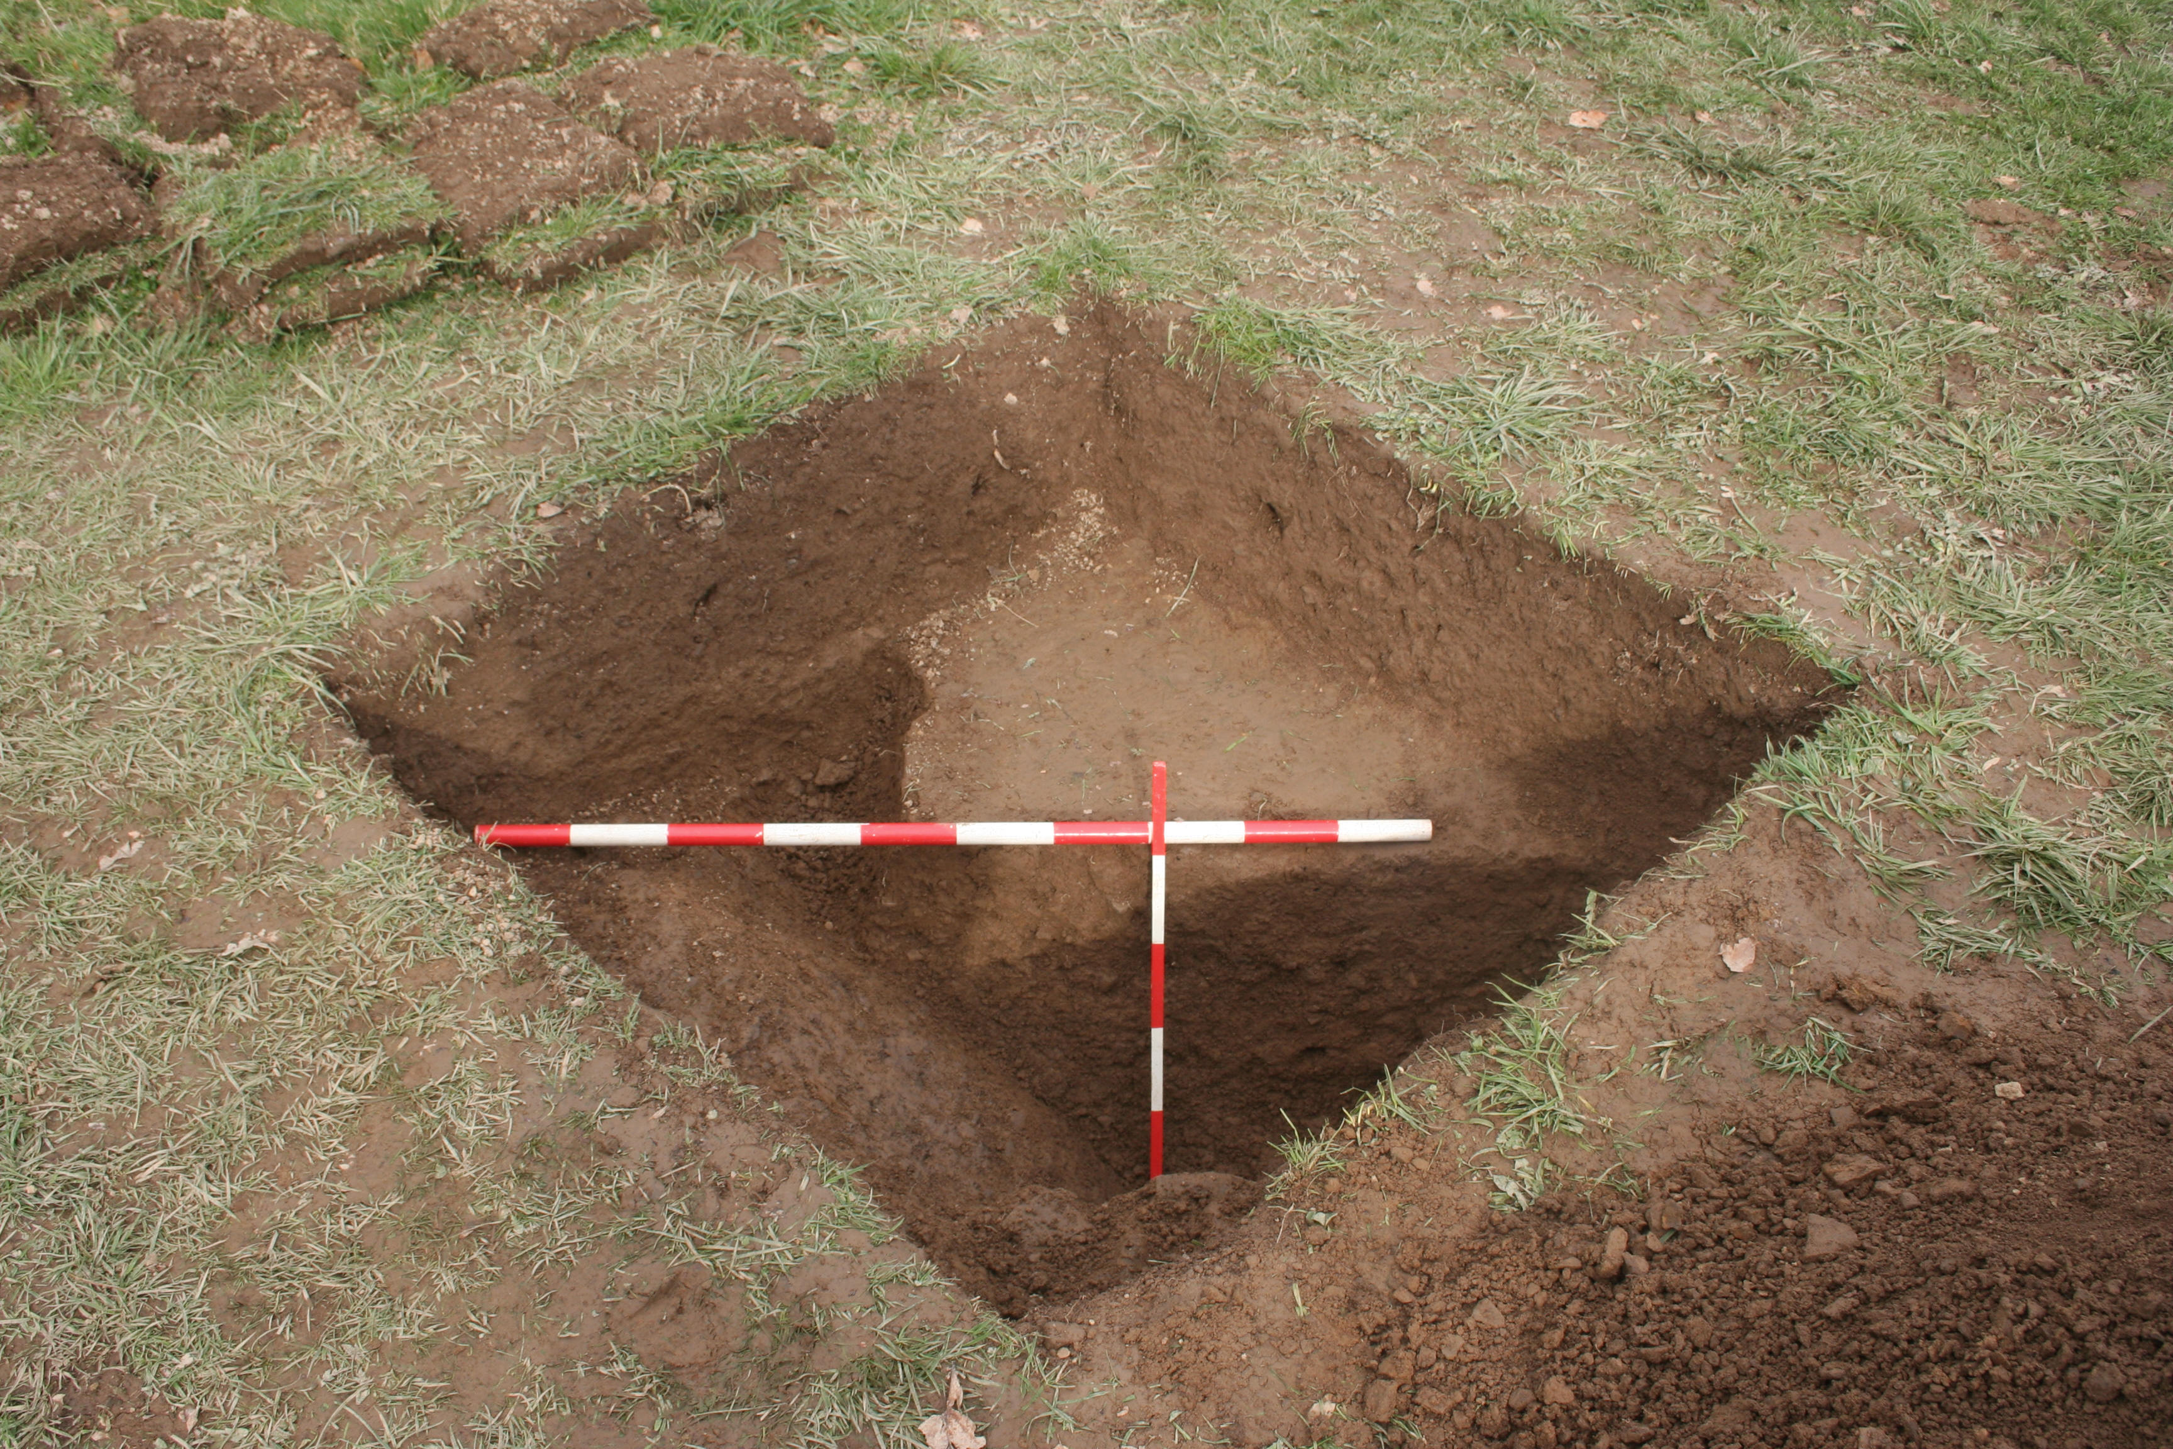
Plate 7. Ditch 602 in Test Area 6 looking northeast.
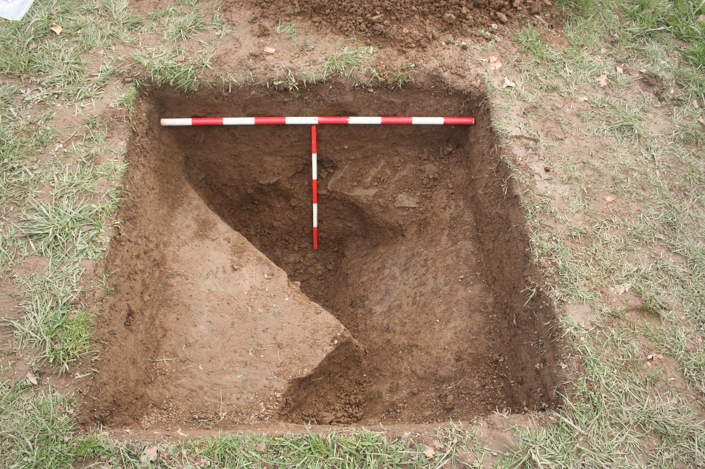

Plate 8. Ditch 602 in Test Area 6 looking south.
11

APPENDIX 1 – Details of test areas.

Test Area 1
Topsoil: Dark yellow-brown silty loam with occasional small angular stones. 0.26m. deep.

Subsoil: Yellow—brown silty clay with frequent shattered shale. Excavated to 0.22m.
Small finds: None

Test Area 2
Topsoil: Dark yellow-brown silty loam with frequent shattered shale and occasional charcoal flecks. 0.20m. – 0.25m. deep.
Subsoil: Yellow—brown silty clay with frequent shattered shale. Not excavated.
Small finds: None

Test Area 3
Topsoil: Dark yellow-brown silty loam with occasional small angular stones. 0.30m deep.
Subsoil: Yellow—orange silty clay with frequent shattered shale. Excavated to 0.10m.
Small finds: one tile fragment; two possible frags ?Samian ware; seven unidentifiable red fabric potsherds/tile fragments; three fragments of possible daub; three Post-Medieval potsherds; one piece of coal.

Test Area 4
Topsoil: Dark yellow-brown silty loam with frequent small angular stones. 0.28m deep.
Subsoil: Yellow—brown silty clay with frequent shattered shale. Excavated to 0.25m.
Small finds: one small fragment of modern glazed pottery; one red fabric rim fragment; one red fabric potsherd.

Test Area 5
Topsoil: Dark yellow-brown silty loam with frequent small angular stones. 0.10m deep.
Subsoil: None: topsoil immediately overlies shale bedrock.
Small finds: None

Test Area 6
Topsoil: Dark yellow-brown silty loam with occasional small angular stones. 0.25m deep.

Context 601 (deposit): Fill of ditch 601. Medium yellow-brown silty clay loam with frequent angular shattered shale fragments. Contained occasional charcoal flecks and burnt stone/brick/tile. Occasional (less than 1%) burnt bone.

Context 602 (cut): Ditch filled by 601 and cut by ?post-hole 603. A steep sided (c45°) ditch cut into shale bedrock. Not bottomed: excavated to 0.45m. Oriented southwest-northeast turning to north-northeast.

Context 603 (deposit): Possible post hole inserted in top of fill of ditch 602. An oval setting of stones measuring c.0.30m x 0.20m.

Test Area 7
Topsoil: Dark yellow-brown silty loam with occasional small angular stones. 0.27m deep.
Subsoil: Yellow—brown silty clay with frequent shattered shale and occasional small pieces of coal. Excavated to 0.50m.
Small finds: None

12

DINEFWR PARK EAST DRIVE
ARCHAEOLOGICAL EVALUATION PRIOR TO THE CREATION OF A NEW FOOTPATH

RHIF YR ADRODDIAD / REPORT NUMBER 2007/15

Mawrth 2006
March 2006

Paratowyd yr adroddiad hwn gan / This report has been prepared by Marion Page

Swydd / Position: Historic Environment Record Manager

Llofnod / Signature ............…………................. Dyddiad / Date

Mae’r adroddiad hwn wedi ei gael yn gywir a derbyn sêl bendith
This report has been checked and approved by

ar ran Archaeoleg Cambria, Ymddiriedolaeth Archaeolegol Dyfed Cyf.
on behalf of Cambria Archaeology, Dyfed Archaeological Trust Ltd.

Swydd / Position:

Llofnod / Signature .............…....…………....... Dyddiad / Date

Yn unol â’n nôd i roddi gwasanaeth o ansawdd uchel, croesawn unrhyw sylwadau sydd gennych ar gynnwys neu strwythur yr adroddiad hwn

As part of our desire to provide a quality service we would welcome any comments you may have on the content or presentation of this report

