Upper House Farm, Evenjobb, Powys, LD8 2SF

Photographic Survey

Christopher M. Welch MCIfA

April 2024

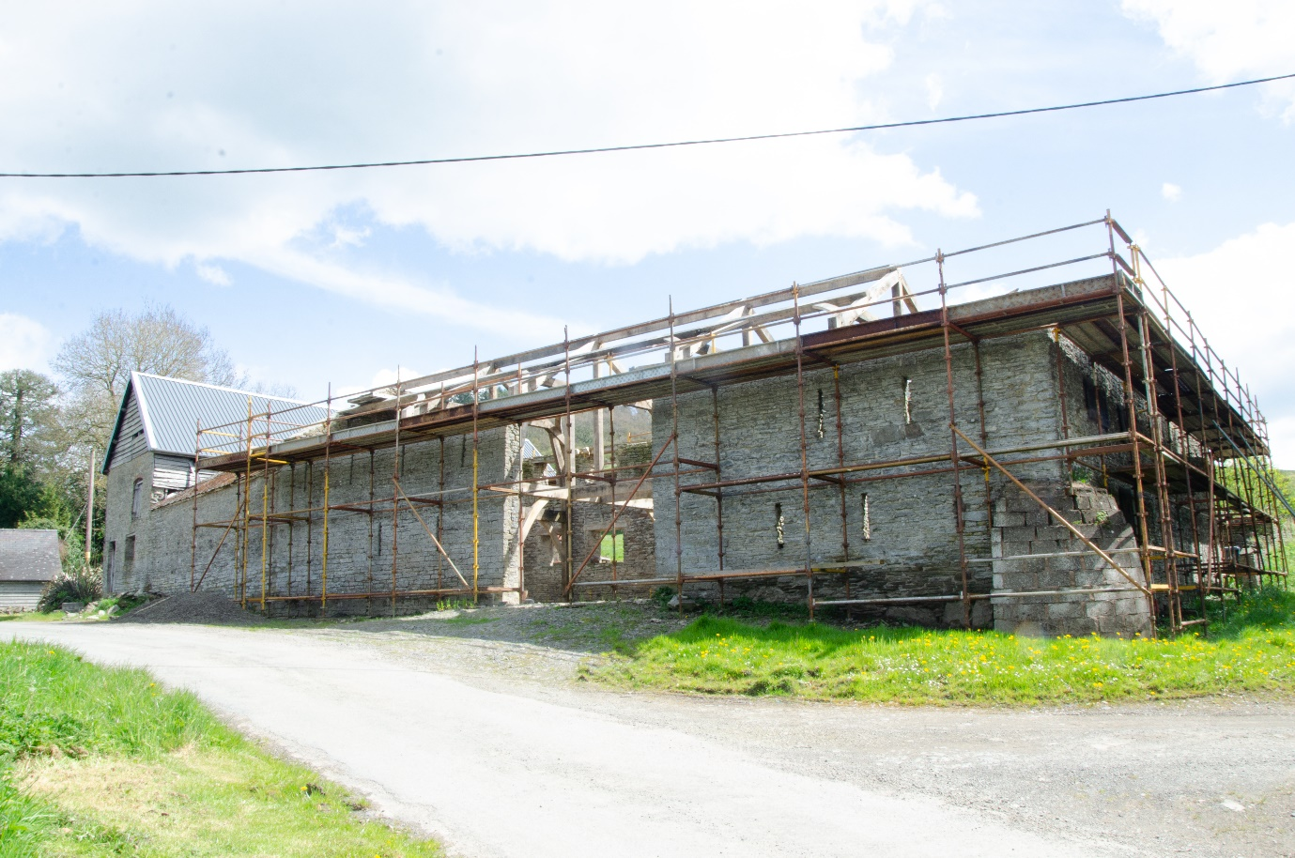

Reference UHF01/24

Contents
Summary
1. Introduction
2. Historical Background
3. Photographic Survey
4. Sources
5. Conclusions
6. Archive Selection Strategy.
Appendix 1 Photo Log
Appendix 2 Photo Location Plans
Summary
A photographic survey of a group of listed nineteenth century farm buildings was carried out, as required by the listed building consent which has been granted to convert them to dwellings. There was evidence for a substantial reconstruction in the nineteenth century.
Crynodeb
Cynhaliwyd arolwg lluniau o grŵp o adeiladau fferm rhestredig o’r bedwaredd ganrif ar bymtheg, yn unol â chaniatâd adeiladau rhestredig a roddwyd er mwyn eu troi’n anheddau. Bu tystiolaeth o ailadeiladu sylweddol yn y bedwaredd ganrif ar bymtheg.

1. Introduction
The buildings which are the subject of the photographic survey are centred approximately at SO2650262426. The Clwyd-Powys Archaeological Trust (CPAT) record number is PRN 32115. The buildings are all functional farm buildings, probably dating to the late nineteenth century. The farm buildings are listed as two items, the barn range (9168) and the cowhouse/stable range (9169) and the description is the same for both:
L-shape barn range, incorporating parts of an older structure. The north-west arm of 5 bays with central full-height opposing doors; the south-west arm converted to cartshed/granary with gable end steps. Coursed rubble with ventilation slits, iron roof, weatherboarded loft over open-fronted cartshed bays. Adjoining single storey open-fronted cowhouse with rubble rear wall and iron roof. North-east range is 2-storey cowhouse/stable block. Coursed rubble, weatherboarded loft, slate roof, brick cambered lintels, boarded doors, glazed stable windows.
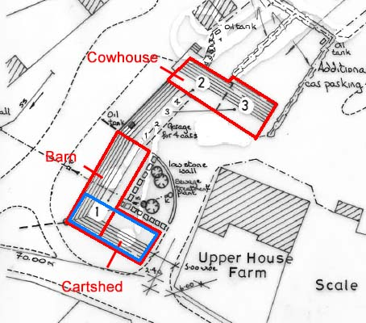

Fig. 1 Buildings Recorded. The extent of the earlier barn is indicated in blue (© M Edmunds)
The L-shaped barn range in the list description is composed of two structures. The south-west arm (as the list description states) in its latest form was a cartshed, but has clearly been converted from an earlier barn, as discussed below. The north-west arm is a barn as described. The separately listed two-storey cowhouse is separated from the barn by a covered yard, which the list description describes as a single storey open-fronted cowhouse, but which is simply a yard covered by a roof supported by a modern steel frame. The key structures are therefore the cartshed, the barn and the cowhouse and these are the subject of the photographic survey.
The owner of the buildings, Mr A. Morris, received listed building consent from Powys County Council in 2005 for conversion of the buildings to domestic units (PR622202 for unit 1 (cartshed and barn) and PR622200 for units 2 and 3(cowhouse)). Both consents included a condition requiring an appropriate photographic survey. Works have commenced on unit 1, the roof and other timberwork on both structures have been removed and the timber framework for the new domestic dwelling has been inserted. No photographic survey was carried out and Mark Walters at the Clwyd-Powys Archaeological Trust advised that work should cease until an appropriate survey has been carried out.
In December 2023 the timber framework within the cartshed collapsed. The fallen timber has now been removed, but no other works had taken place at the time of the survey.
2. Historical Background
Until the 1990s Upper House Farm formed part of the estate of Evancoyd (itself a registered historic park and garden). The farmhouse (which is not the subject of this survey) is listed at grade II and is described as having sixteenth century origins with nineteenth century additions.
3. Photographic Survey
The buildings were recorded on 20 and 28 April 2024 using a Nikon D5000 camera and tripod. All photographs were taken by C. Welch. All areas were accessible except the first floor and roof timbers to the cowhouse, but these were partly recorded from ground level. This report was compiled in May and June 2024.
The survey covered three structures; the cartshed, the barn and the cowhouse (fig. 1). The open fronted cowhouse referred to in the list description is simply a modern covered yard, and blocked windows in the north elevation of the barn confirm that there was never intended to be a structure here.
The long axis of the barn is aligned approximately thirty degrees east of north, and the cartshed and cowhouse are aligned at right angles to that, but for ease of reference in the following discussion the barn will be treated as if it was aligned north-south and the other two structures as if they were aligned east-west.
The Cartshed
Of the three structures, this has evidently undergone the most change. All the roof and the weatherboarding had been removed at the time of the survey, but drawings submitted with the planning application indicate that it was open on the north side at ground floor level, so the interpretation as a cartshed is reasonable. But the evidence suggests it was originally part of a larger barn which was aligned east-west. Firstly, it has the ‘arrowslit’ openings commonly seen in barns of this period and secondly, in the south elevation there is clearly a blocked full-height door (figs 2 and 3). Any evidence of an opposing door on the north side would have been removed when it was converted to a cartshed.
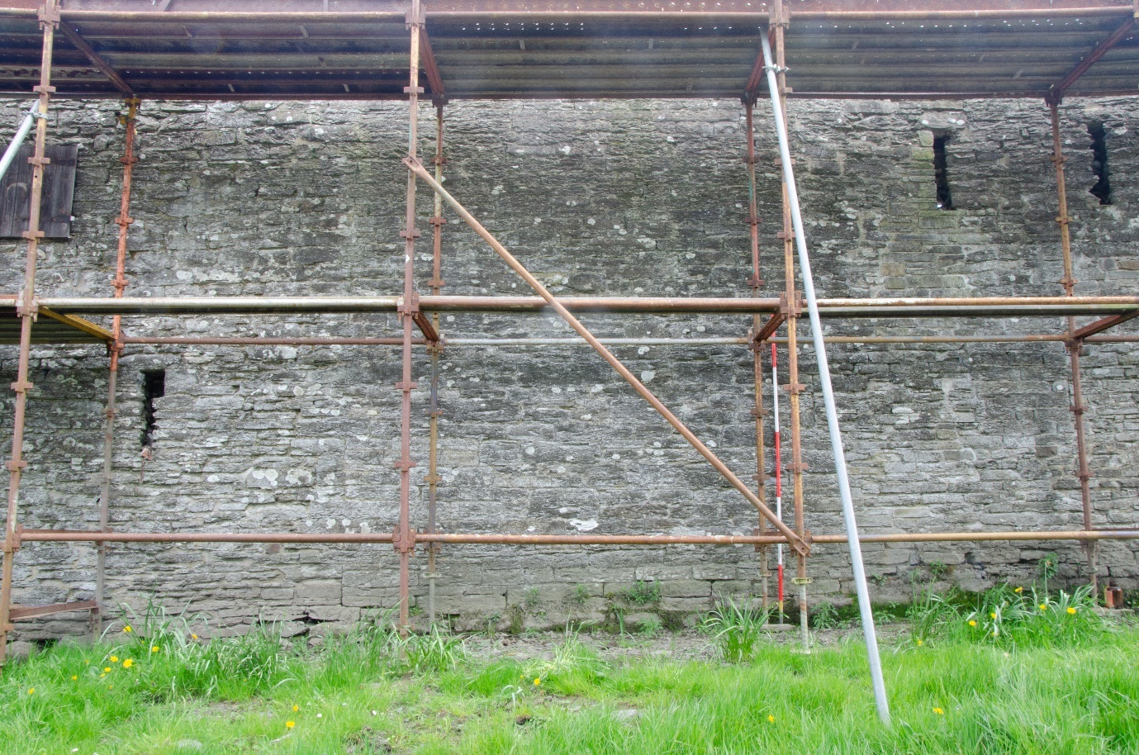
Fig 2. Cartshed external south elevation, showing location of blocked full-height door.
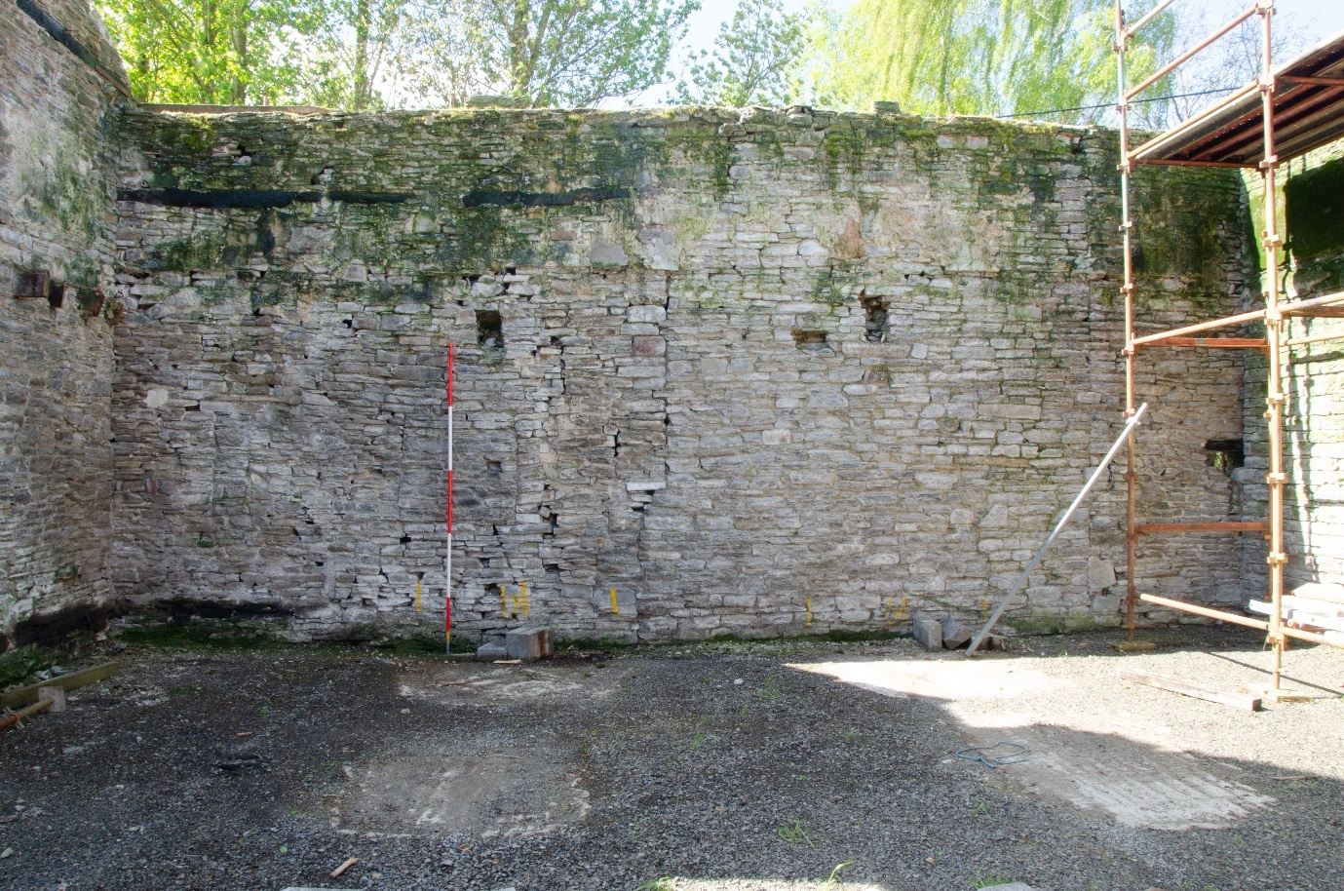
Fig 3. Cartshed internal elevation, showing location of blocked full-height door.
This conversion evidently came about when the current barn (i.e. the north-south aligned one) was built. This current barn was, in effect, inserted into the west end of the earlier barn so that the west end of the earlier barn became the south end of the new one. The evidence for this is most clearly seen where the east wall of the new barn meets the south wall of the earlier barn. The new wall almost completely blocks one of the ‘arrowslit’ openings and is not tied into the earlier wall at all (fig. 4).
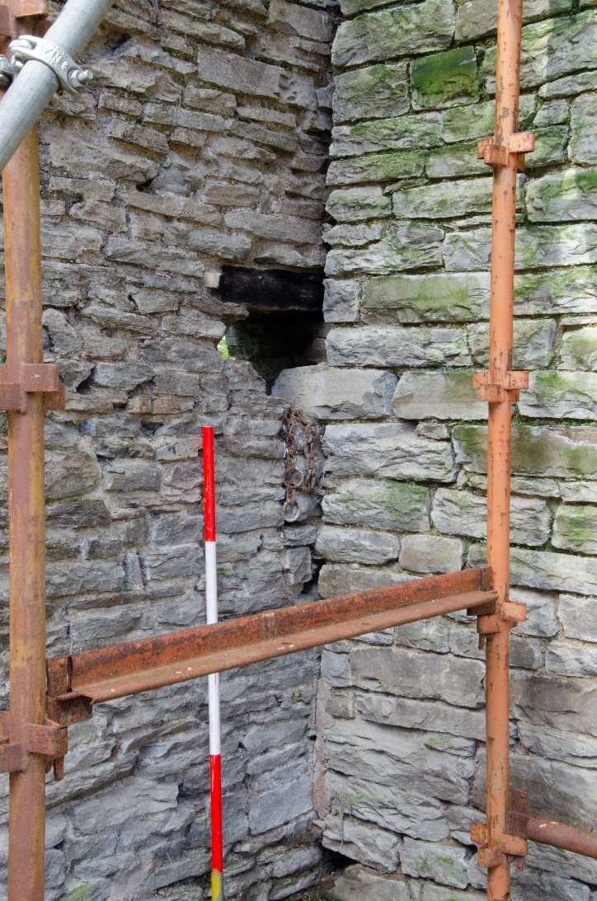
Fig. 4. Junction of east wall of barn and south wall of preceding barn, showing the partially blocked ‘arrowslit’.
It is possible that the earlier barn was also shortened at the same time as its conversion to a cartshed. The evidence for this lies in the east wall of the cartshed, which had a first floor, which the earlier barn would not have had. Access and light to this first floor are provided by a window and door at first floor height in the east wall, and external stone stairs (fig 5). There is no sign that either window or door are inserted, and there are no indications of the blocked ‘arrowslit’ openings that would be expected here, so this east wall may be a later construction replacing the original east gable end.
Any evidence for a threshing floor located between the opposing doors has now been lost.

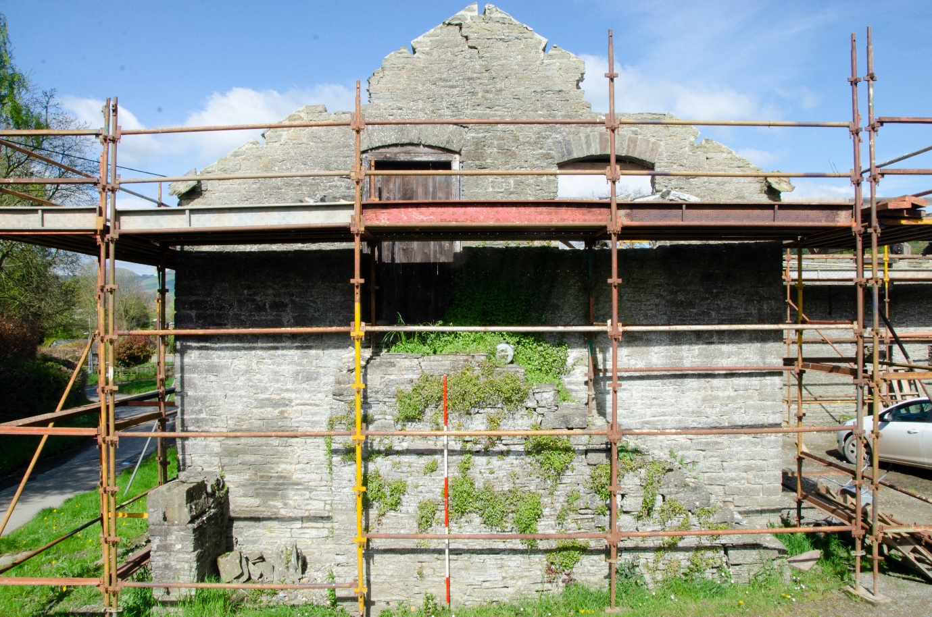
Fig. 5. East elevation of cartshed.
The outcome of the conversion was to create a new barn leaving the remainder of the earlier barn to be converted to a cartshed. Possibly the earlier barn was shortened to accommodate the external steps without narrowing the entrance to the farmyard.
Unfortunately none of the above changes can be dated. The Tithe map depiction is difficult to reconcile with the current layout and neither the first nor the second edition 1:2500 Ordnance Survey County sheets are available online or at the Powys Record Office. There is no reason to think that the earlier barn and its successor date from anything other than the nineteenth century.
The owner says that the cartshed was subject to a serious fire in recent years, and the effect of this is visible in the charring of some of the wooden lintels over the arrowslit openings.
The Barn
As discussed above, this barn was inserted into an earlier barn at the latter’s west end and at right angles to it. As a result, the southern end of the west wall of the later barn is the gable end of the earlier one, and the junction of the rest of the west wall of the later barn with the earlier gable is clearly visible (fig. 6). The new barn has the full height opposing doors set slightly off centre to the south, with ‘arrowslit’ openings matching those retained from the earlier barn. On the east wall, facing into the farmyard, there are openings for what might have been either casement or sash windows, although all the woodwork relating to these has been removed. The north gable of the barn has a number of ‘arrowslit’ openings which would have opened out into a yard area which has now been covered by a roof and a supporting steel frame.
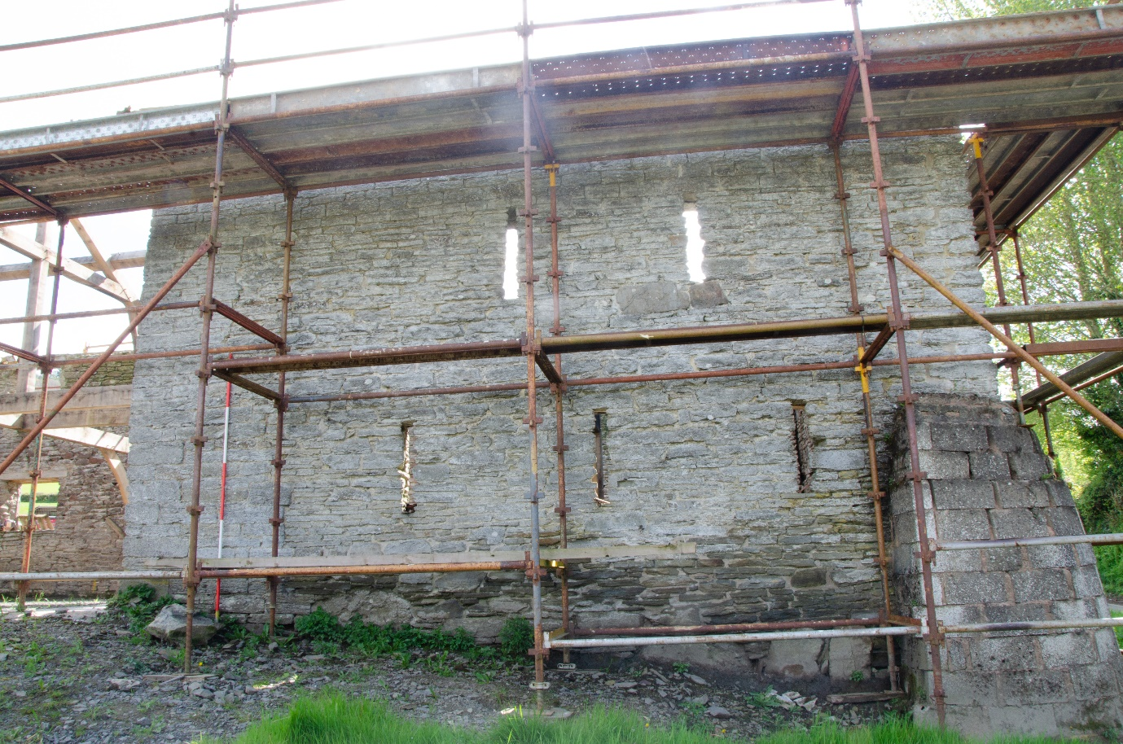
Fig. 6. External west elevation of south end of barn. The five ‘arrowslit’ windows were in the gable end of the earlier barn. The west wall of the later barn continues to the left of the ranging pole.
The Cowhouse
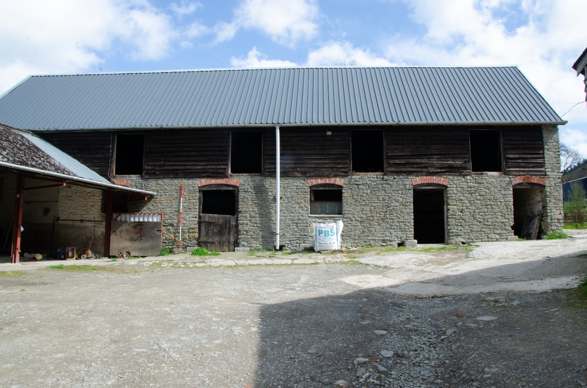
Fig 7. South elevation of cowhouse, showing blocked doors and brick arches over doors.
The cowhouse is a rectangular four-bay structure with a dairy added at the west end. The south elevation has five doors with brick voussoirs; two of the doors have been partially blocked to create windows (fig. 7). On the north elevation, at the west end, the section corresponding to the dairy has the same brick voussoirs as the south elevation, with a very clear straight joint where the weatherboarding ends, separating it from the rest of the north wall (fig.8). Internally, the wall between the four main bays and the dairy is massive (fig. 9) and it seems likely that the north wall of the cowhouse and this dividing wall are part of an earlier building. Internally there is a surviving section of original cobbled floor with a longitudinal drain, suggesting that the cows were lined up alongside each other along the length of the building with a drainage channel behind them.
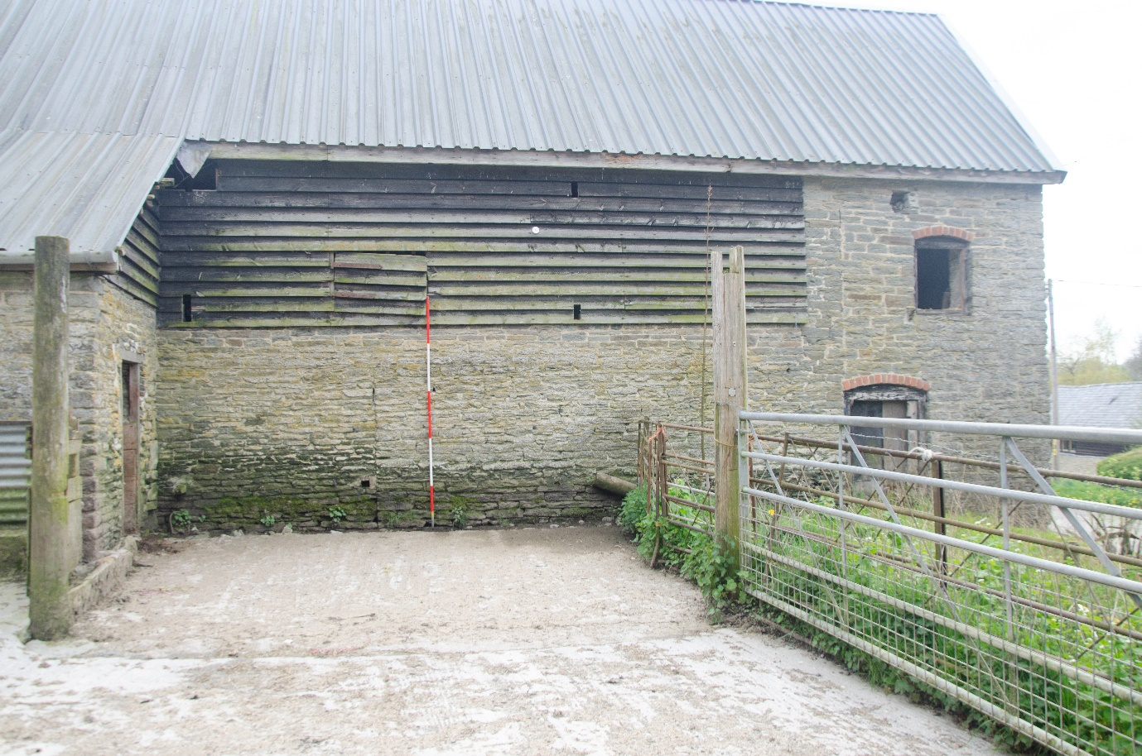
Fig. 8. North elevation of cowhouse. Note dairy added at w end (straight joint alongside brick arch), and note earlier straight joint to left of ranging pole.
Further east along the north wall is another straight joint, seen internally and on the exterior, but the origin of this is unclear, possibly representing a modification of an earlier structure. At the time of the survey it was not possible to access the first floor, but the roof timbers appeared to be relatively recent.
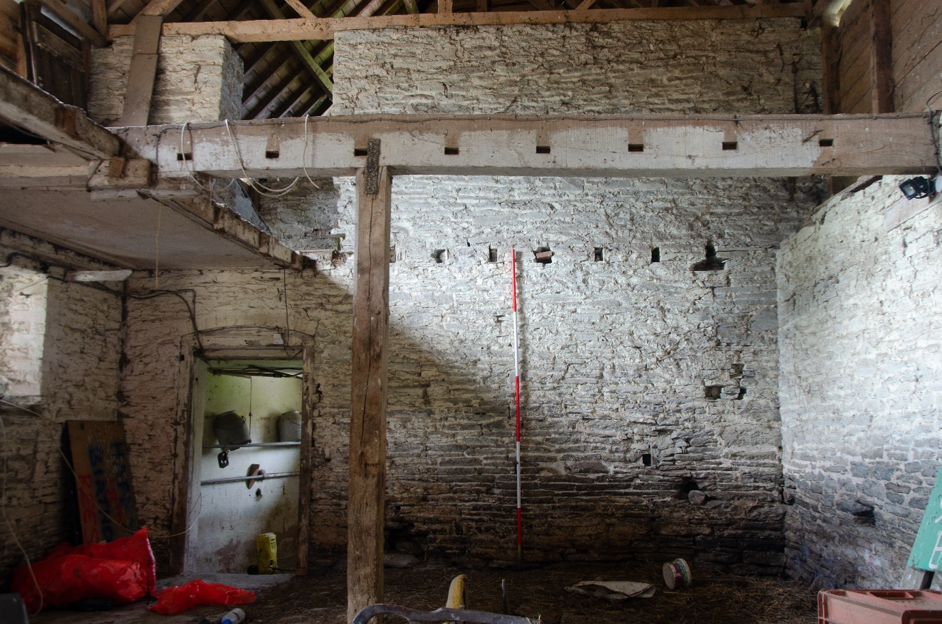
Fig. 9. Internal wall separating cowhouse from the dairy, and which originally formed the gable end of the building.
At the rear of the cowhouse, on the north side, a structure has been added which, from the stone feeding trough which allows feeding from outside, is presumably a pigsty.
A door has been inserted into the west side of the dairy above ground level, evidently to give access to allow milk churns to be loaded directly onto a cart. This might relate to the railway milk trade, and was possibly done after the opening of the line to Presteigne in the mid-1870s.
Although no absolute date can be offered, it is noticeable that the masonry is of a higher quality and the coursing is virtually continuous from the full height door of the barn, along the wall of the covered yard and through into the gable end of the cowhouse, which indicates that the later barn and the cowhouse in its latest form (characterised by the use of the brick voussoirs) were all created at the same time.
4. Sources
Wiliam, E. The Historic Farm Buildings of Wales (1986)
5. Conclusions
An earlier group of buildings, which included a substantial stone barn, has been very substantially modified, possibly to allow the creation of a cartshed in part of the earlier barn. This must have represented a considerable capital investment on the part of the estate, and was perhaps to accommodate the machinery which was becoming more common on farms in the later part of the nineteenth century.
6. Archive Selection Strategy
About 100 photographs were taken during the survey, and of these 53 were selected for submission to the local authority. The photographs were examined on completion of the survey, and any duplicate, out-of-focus or otherwise unsuitable images were noted and discarded. The archive will be submitted to the Royal Commission on the Ancient and Historical Monuments of Wales.

Appendix 1. Photo Log

UHF No. | DSC No. | Date | Description | Figure in report
001 | 4215 | 28/04/2024 | General view facing ne | Cover
002 | 4100 | 20/04/2024 | General facing ne covered yard to centre
003 | 4196 | 28/04/2024 | General view facing s
004 | 4197 | 28/04/2024 | General view facing s
005 | 4198 | 28/04/2024 | General view facing sw
006 | 4168 | 28/04/2024 | Cartshed ext e elev | Fig. 5
007 | 4209 | 28/04/2024 | Cartshed ext s elev facing nw
008 | 4211 | 28/04/2024 | Cartshed ext s wall s elev e section
009 | 4210 | 28/04/2024 | Cartshed ext s wall s elev central section with blocked doorway | Fig. 2
010 | 4212 | 28/04/2024 | Cartshed ext s wall s elev w section
011 | 4213 | 28/04/2024 | Cartshed/Barn s wall s elev facing ne
012 | 4171 | 28/04/2024 | Cartshed int e wall w elev
013 | 4177 | 28/04/2024 | Detail of e wall of Cartshed meeting s wall. Note floor beams built in, not later insertions, and straight joint.
014 | 4173 | 28/04/2024 | Cartshed int s wall n elev with blocked doorway | Fig. 3
015 | 4174 | 28/04/2024 | Cartshed int w wall / e wall of Barn e elev
016 | 4176 | 28/04/2024 | Detail of east wall of Barn meeting s wall of Cartshed. Note blocked 'arrowslit' window. Facing sw. | Fig. 4
017 | 4178 | 28/04/2024 | Barn int s wall n elev (formerly s wall earlier barn). Note blocked window to l.
018 | 4186 | 28/04/2024 | Barn facing n
019 | 4184 | 28/04/2024 | Barn int west wall e elev s part
020 | 4183 | 28/04/2024 | Barn int west wall e elev n part
021 | 4182 | 28/04/2024 | Barn int n wall s elev Note blocked windows into covered yard.
022 | 4180 | 28/04/2024 | Barn int e wall w elev n part
023 | 4179 | 28/04/2024 | Barn int e wall w elev s part. Note straight joint where it meets s wall.
024 | 4201 | 28/04/2024 | Barn ext e wall e elev n part
025 | 4189 | 28/04/2024 | Barn ext w wall w elev s part. (Former w wall to earlier barn) | Fig. 6
026 | 4190 | 28/04/2024 | Barn ext w wall w elev n part
027 | 4192 | 28/04/2024 | Covered yard west wall w elev
028 | 4194 | 28/04/2024 | General view facing se. Cowhouse to l, Barn to r
029 | 4187 | 28/04/2024 | Cowhouse ext s elev | Fig. 7
030 | 4104 | 20/04/2024 | Cowhouse ext s elev west end
031 | 4105 | 20/04/2024 | Cowhouse ext s elev east end
032 | 4107 | 20/04/2024 | Cowhouse ext s elev partially blocked doorway
033 | 4108 | 20/04/2024 | Cowhouse ext s elev drain hole
034 | 4110 | 20/04/2024 | Cowhouse ext e elev
035 | 4111 | 20/04/2024 | Cowhouse ext e elev pigsty feeding trough (broken)
036 | 4113 | 20/04/2024 | Cowhouse pigsty ext n elev e end
037 | 4114 | 20/04/2024 | Cowhouse pigsty ext n elev w end
038 | 4115 | 20/04/2024 | Cowhouse pigsty ext w elev
039 | 4116 | 20/04/2024 | Cowhouse ext n elev w end | Fig. 8
040 | 4193 | 28/04/2024 | Cowhouse ext w elev
041 | 4117 | 20/04/2024 | Cowhouse int e elev of wall between cows and dairy | Fig. 9
042 | 4118 | 20/04/2024 | Cowhouse cobbled floor facing w
043 | 4122 | 20/04/2024 | Cowhouse int n wall s elev west end (note straight joint)
044 | 4125 | 20/04/2024 | Cowhouse int n wall s elev central part
045 | 4126 | 20/04/2024 | Cowhouse int n wall s elev east end and door to pigsty
046 | 4128 | 20/04/2024 | Cowhouse int s wall n elev e end partially blocked door to r
047 | 4130 | 20/04/2024 | Cowhouse int s wall n elev west end
048 | 4131 | 20/04/2024 | Cowhouse int s wall n elev central part
049 | 4140 | 20/04/2024 | Cowhouse roof facing e
050 | 4207 | 28/04/2024 | Cowhouse roof timbers facing sw
051 | 4203 | 28/04/2024 | Pigsty facing w
052 | 4204 | 28/04/2024 | Pigsty facing e
053 | 4205 | 28/04/2024 | Pigsty detail of feeding trough

Appendix 2. Photo Location Plans (© M Edmunds)

