Comisiwn Brenhinol Henebion Cymru

Royal Commission

on the

Ancient and Historical Monuments of Wales



Castle Malgwyn Model Farm

County: Pembrokeshire
Community: Manordeifi
NGR: SN21704304
NPRN: 406549
Date of Survey: August 2007
Surveyed by: Geoff Ward, Susan Fielding & Daniel Jones
Report Author: Geoff Ward
Illustrations: Geoff Ward

© Crown Copyright: RCAHMW 2008

Comments or queries regarding the content of the report should be made to the author:
RCAHMW, Plas Crug, Aberystwyth, Ceredigion SY23 1NJ
Tel: 01970 621200

World Wide Web: http//www.rcahmw.gov.uk 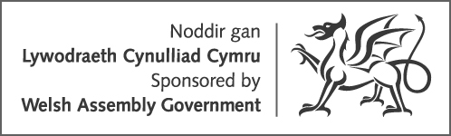

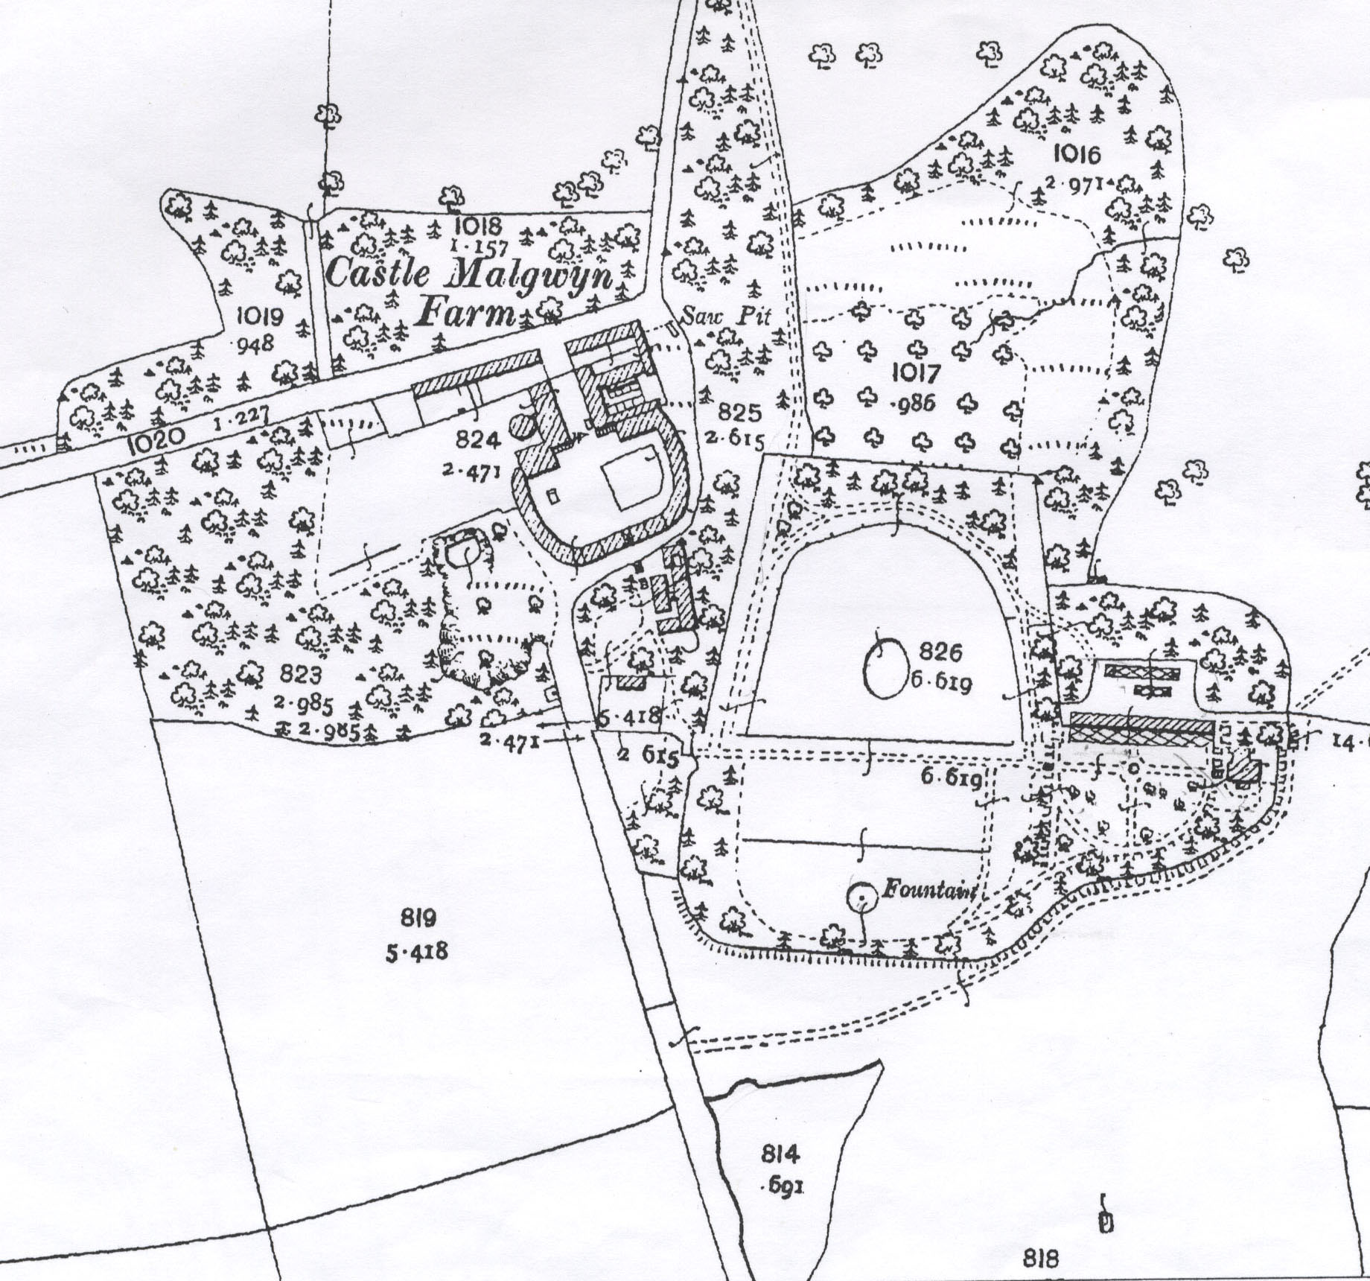
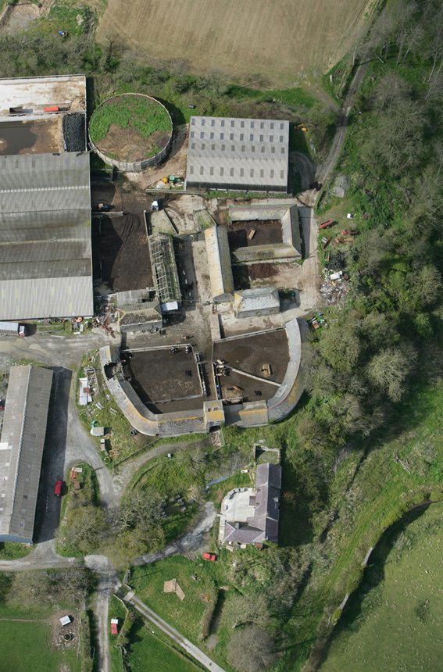 Aerial photo (AP_2008_0460.TIF)
OS 25” map, second edition 1906

Castell Malgwyn lands were purchased by the Penygored Ironworks in 1771, and then by Sir Benjamin Hammet in 1791. At that time the site of the present day Model farm was probably the main homestead. This site has an early history, once regarded as the site of a medieval castle, and has a strong tradition that it was the home of certain Welsh Princes (ref. Cambria archaeology).
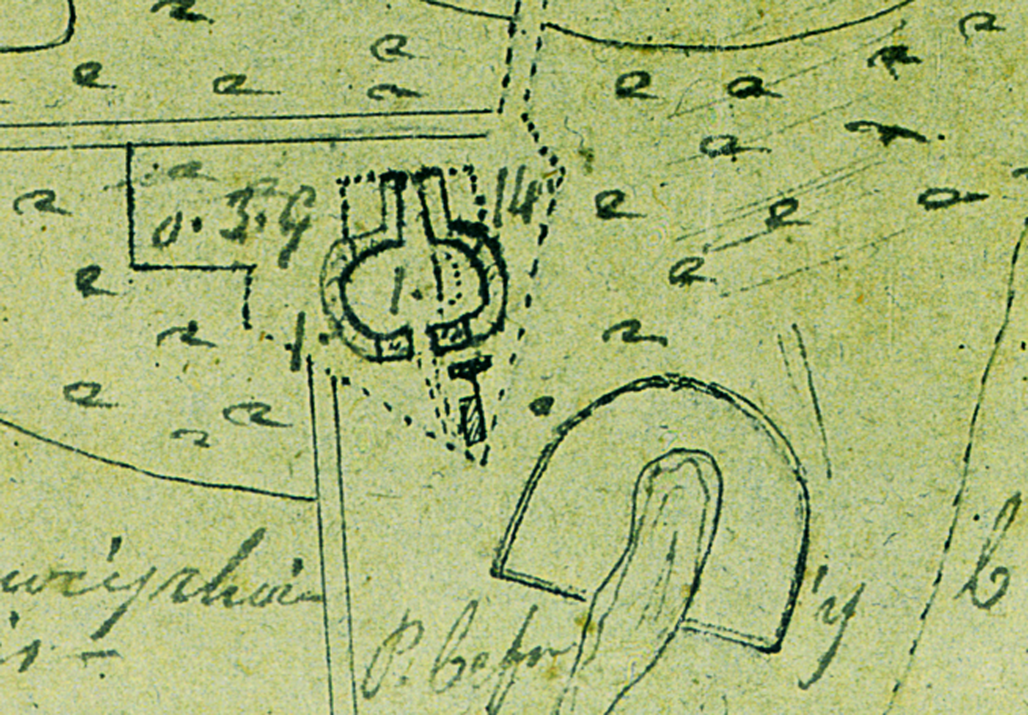
By 1795 Hammet had built a mansion house away from the homestead, close by the ironworks and river Teifi, naming it Castell Malgwyn NPRN21729, the site of the present hotel . Hammet built the Model Farm and adjacent Kitchen Gardens NPRN21730, near to the old homestead site shortly after 1795, perhaps by the time a new road was opened in 1800. The building plans are much as shown on the 1820 sale particulars map, although an 1814 Ordnance Survey (OS) surveyer’s drawing map suggests the stables wern’t built then. A farmhouse (not recorded), much modernised externally, survives to the south of the present Model Farm buildings, is shown on the map of 1814. The first edition OS map of 1889 shows all the buildings, although some are now demolished.
The estate was sold to the Gower family in about 1824, and after Edith Gower’s death in 1876, by an agreement of 1877 (Glandovan
Sales particulars Estate Map c1820

papers NLW) the “farm and lands” were leased to tennants. A “shedule of repairs 1876” (Glandovan papers NLW) to Castell Malgwyn farm (the Model Farm) valued it with 339 acres at £340.

Today the Model Farm buildings, although in poor condition, survive to a large extent and are presently used for fattening cattle, along with a number of large, modern, buildings adjacent. Many of the original openings to the Model Farm buildings are
blocked, some in 19th century, stone some in 20th century block-work. Similarly many
timber floors and tethering details

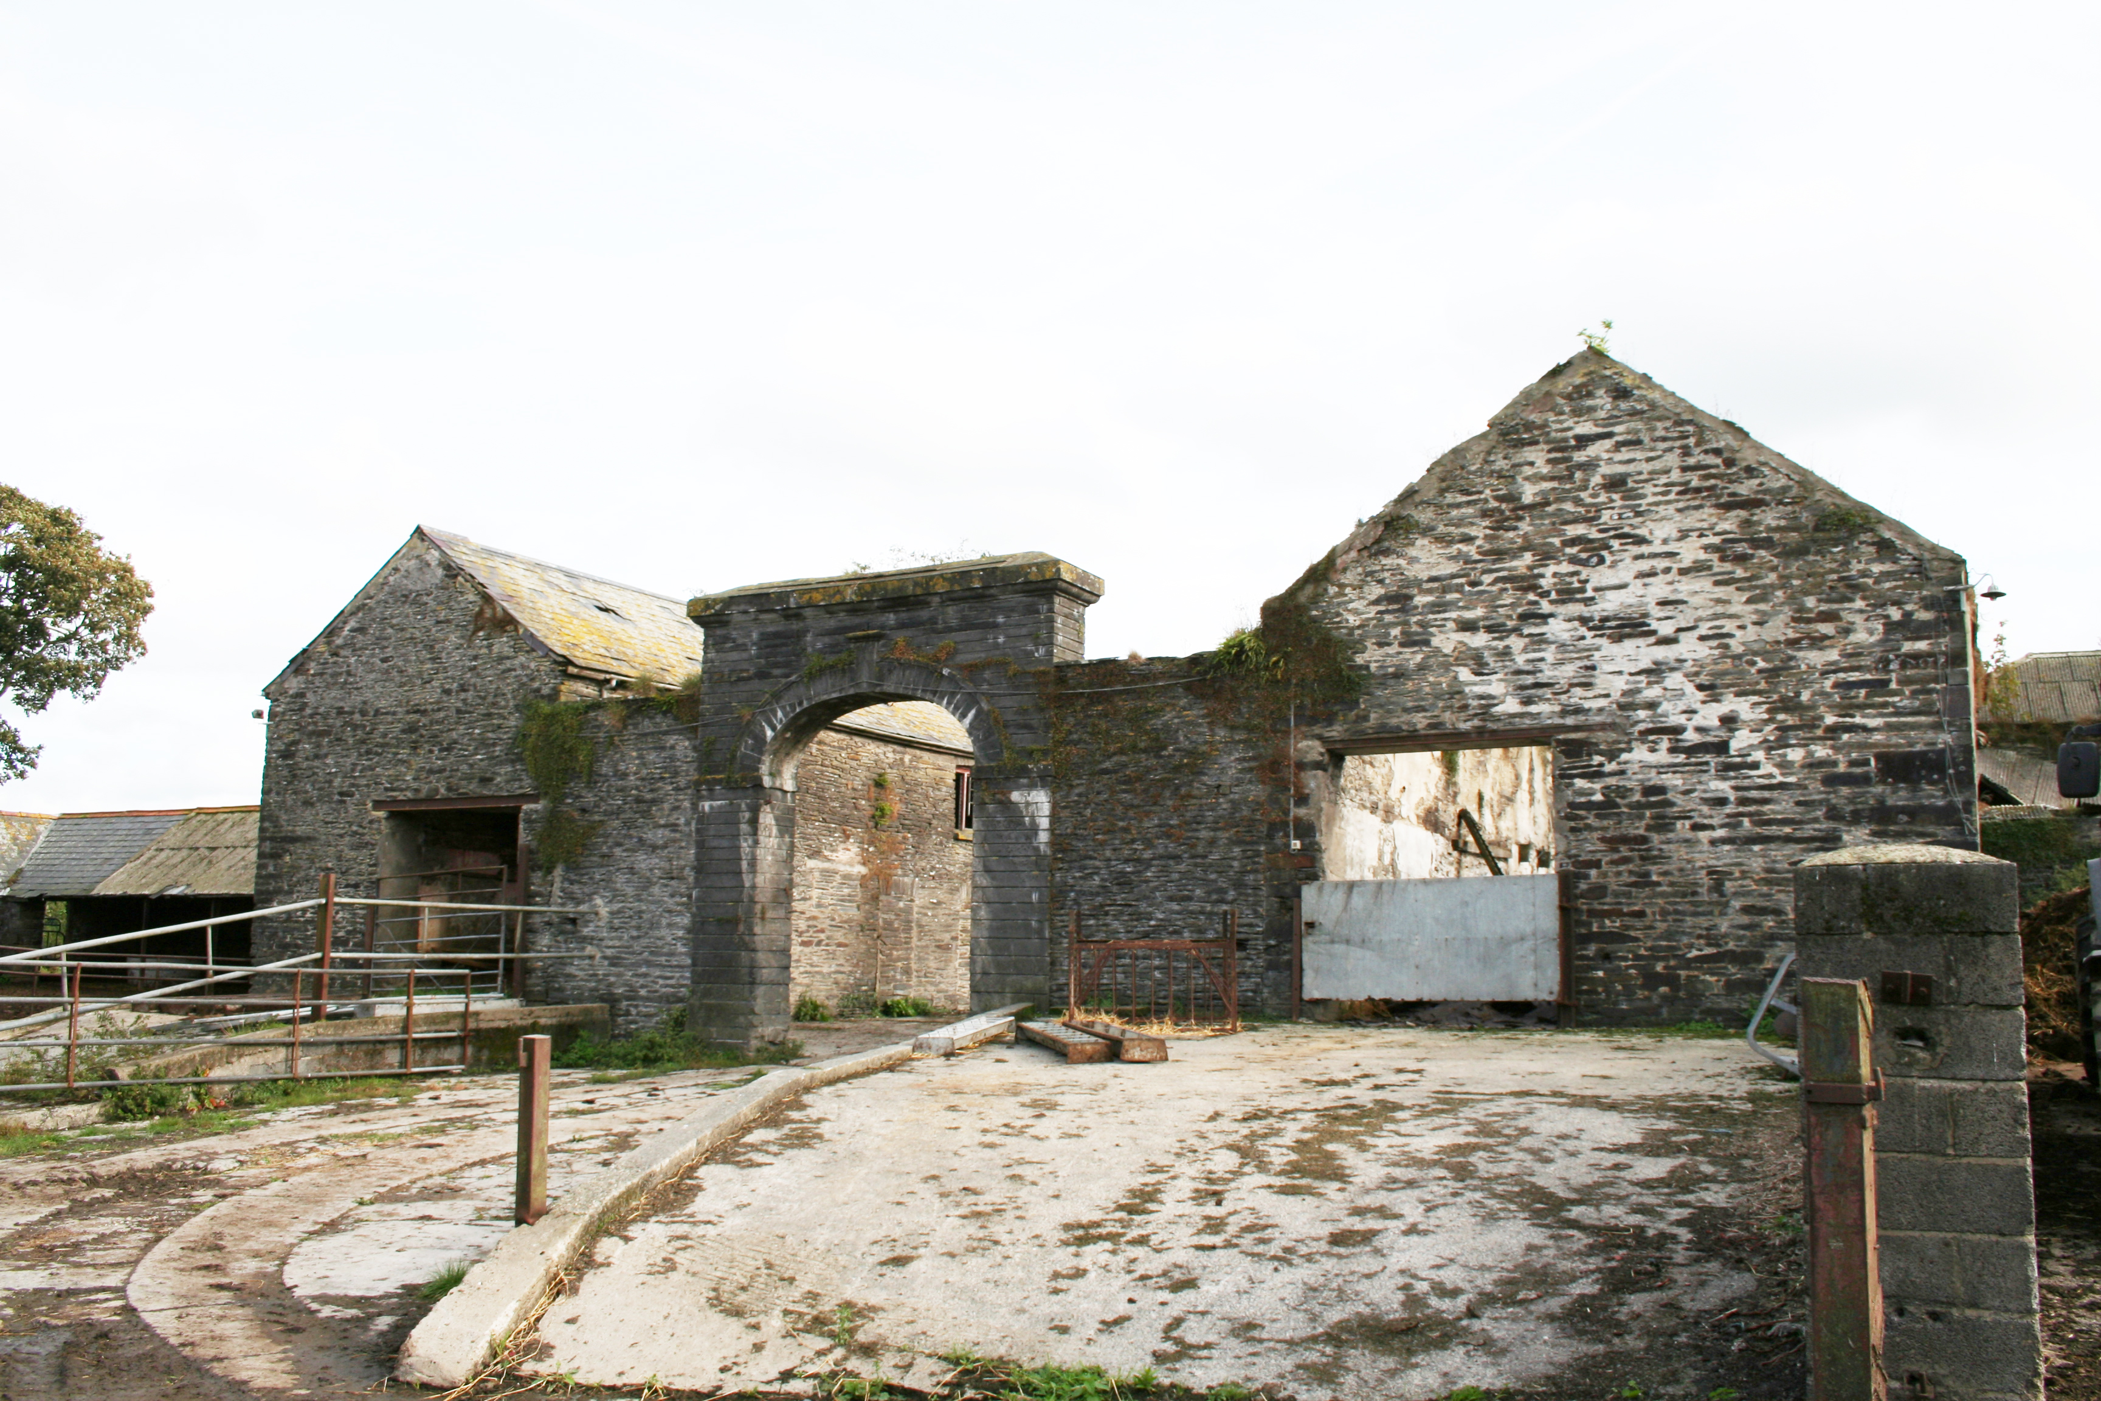

North arched entrance way with cow-house to left and barn to right
have been removed.Despite these alterations the essntial features survive and original usage can be interpreted. 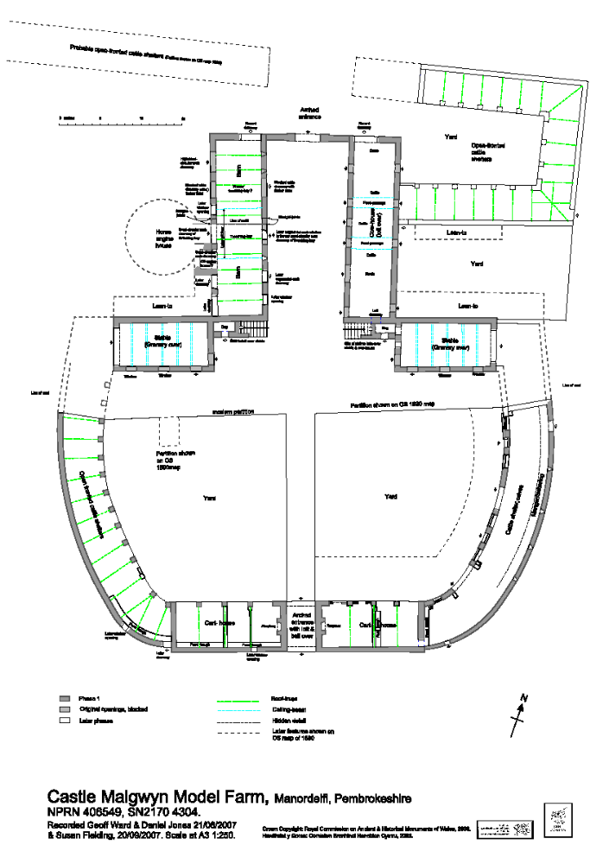

The original Model Farm buildings are symmetrically built around a north-south track, with arched entrances at each end.
The track runs between semi-circularcattle-ranges each with cart-houses to the south and between a barn/stable-range and cow-house/stable-range to the north, each forming an ‘L’ shape plan.

The north entrance archway has a very fine rusticated ashlar arch with keystone, imposts, pilasters and plain mouldings to cornice of frieze. The south entrance archway is built of coursed rubble, with dressed stone arch, has a room above with window, and a bell located on roof timbers. It has end chimneys and the appearance of a gatehouse when

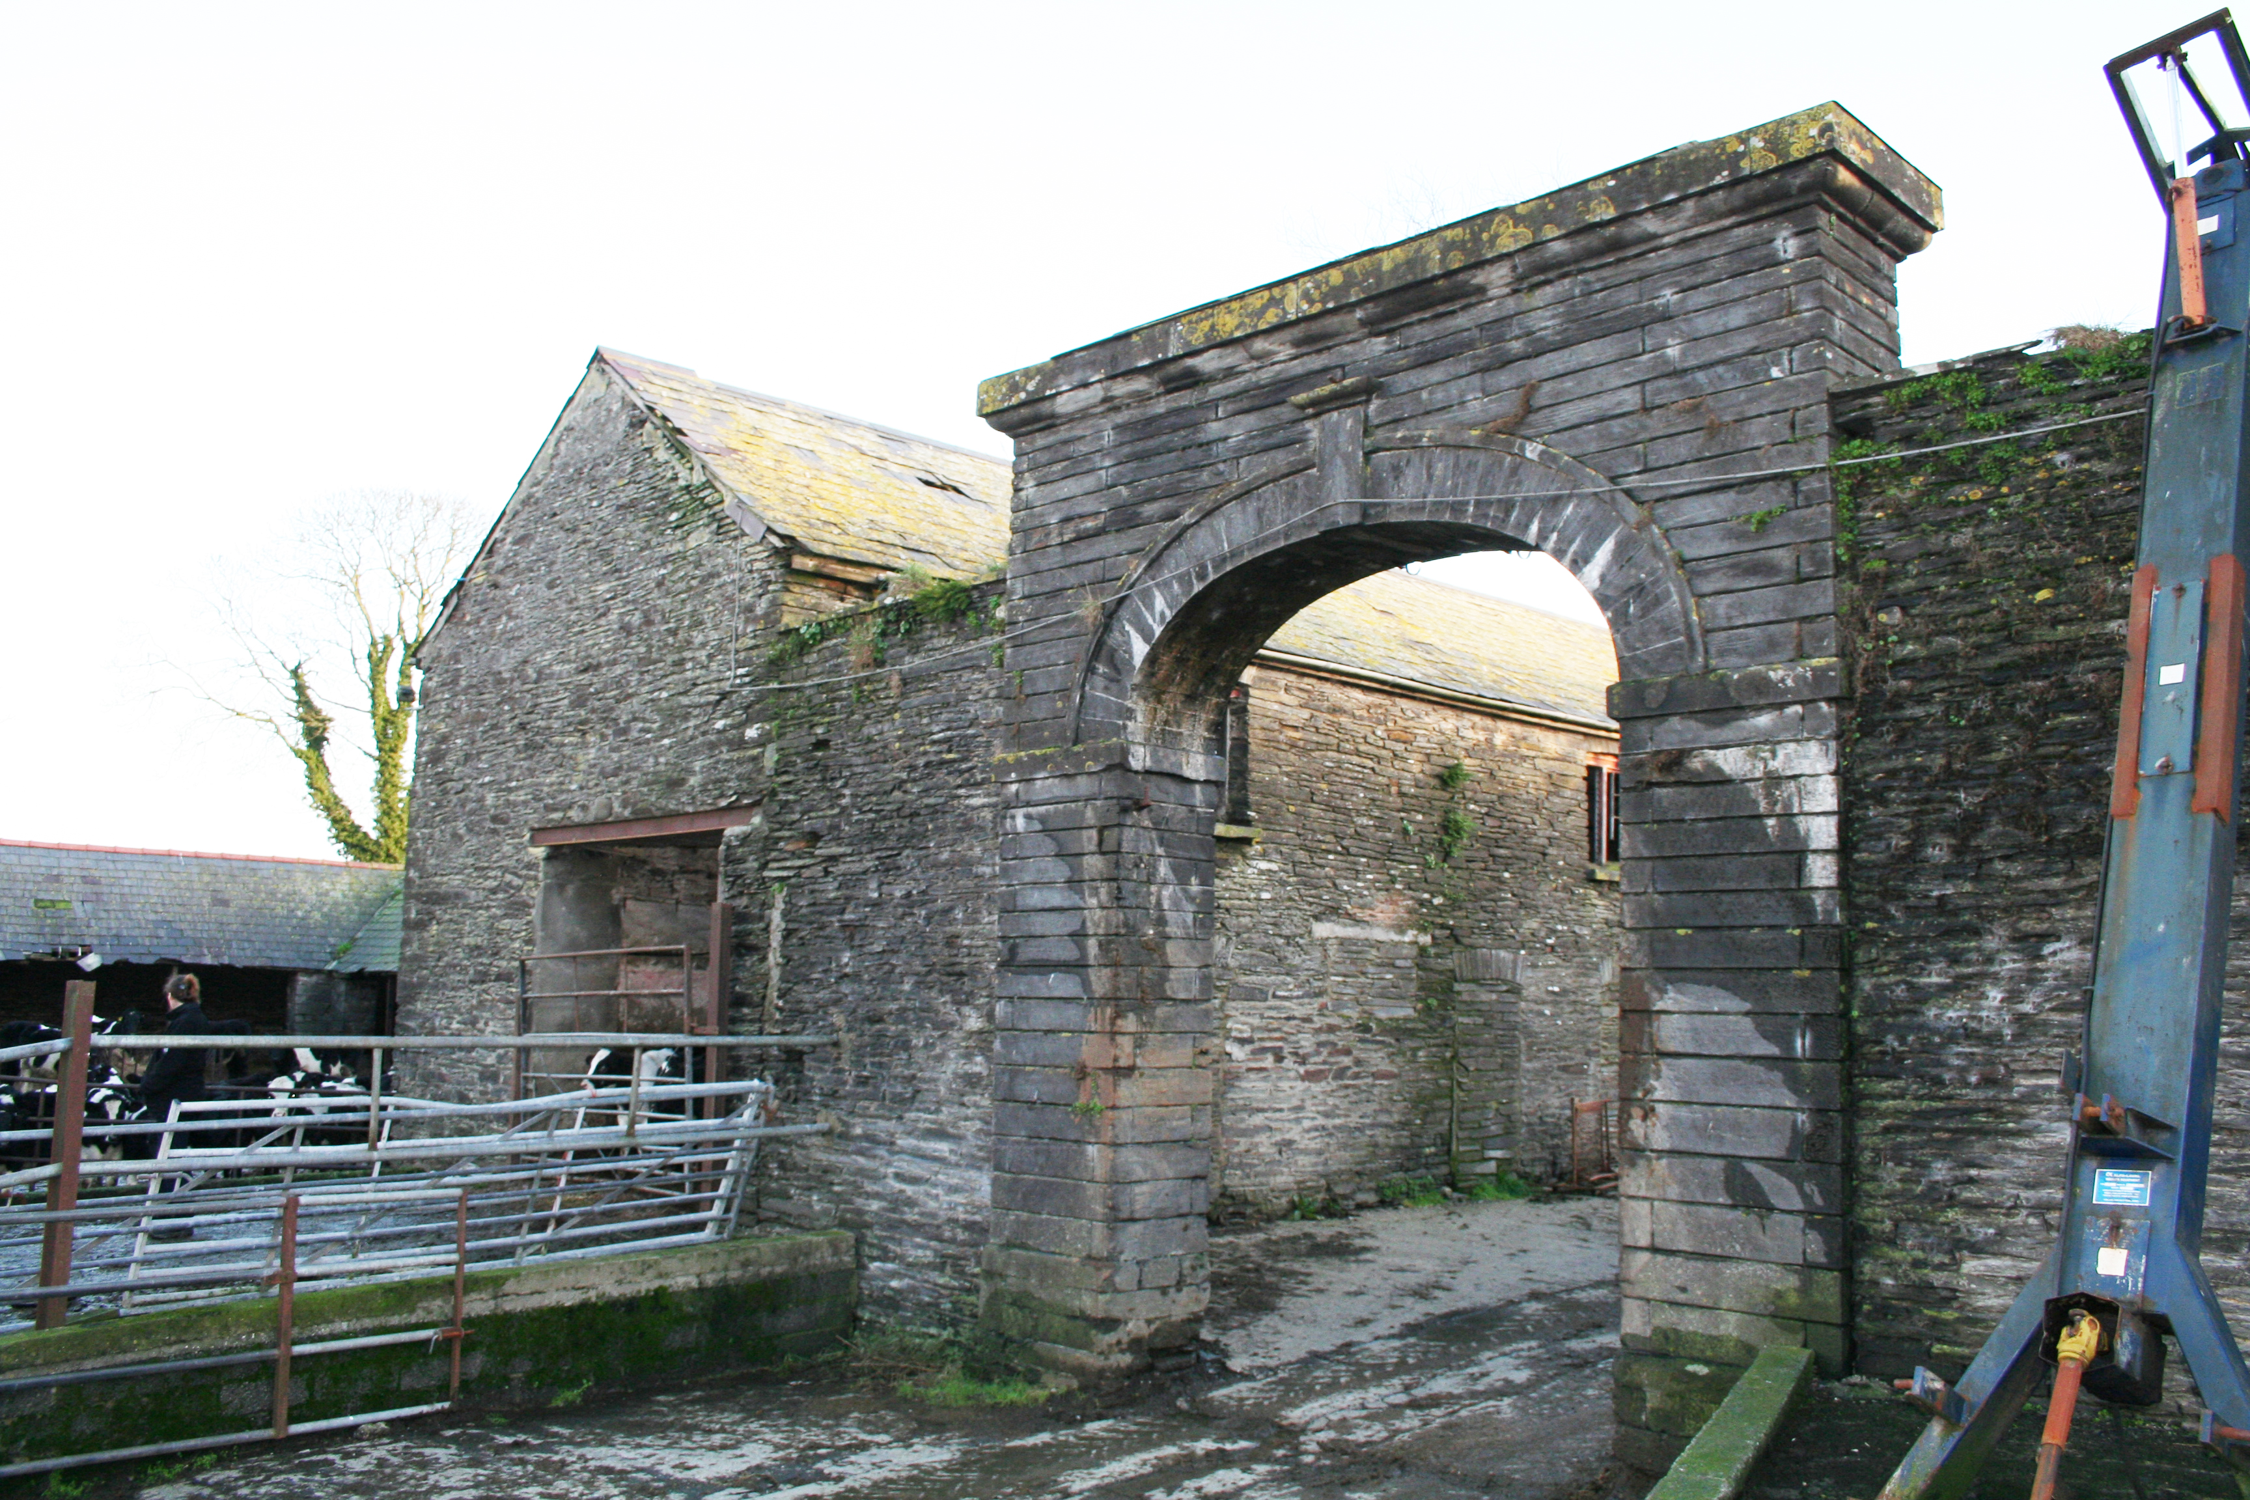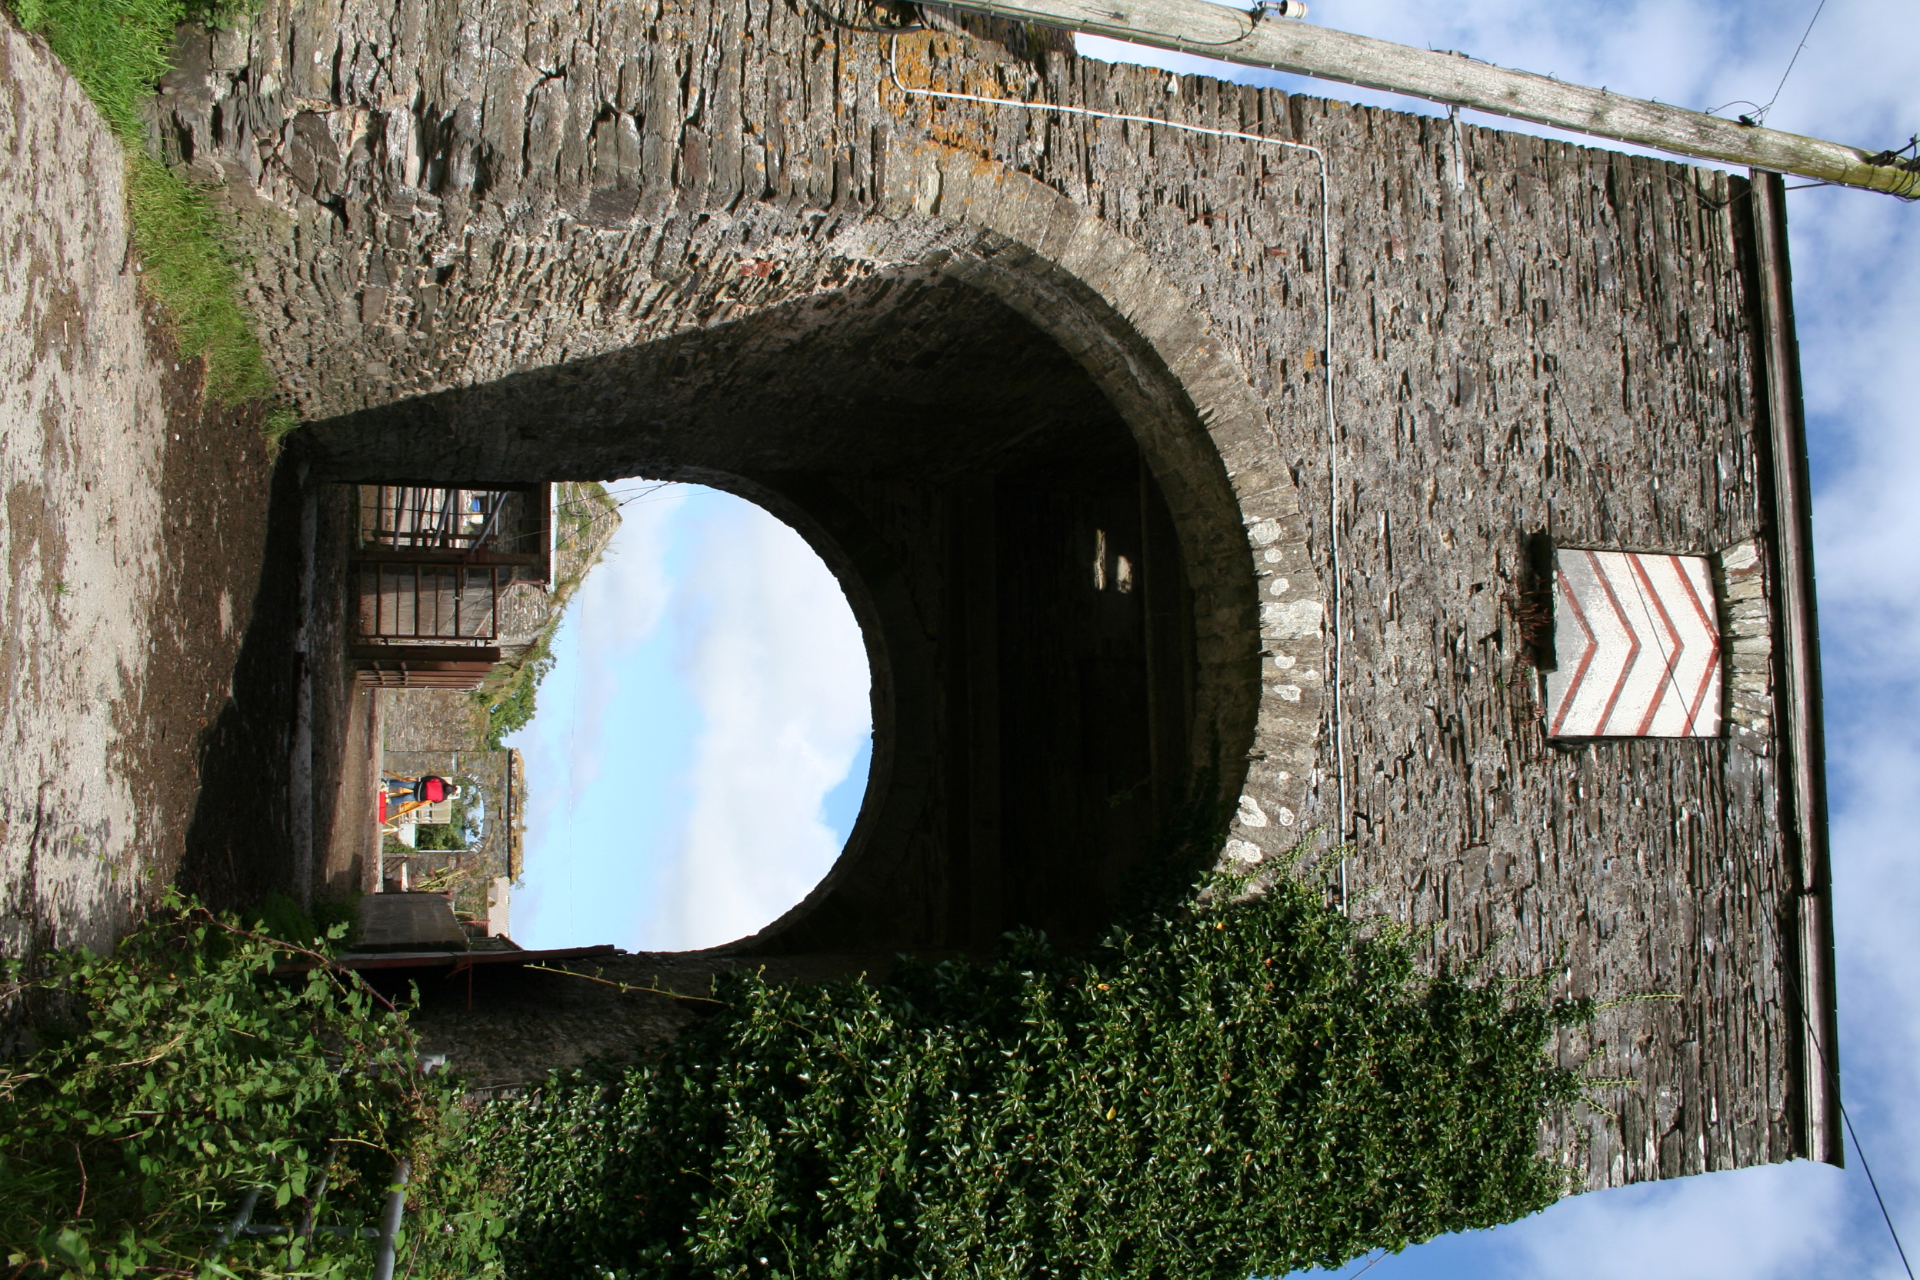
North entrance archway South entrance archway

viewed from a distance. Its former iron weather-vane has the inscription ‘EG 1867’, relating to Elizabeth Gower who carried-out improvements at that time.
A late-19th century rectangular cattle-yard with surrounding cattle shelter-sheds was added adjoining the cow-house/stable at the north-east. Another, probable cattle-shelter- range, to the north-west, shown on this map, has been demolished.
Later alterations include part demolition of the semi-circular cattle ranges, where they adjoined the stables, to provide an east-west track.

The stone-built and slate roofed barn-range is aligned south-north down the gently sloping ground. It has been much altered, and consists today of 11 bays with central opposed semi-circular arch dressed stone openings (blocked) to a threshing-bay. There are 10 collar roof-trusses and 3 ventilation slits along the east wall. It has a row of projecting eave-stones along its complete length. An unusual double straight-joint, or infill of approx 60 cms on each lateral wall below the central threshing-bay appears to define the extent, of a former cross wall, which may have been the end wall of an earlier 5-bay barn. Its lower north end has different roof-trusses of oak with curved-feet to principals and pegged collars, and must be the original roof. The other trusses are of sawn softwood, have iron cleats to collar and a single pegged apex. These later roof-trusses are the same as in the other buildings, perhaps dating from an 1876 known schedule of roof repairs “roofs of stable barn cowshed and other houses repaired and pointed”(Glandovan papers, NLW).

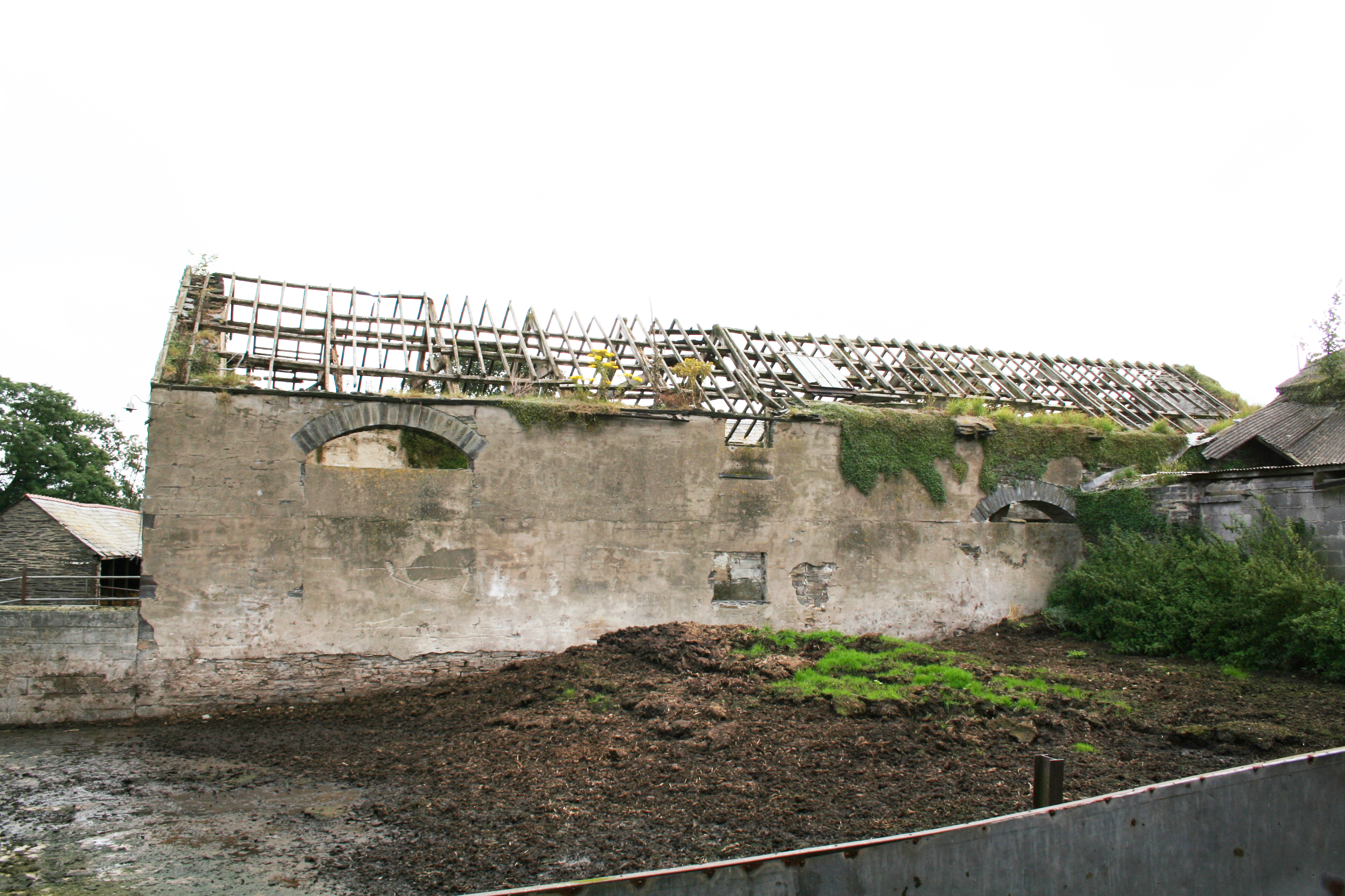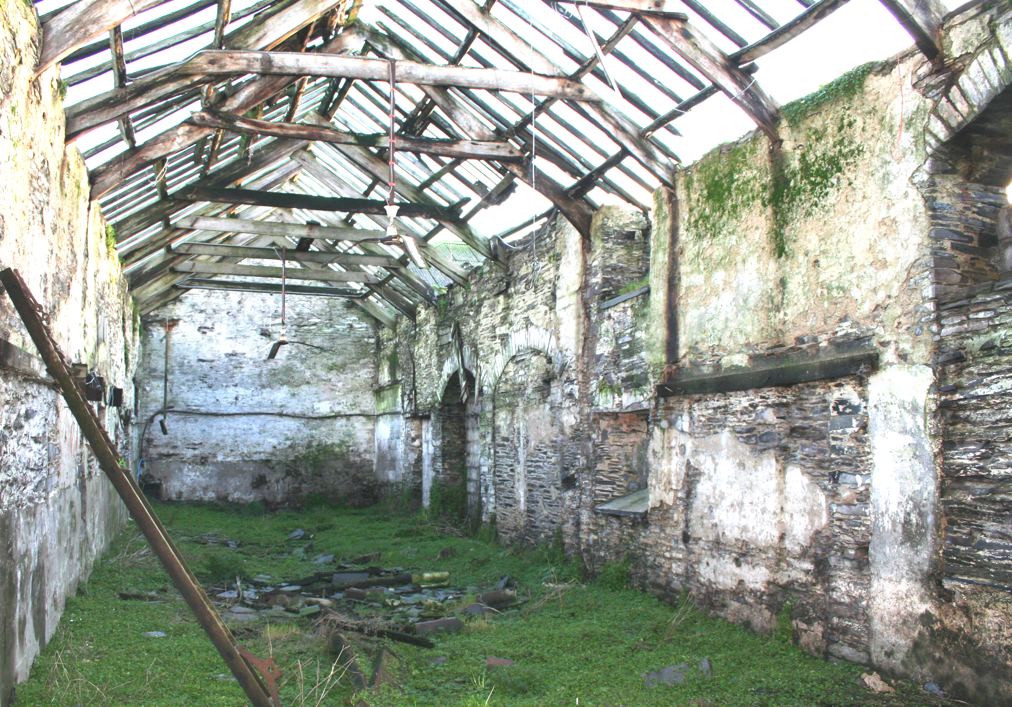
Barn, west elevation Barn, interior, view to south

The west elevation’s central threshing-bay, once had an external circular engine-house , which is shown on the OS map of 1889, but not on the tithe map of 1842. An adjacent similarly constructed dressed-stone arch opening to the south, may have provided access to a lean-to for an oil engine or machinery. Its outline can be reconstructed from surviving remnants. An unusual, taller, semi-circular dressed-stone arch opening on this west side at the lower north end, was perhaps for use with an elevator for loading, as there are no loading doorways in the gable-ends.

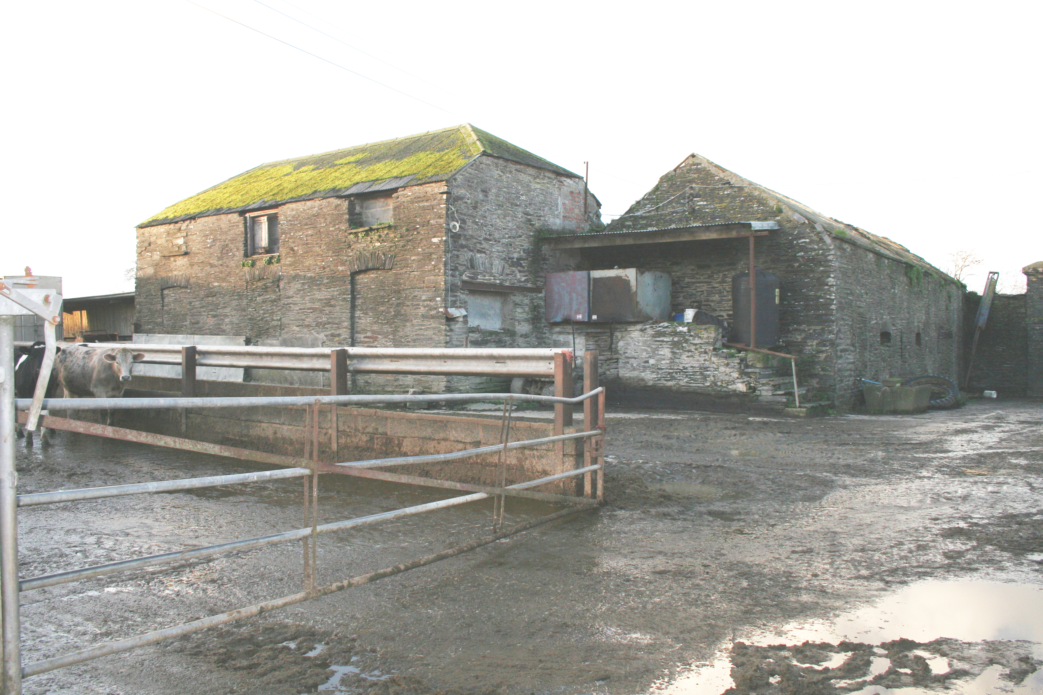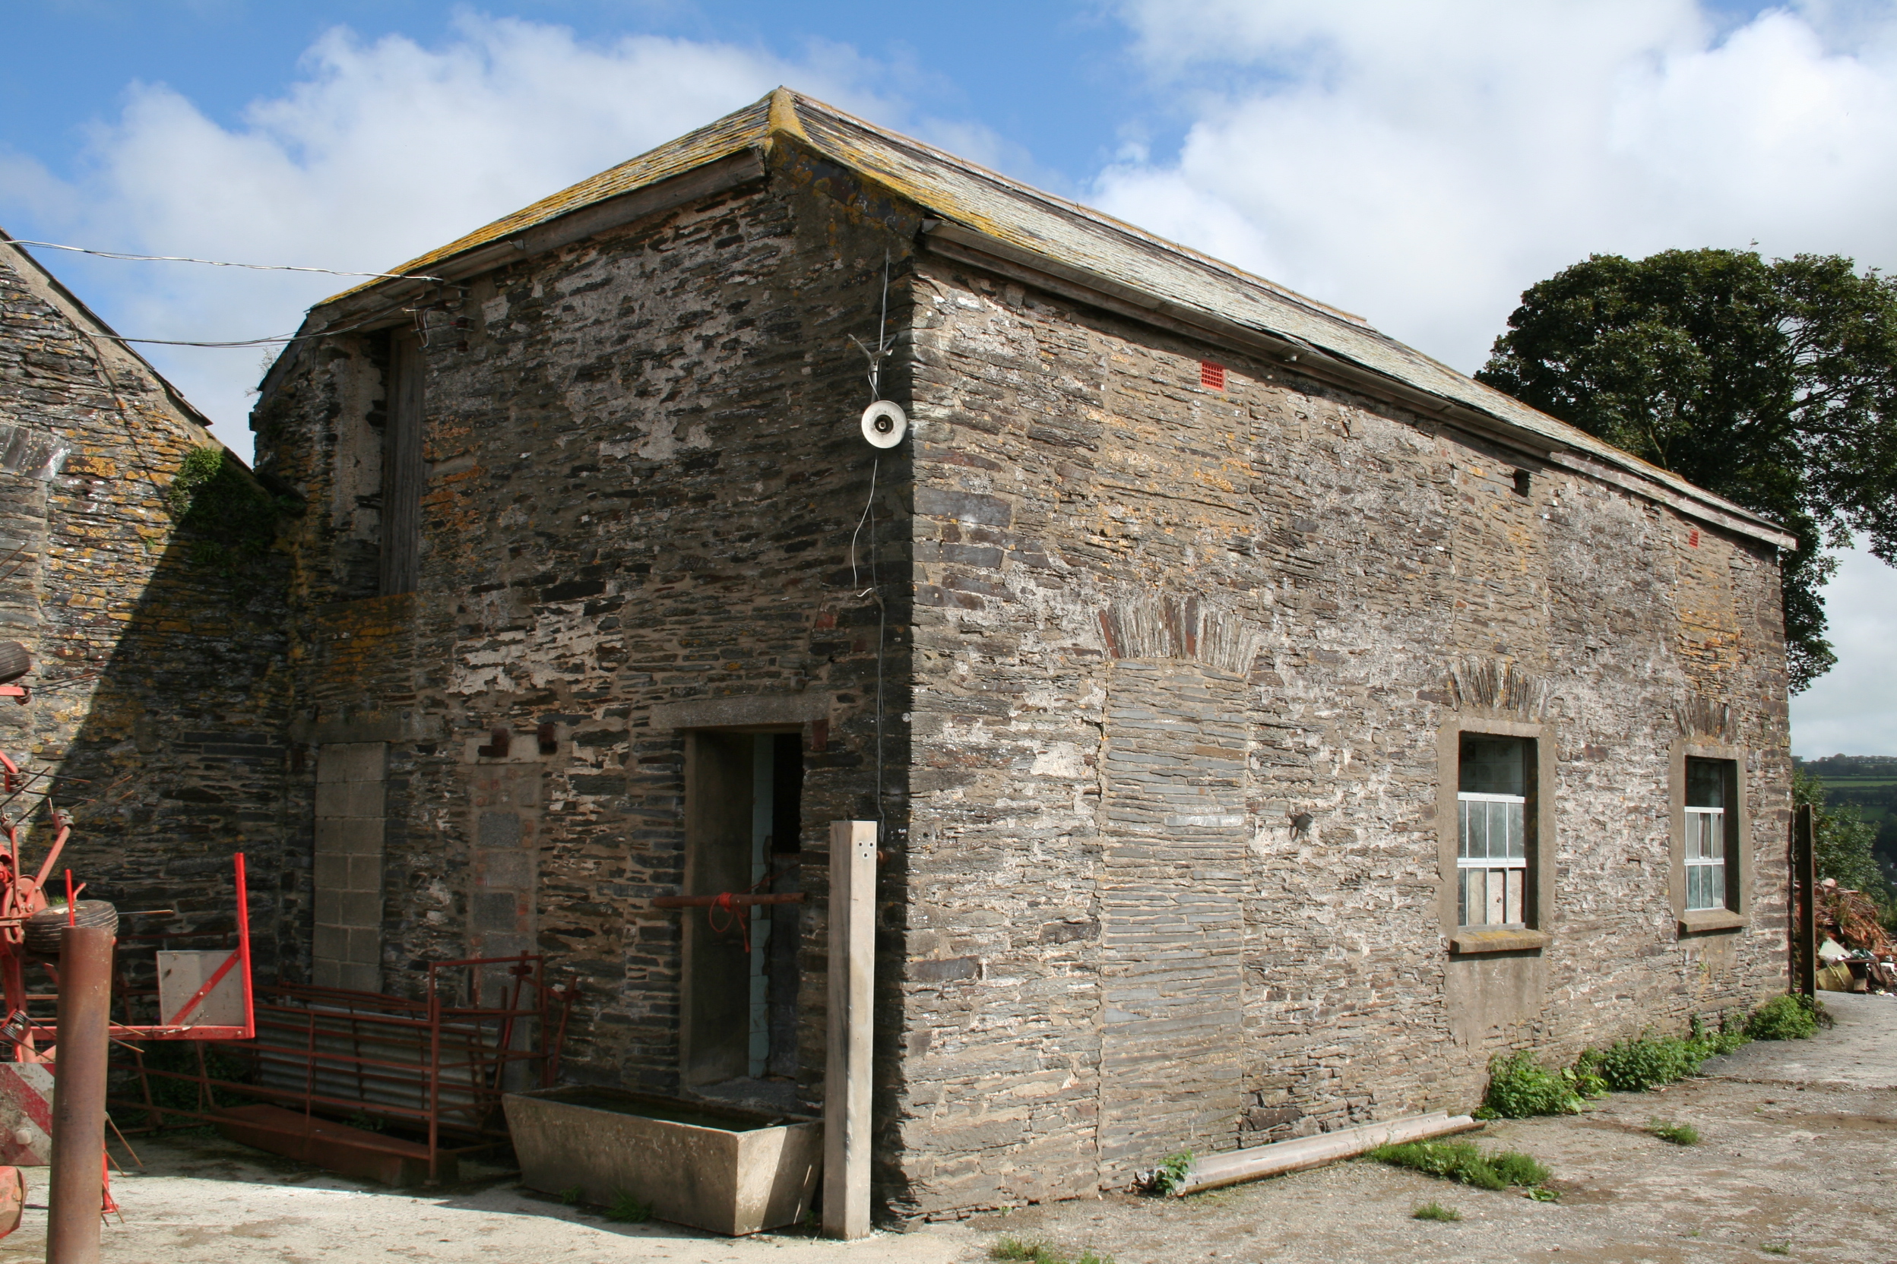
West Stable, south elevation and hip-end. East Stable, south elevation and hip-end.

A wide doorway adjoining the stable is a later phase, which has timber lintels to its blocked opening, into the stable lean-to, which is now a modern replacement of that shown on the OS map of 1889.
In the east elevation, the former opening of the central threshing-bay is blocked by a segmental headed window, indicating a change of use, from barn to cow-house, in the late-19th century. A segmental headed doorway to the south, a window beyond and a ventilation slit below are probably of the same period. At this time, a floor of 10 joists was inserted (mortises in wall) to provide a hay loft, to the central part of the barn
In the mid-C20th other doorways have been blocked up and access made in the north gable for a tractor to clean out manure. This building is unused at present, its slate roof has gone and the roof timbers are rotting.
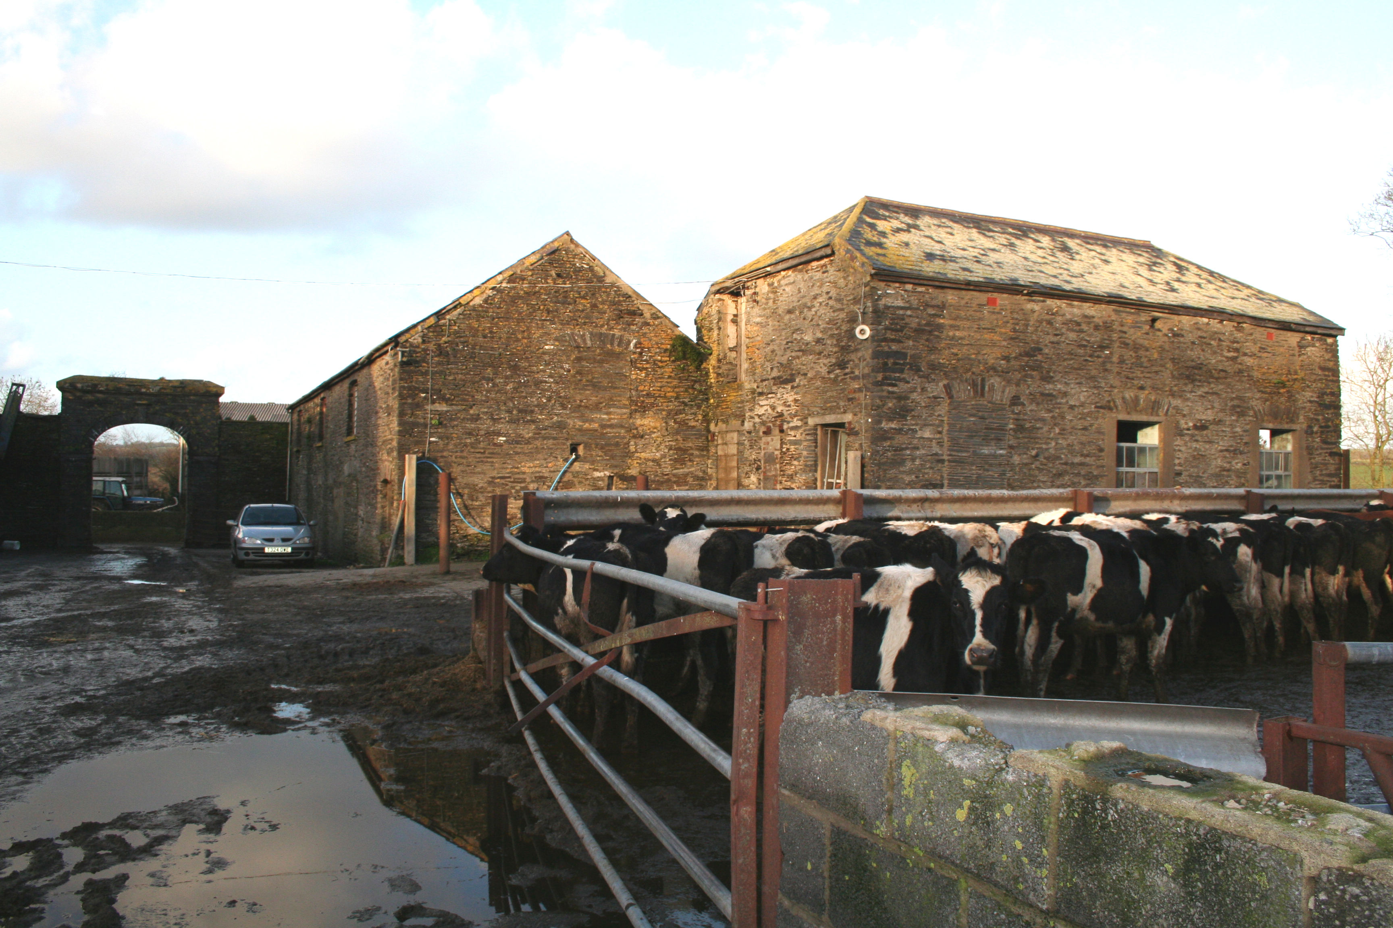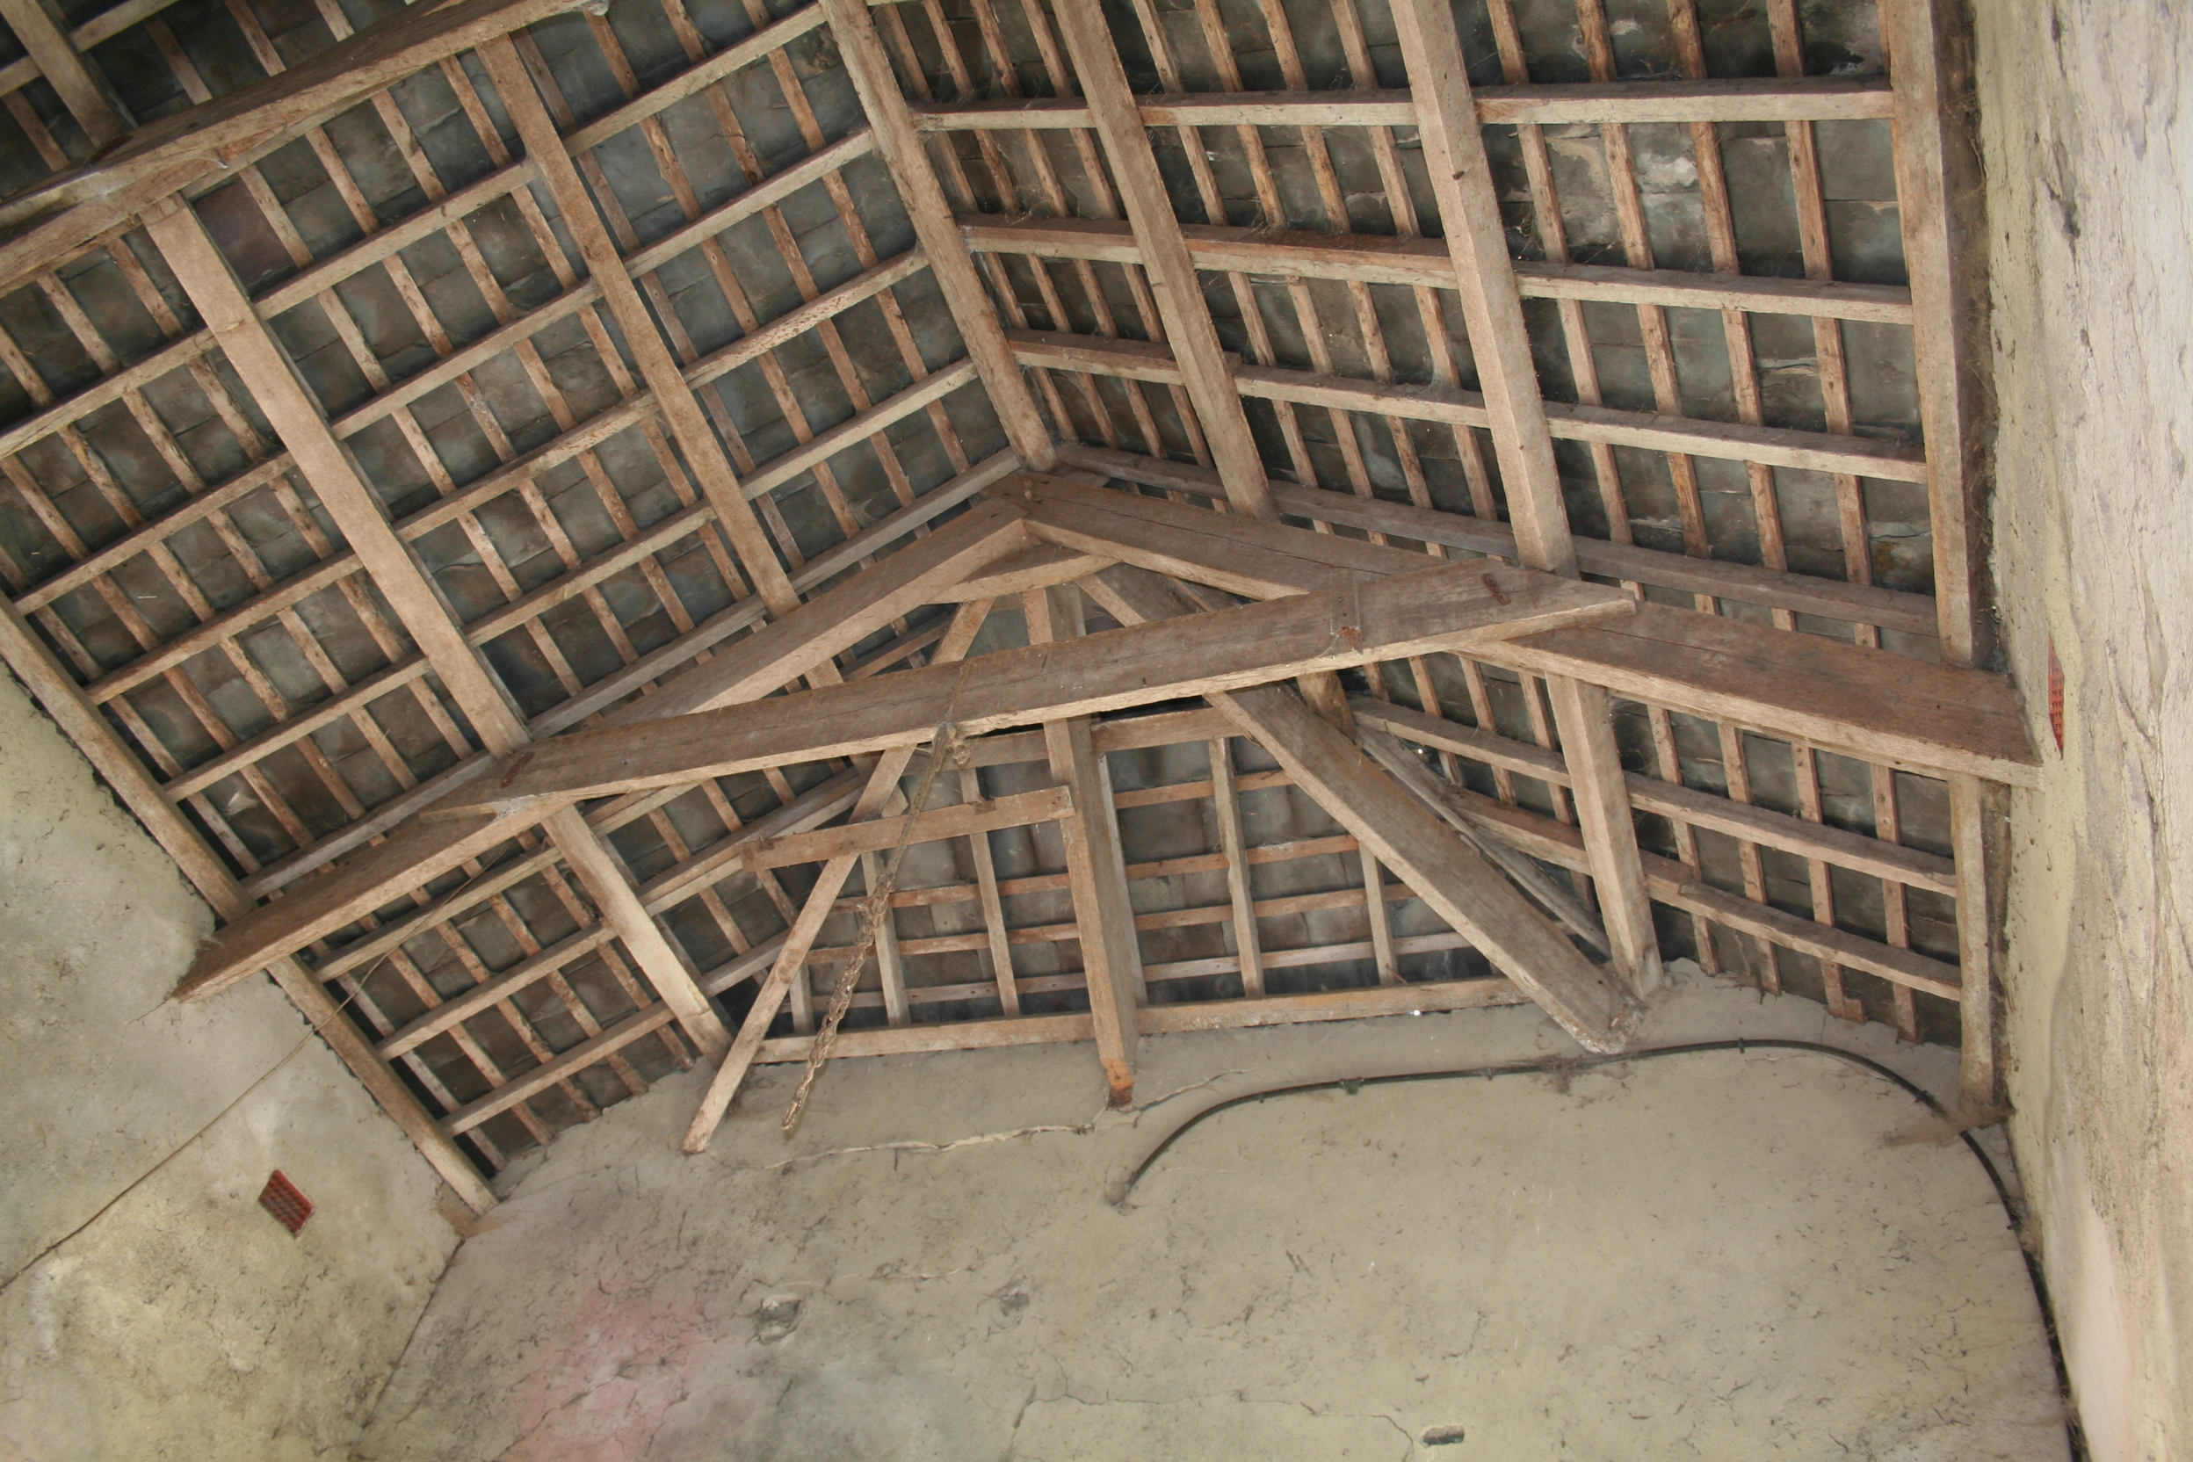
Cow-house and stable Stable hip roof
The adjoining 5-bay former stable with loft over is at right angles to the barn, has a hip-roof of sawn softwood trusses with cleats to collar. Today the floor has been removed and it is used as a workshop. Its south elevation has two blocked window openings and a very high blocked doorway all with thin stone voussoirs. Its east end has a blocked voussoir opening to former doorway and a later wider blocked opening. A wide stair of slate steps runs along the south gable end of the barn, formerly to the stable’s first-floor. The former loft floor was supported on 5 cross-beams with joists and was probably a granaryor hay-loft. The present entry is a wide mid-20th century opening in the west end. An identical stable is atached to the cow-house. Both buildings may be slighty later, as they have thin voussoirs and are not shown on the 1814 OS map, although on the 1820s estate map.

The stone-built and slated cow-house range is parallel, to east of the barn, and similarly aligned south-north down the sloping ground. It was a 2-storey, 11-bay structure, with cleats to softwood collar-trusses. It has a series of blocked doorways to the west side, all with segmental dressed stone arches (see plan). The east wall has some similar blocked doorways visible internally. These doorways indicate opposed cattle entrances at the lower north end, providing access to the cattle shelter sheds and yards. Then, a pair of feed passages with opposed entrances flank a narrow entrance to an area between, probably for calves. The next wider opening, is a cart entrance for storing roots, while at the south end, opposed doorways provide access to a former lean-to shelter-shed.
At the former first-floor a series of rebates indicate the position of a joist floor with cross-beams, to a former granary. The first-floor walls are plastered and the 3-light windows each have a single glazed light and two louvered lights. One end still has a plaster wall ceiling under its collar-trusses. The windows are well made with dressed stone almost flat arches over. There is a blocked doorway in the south end wall at first-floor, leading from a former external stair to room over adjoining stable. There are no eave-stones to sidewalls, while scar evidence suggests the walls have been slightly raised at the north end, perhaps altered in 1876, when the roofs were repaired.
The ground-floor is now used for cattle with blocked-up openings and a wide mid-20th century opening in the north end for access.
The adjoining 5-bay stable at right angles is identical in plan & form to the barn stable. This one has also had its floor removed and is used to store grain with a wide mid-20th century opening to its east end. A stub of narrower walling to the north side of the east gable-end extends eastwards, part of the formerly linked semi-circular cattle-range. A scar of walling indicates the other side of this cattle-range.
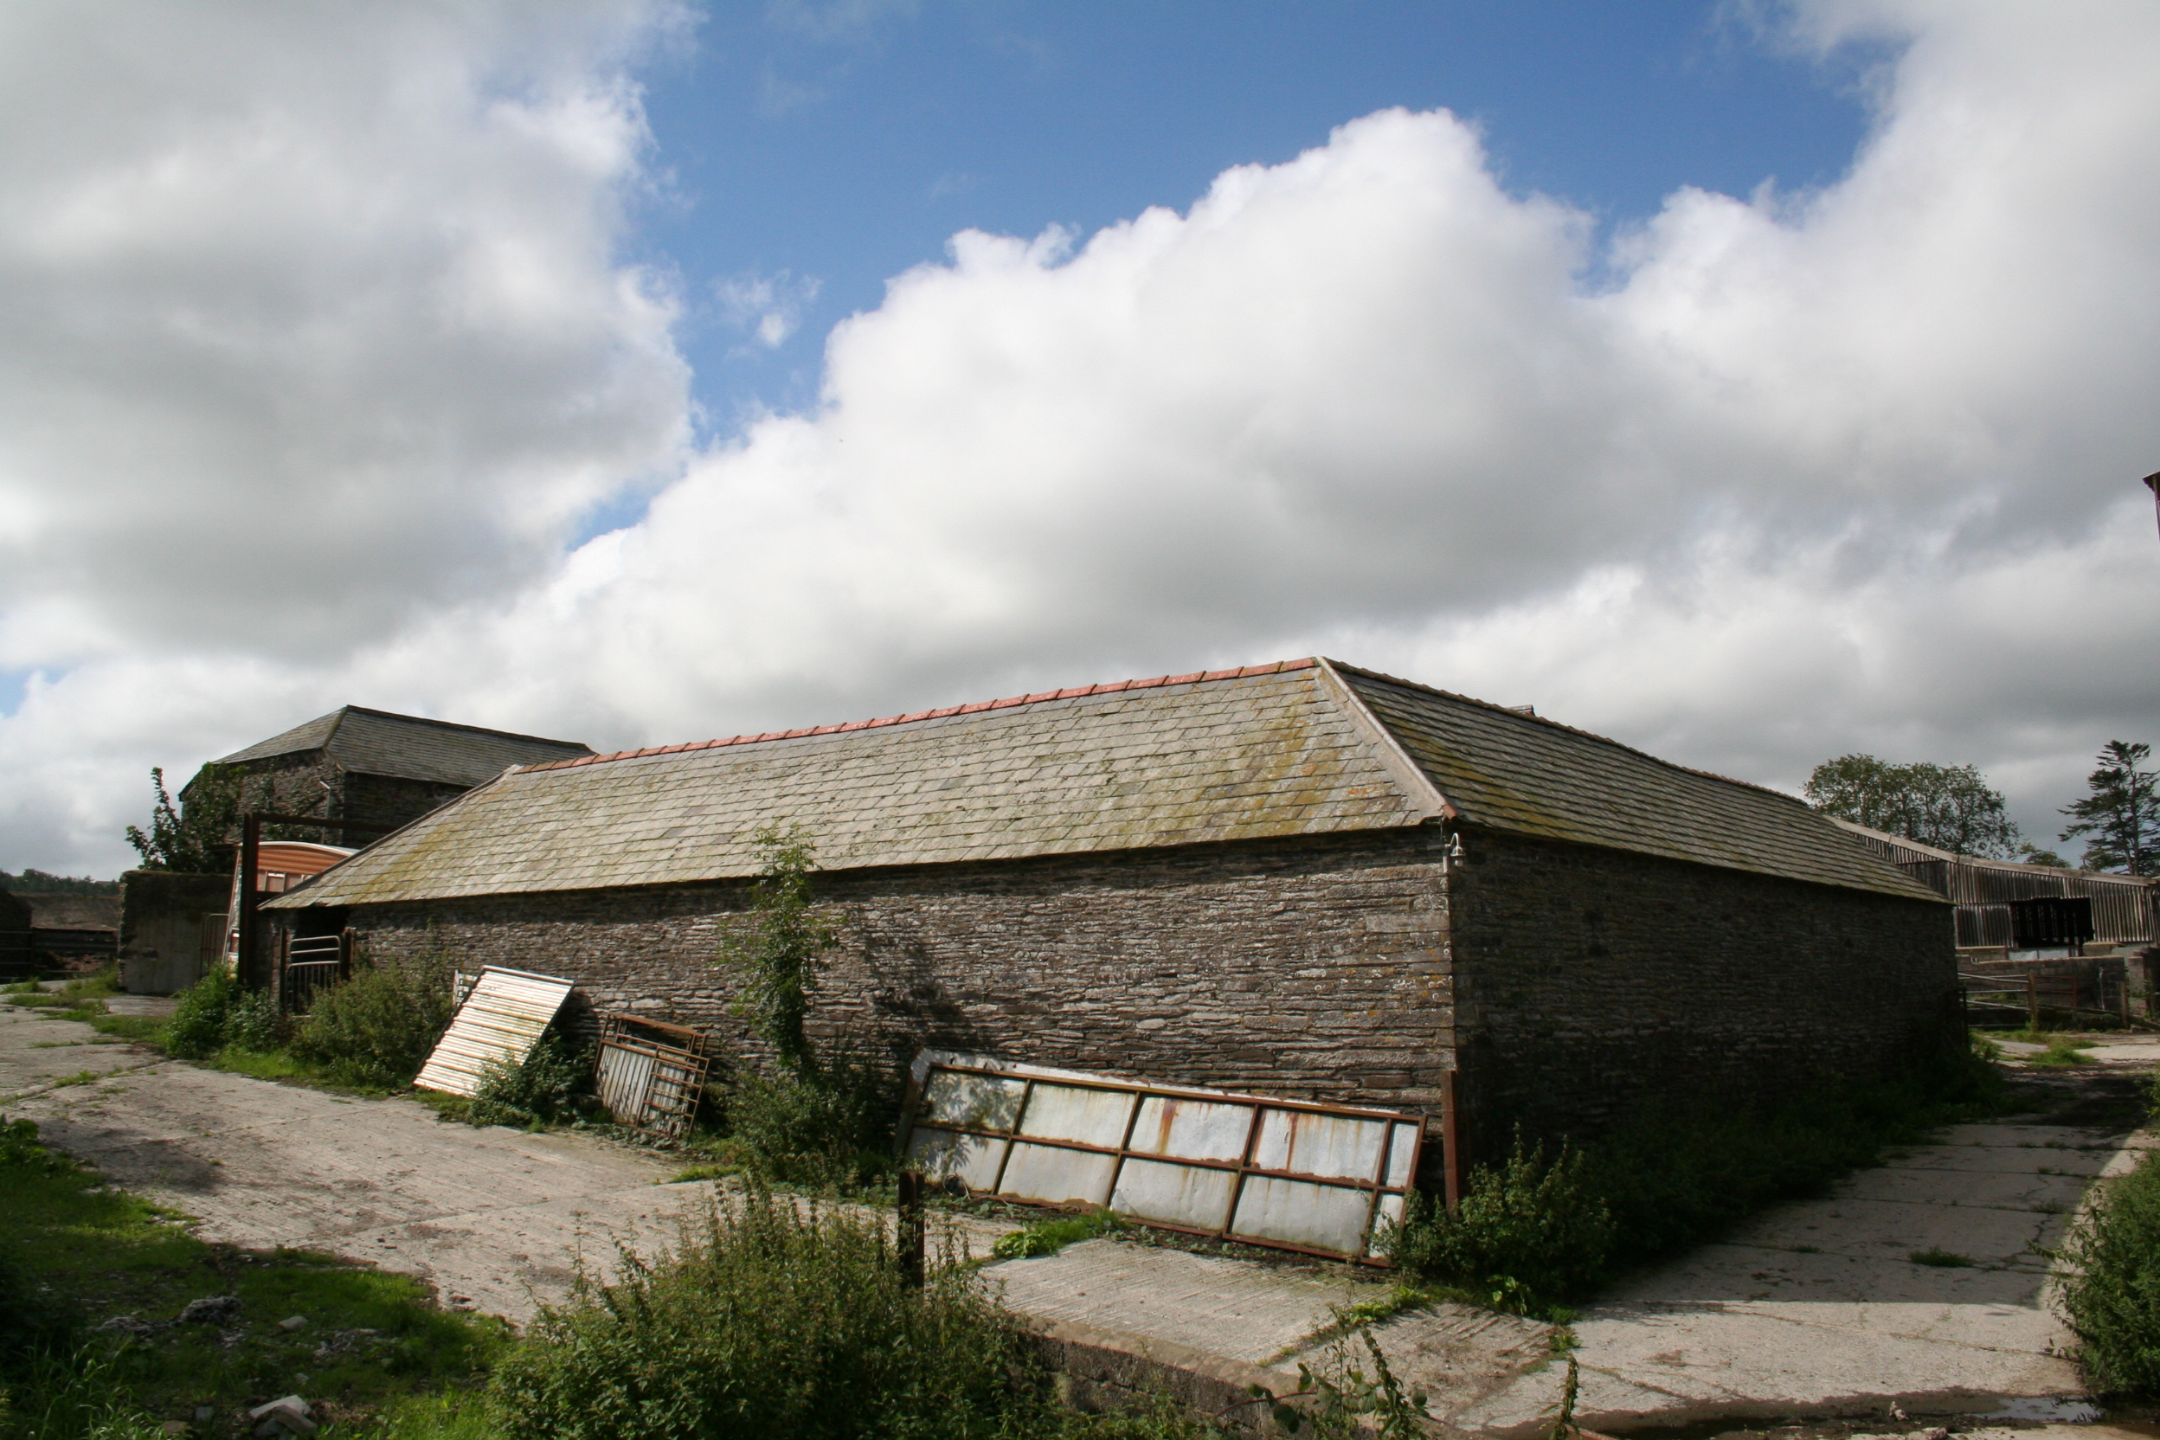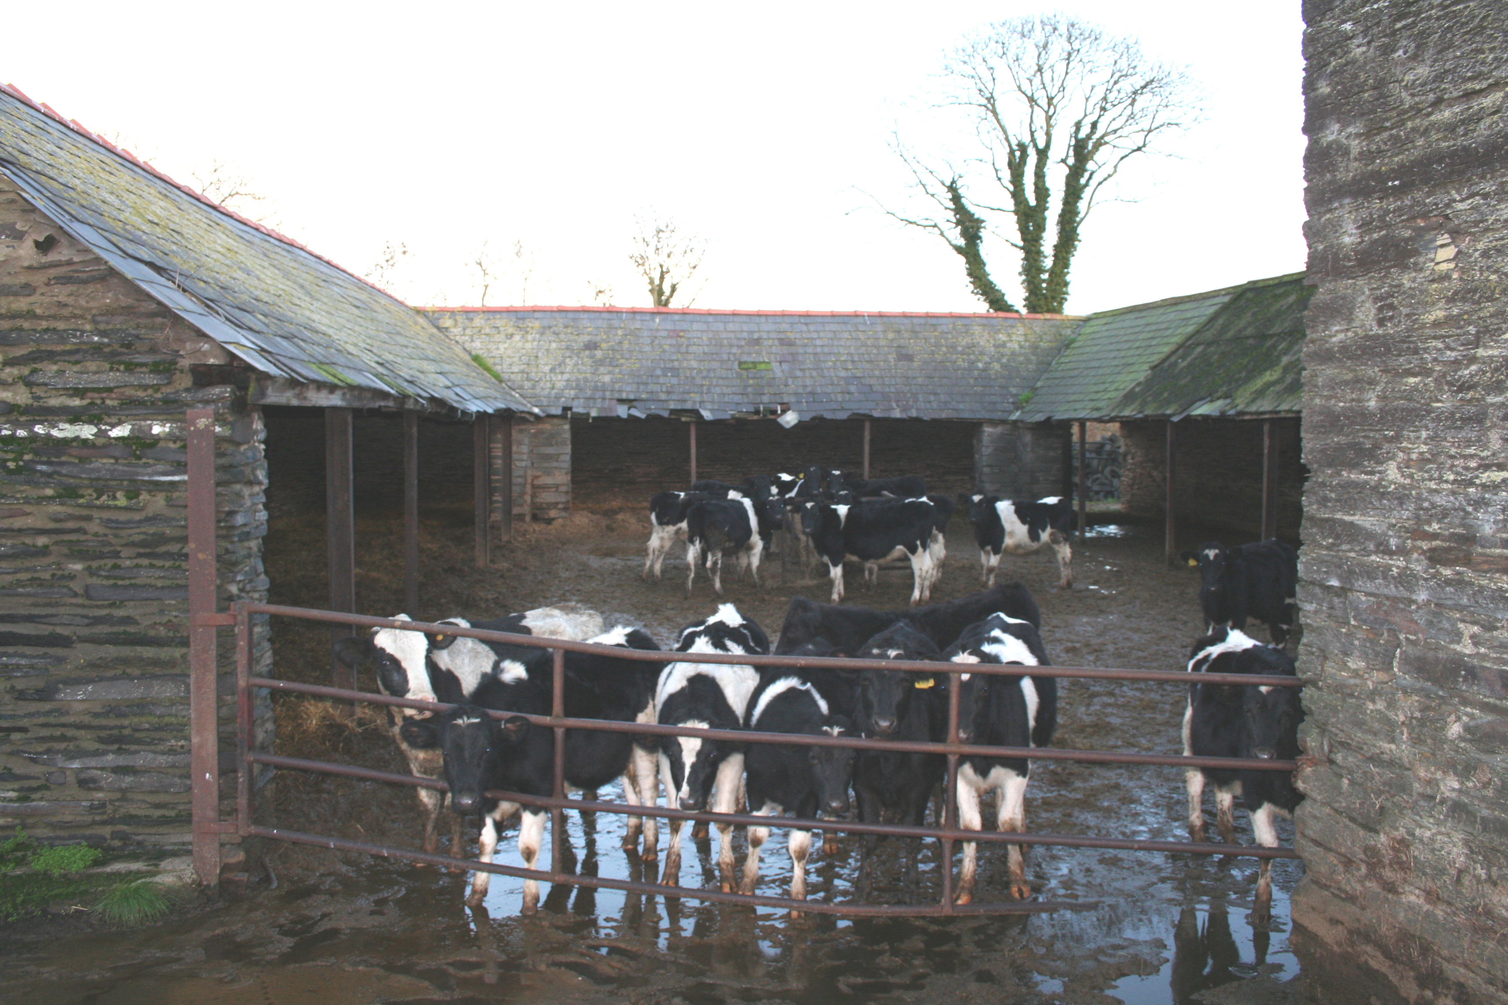
Open cattle shelter-shed at north-east Open cattle shelter-shed yard from west

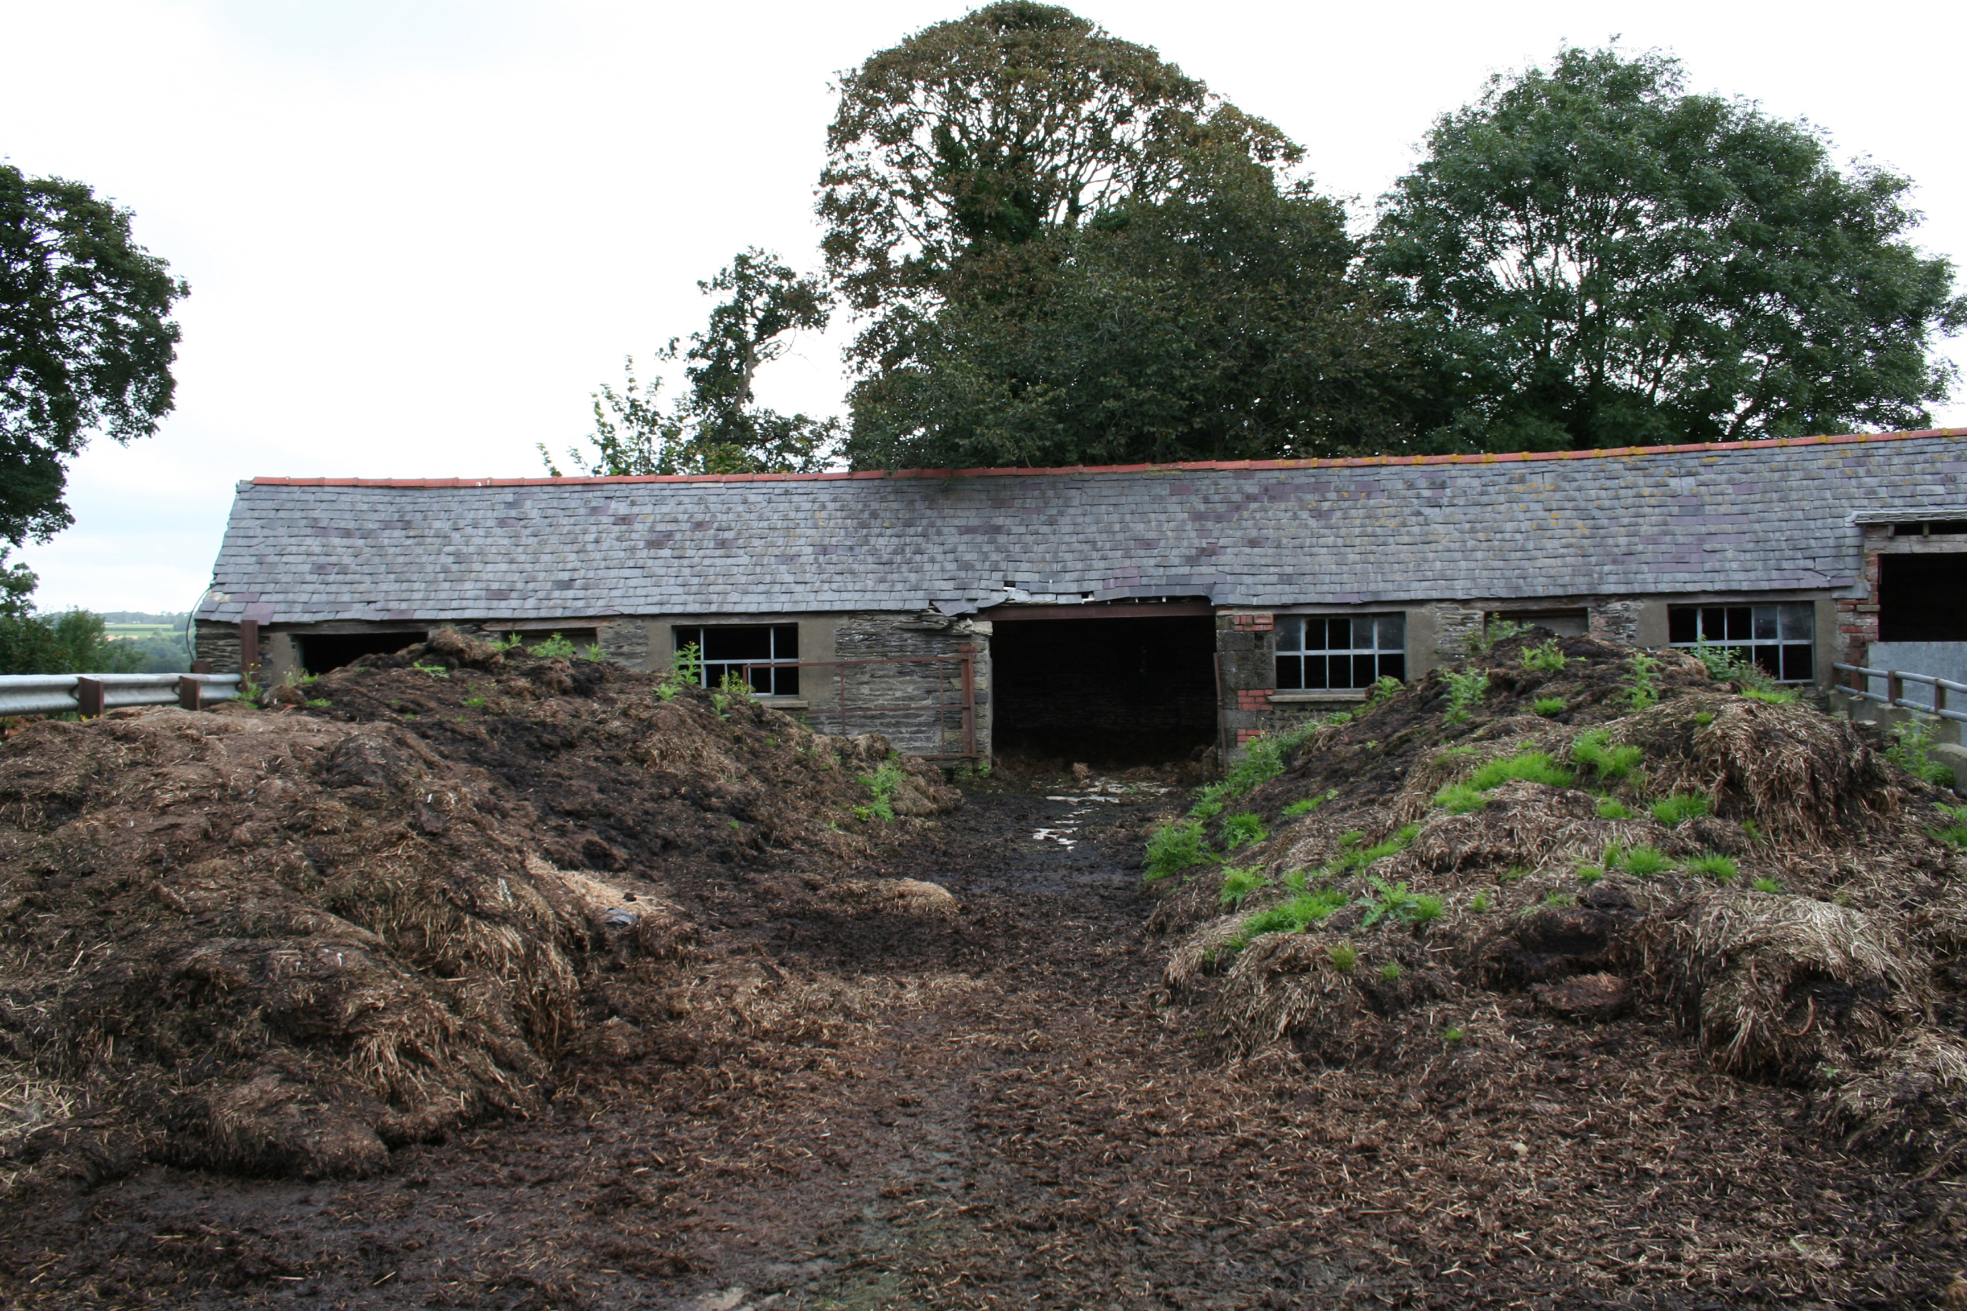
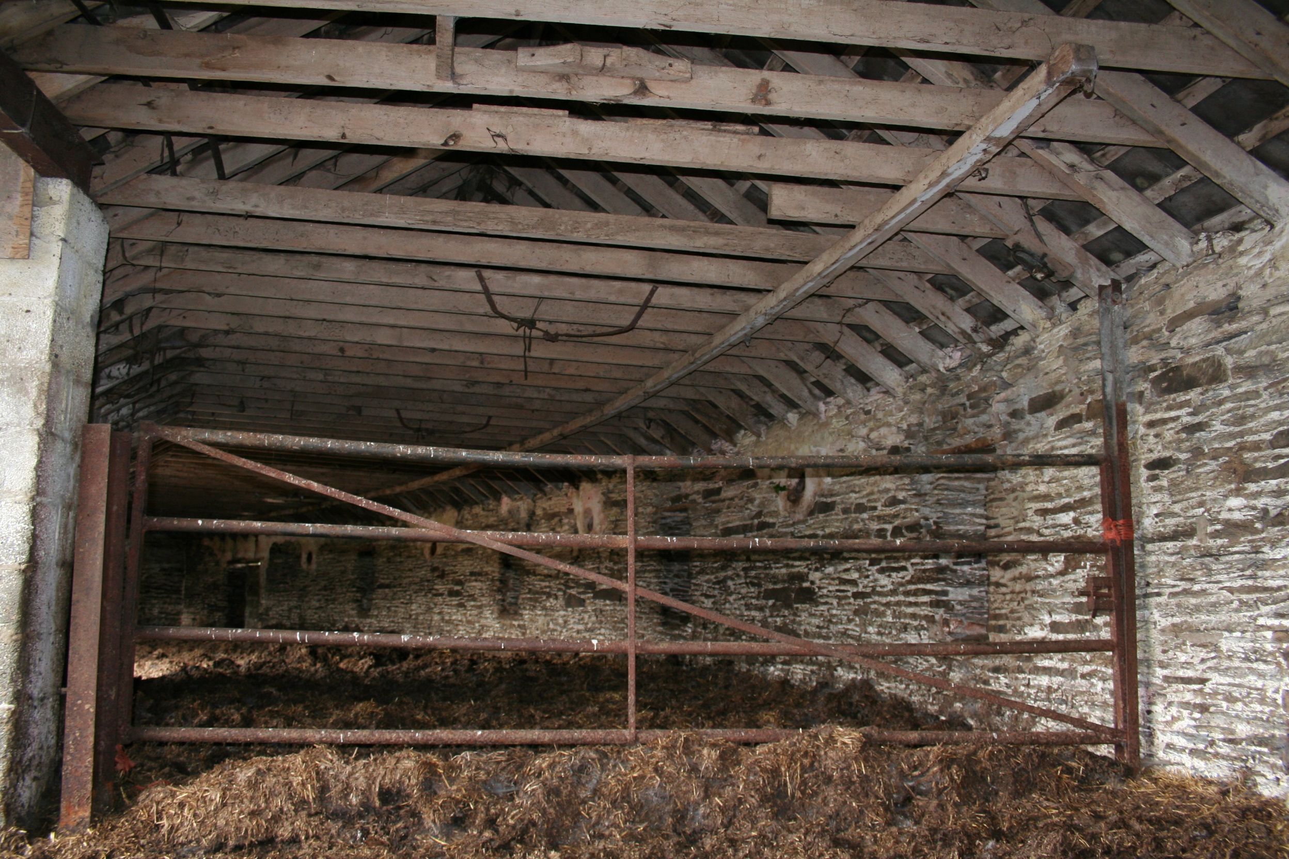
The cattle shelter sheds to north-east of the cow-house were built after1842, as they are not shown on the Tithe map, but before the1889 OS map. They form a walled courtyard, of open-fronted, double pitch slate-roofed shelters for cattle with access from the west. Each roof-truss was originally supported on stone piers, most are now replaced by iron

girder supports. They have been reduced by a couple of bays at the west-end, but are otherwise little altered. A former detached range in-line to the west (probably similar), is shown on the OS 1889 map, but has been demolished. The OS map may indicate the site of possible pig-sties at the rear of the shelter shed’s south wall.

Semi-circular east cattle-range & yard. Semi-circular east cattle-range interior

South entrance archway, cart-house ranges and semi-circular cattle-ranges.
The single-storey cart-houses of 4 units on either side of the gate-house are in-line and open-fronted internally, with stone piers supporting the roof-trusses.

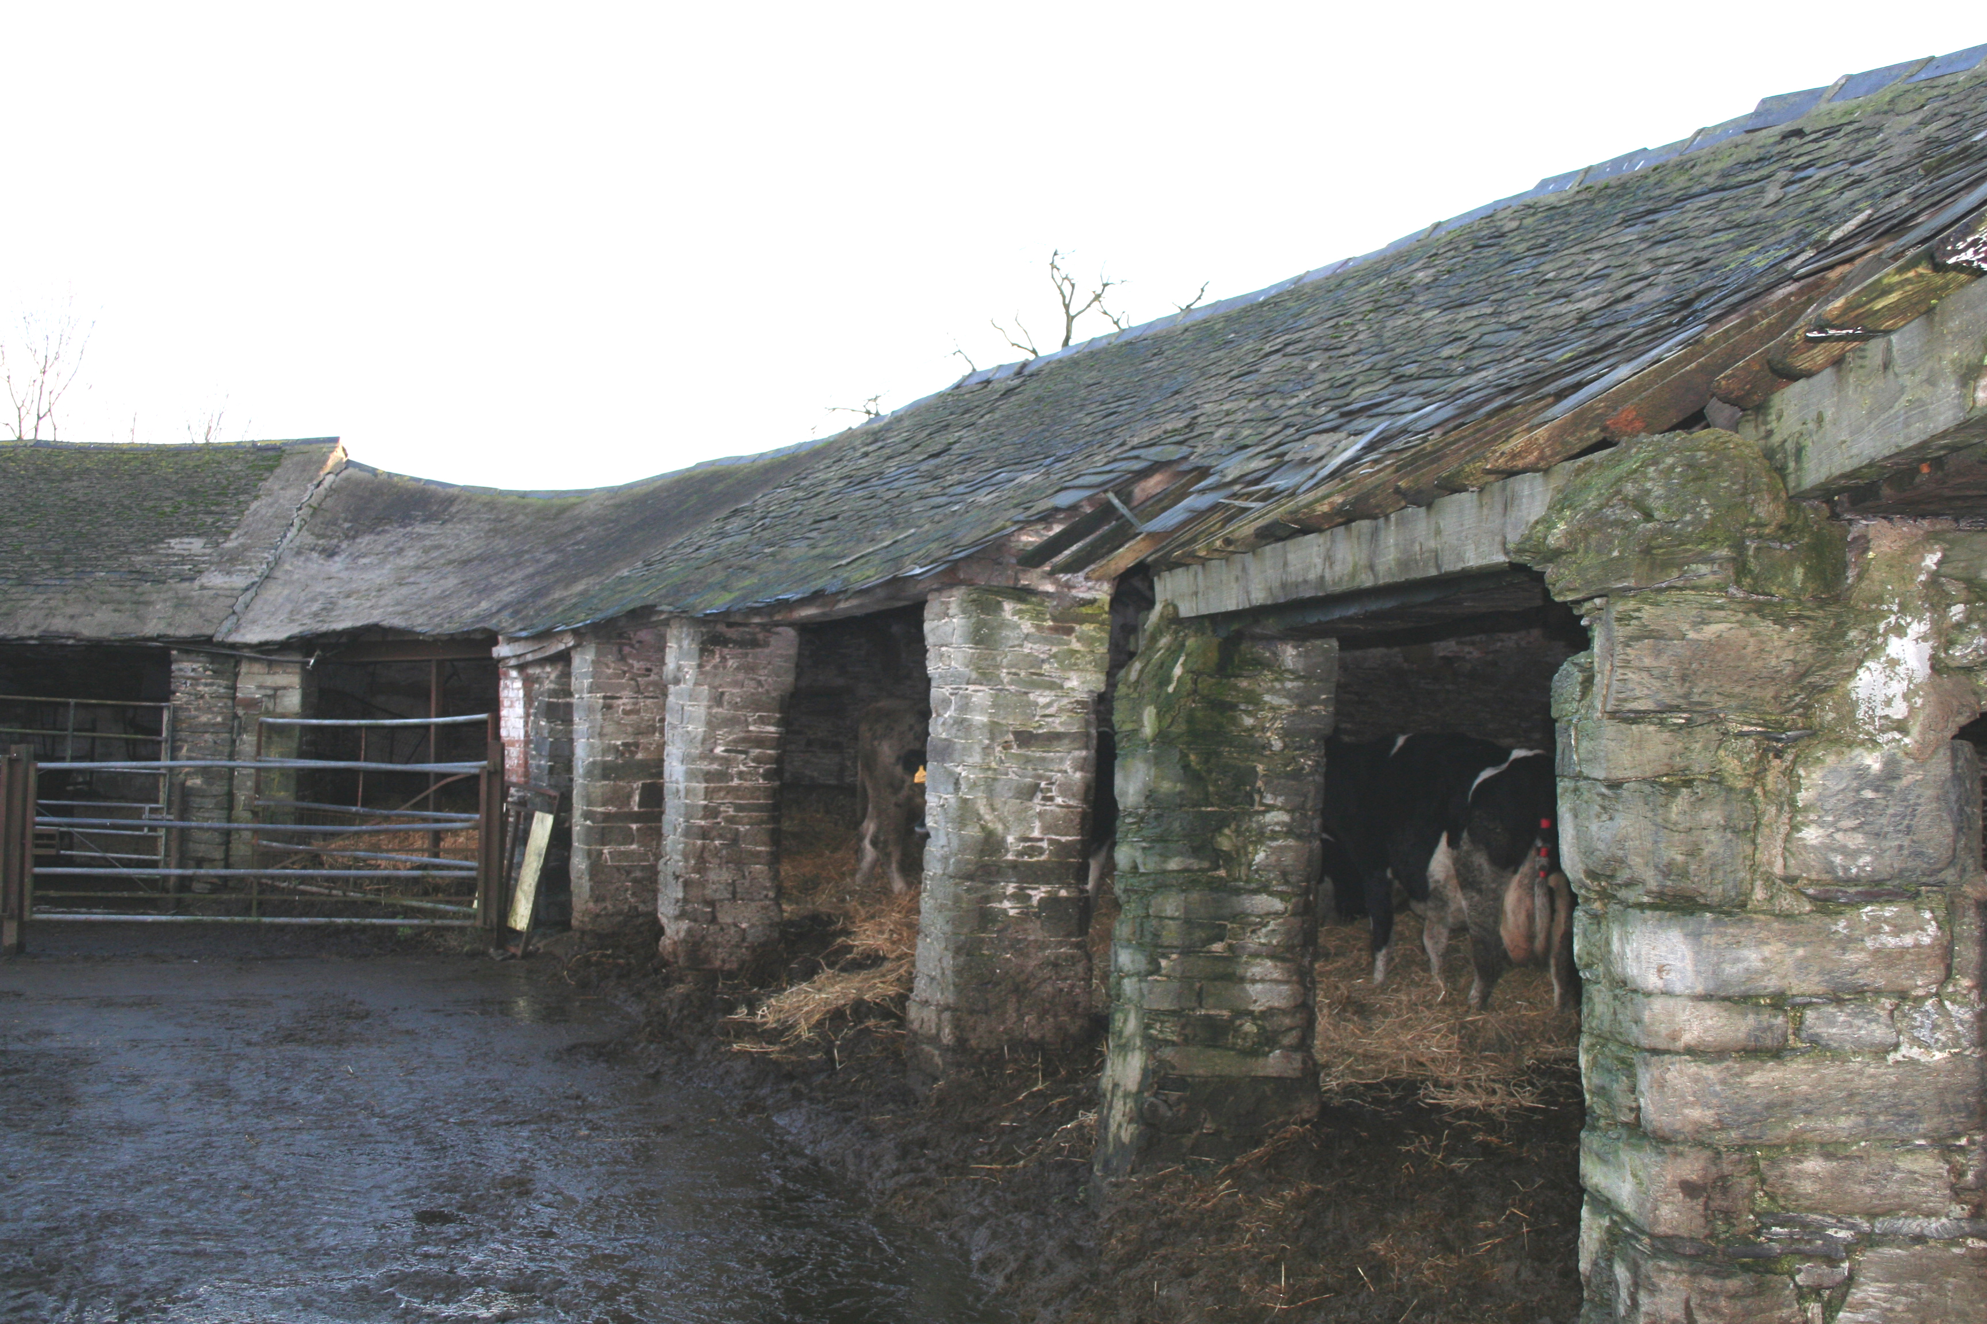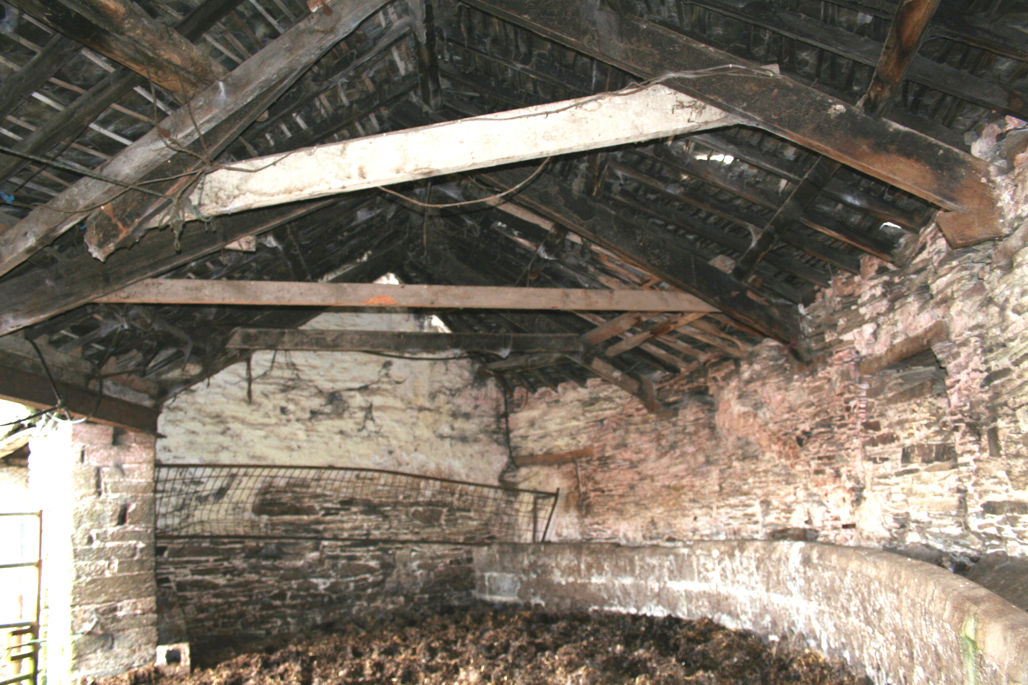

Semi-circular open cattle-shelter, exterior and interior

The chimneys to the gate-house are from fireplaces in flanking cart-houses. The semi-circular cattle-ranges on each side begin where the external wall is set-back, attached to the cart-houses. The west-range (cattle shelter) is open–fronted with chamfered and stopped dressed-stone piers supporting original oak, pegged and morticed collar trusses. There are ventilation slits in its outer wall. The east cattle-shelter range (for housing calves) has various doorways and windows on its west side. It has a later common rafter type roof with ventilation openings, with evidence for a former hay-rack, and exterior doorways at each end. The north end of each range once adjoined the stables, but they have been reduced to provide a 20th century east-west track.
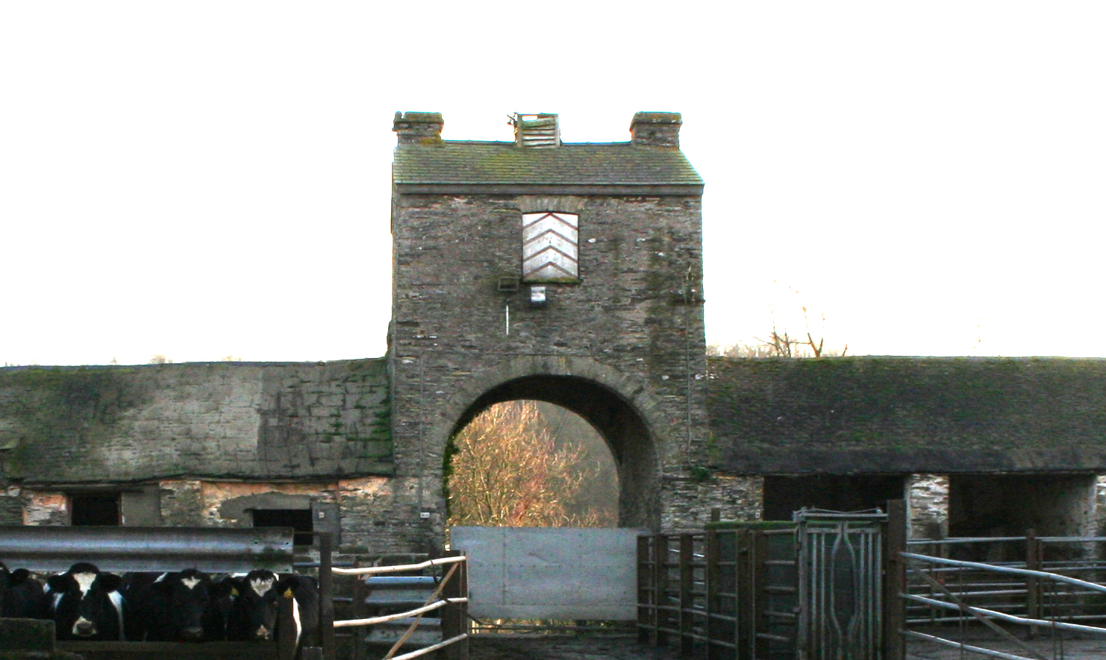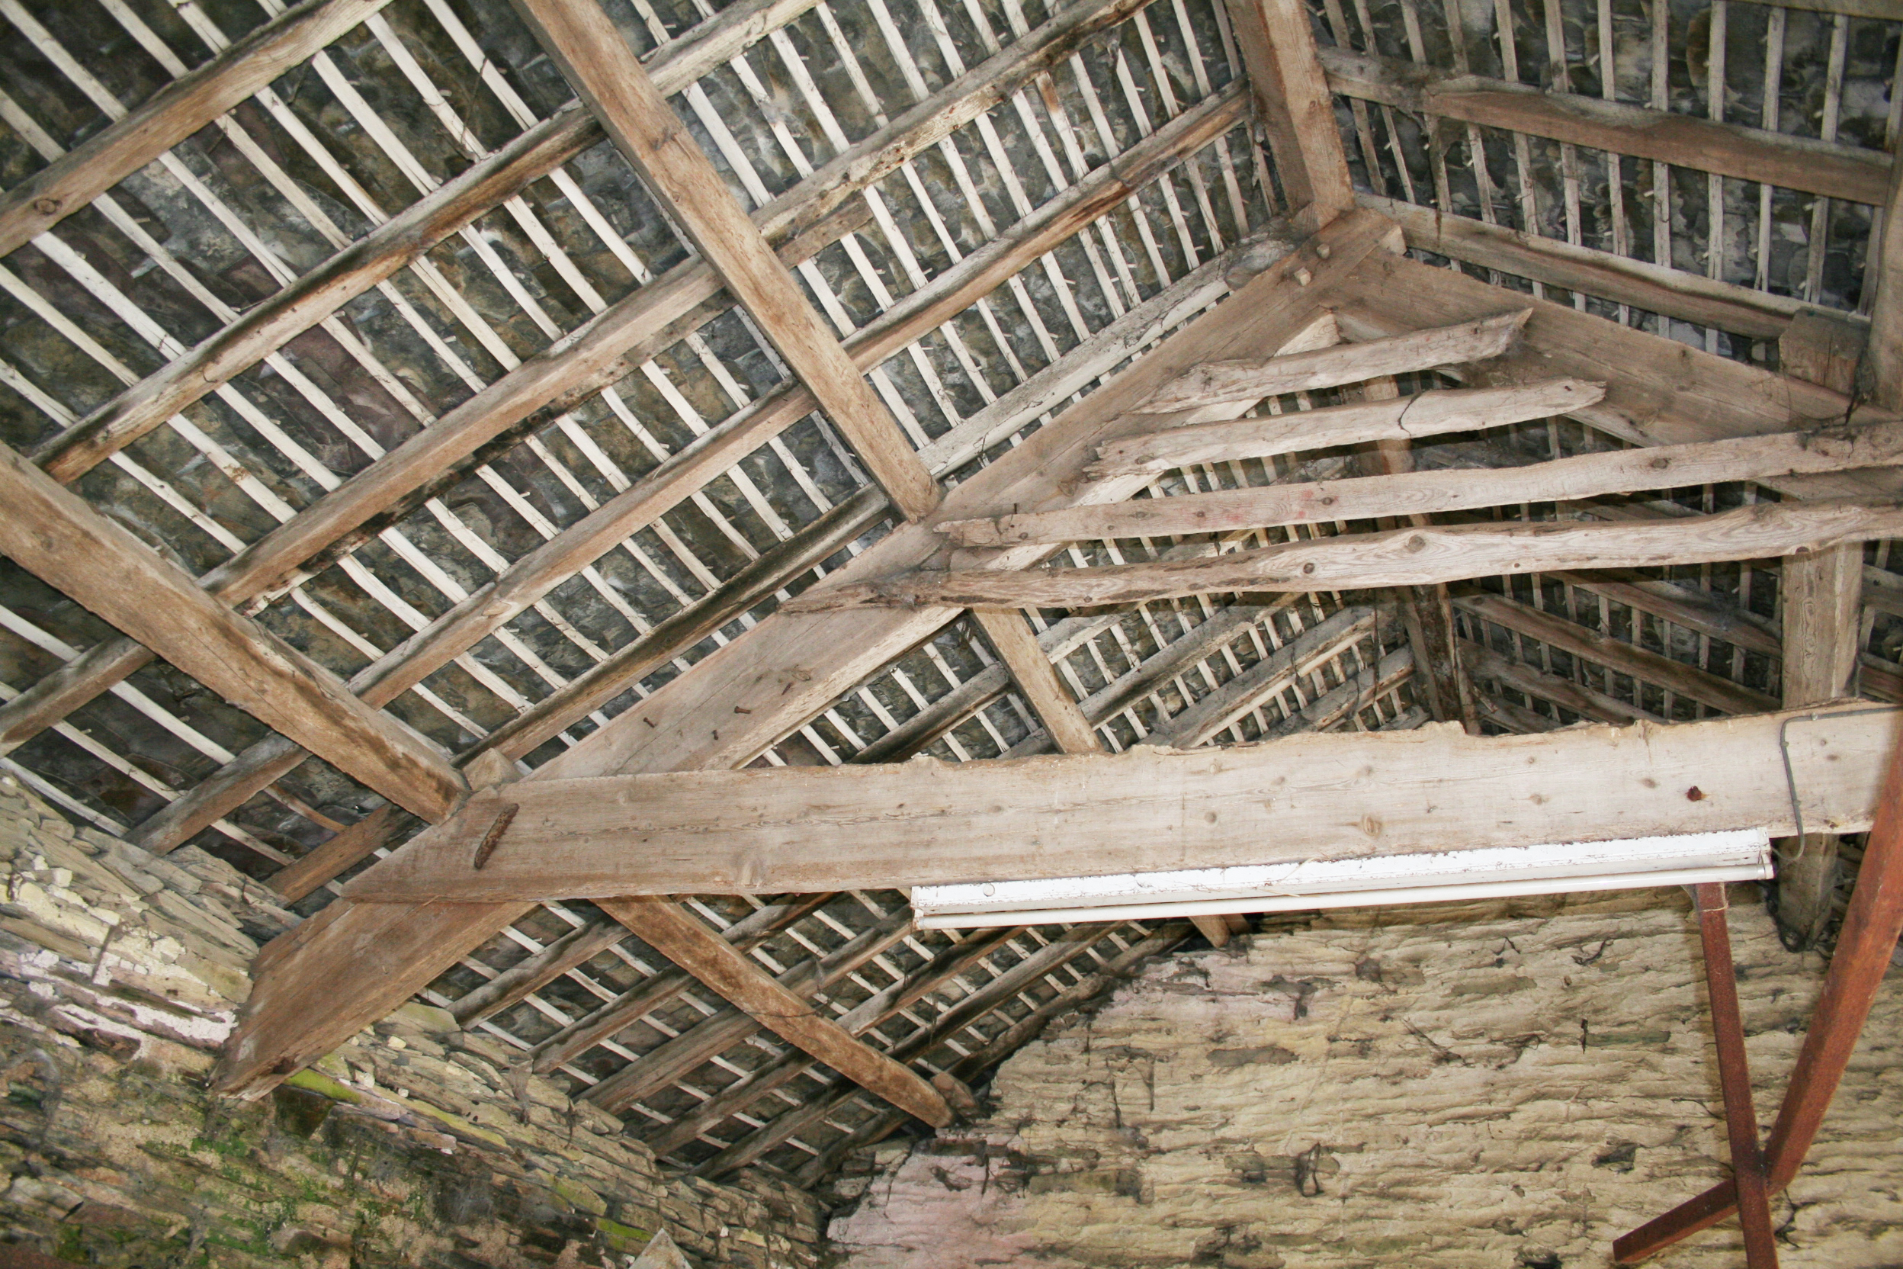

South arched entrance and flanking cart-houses Cart-house roofs

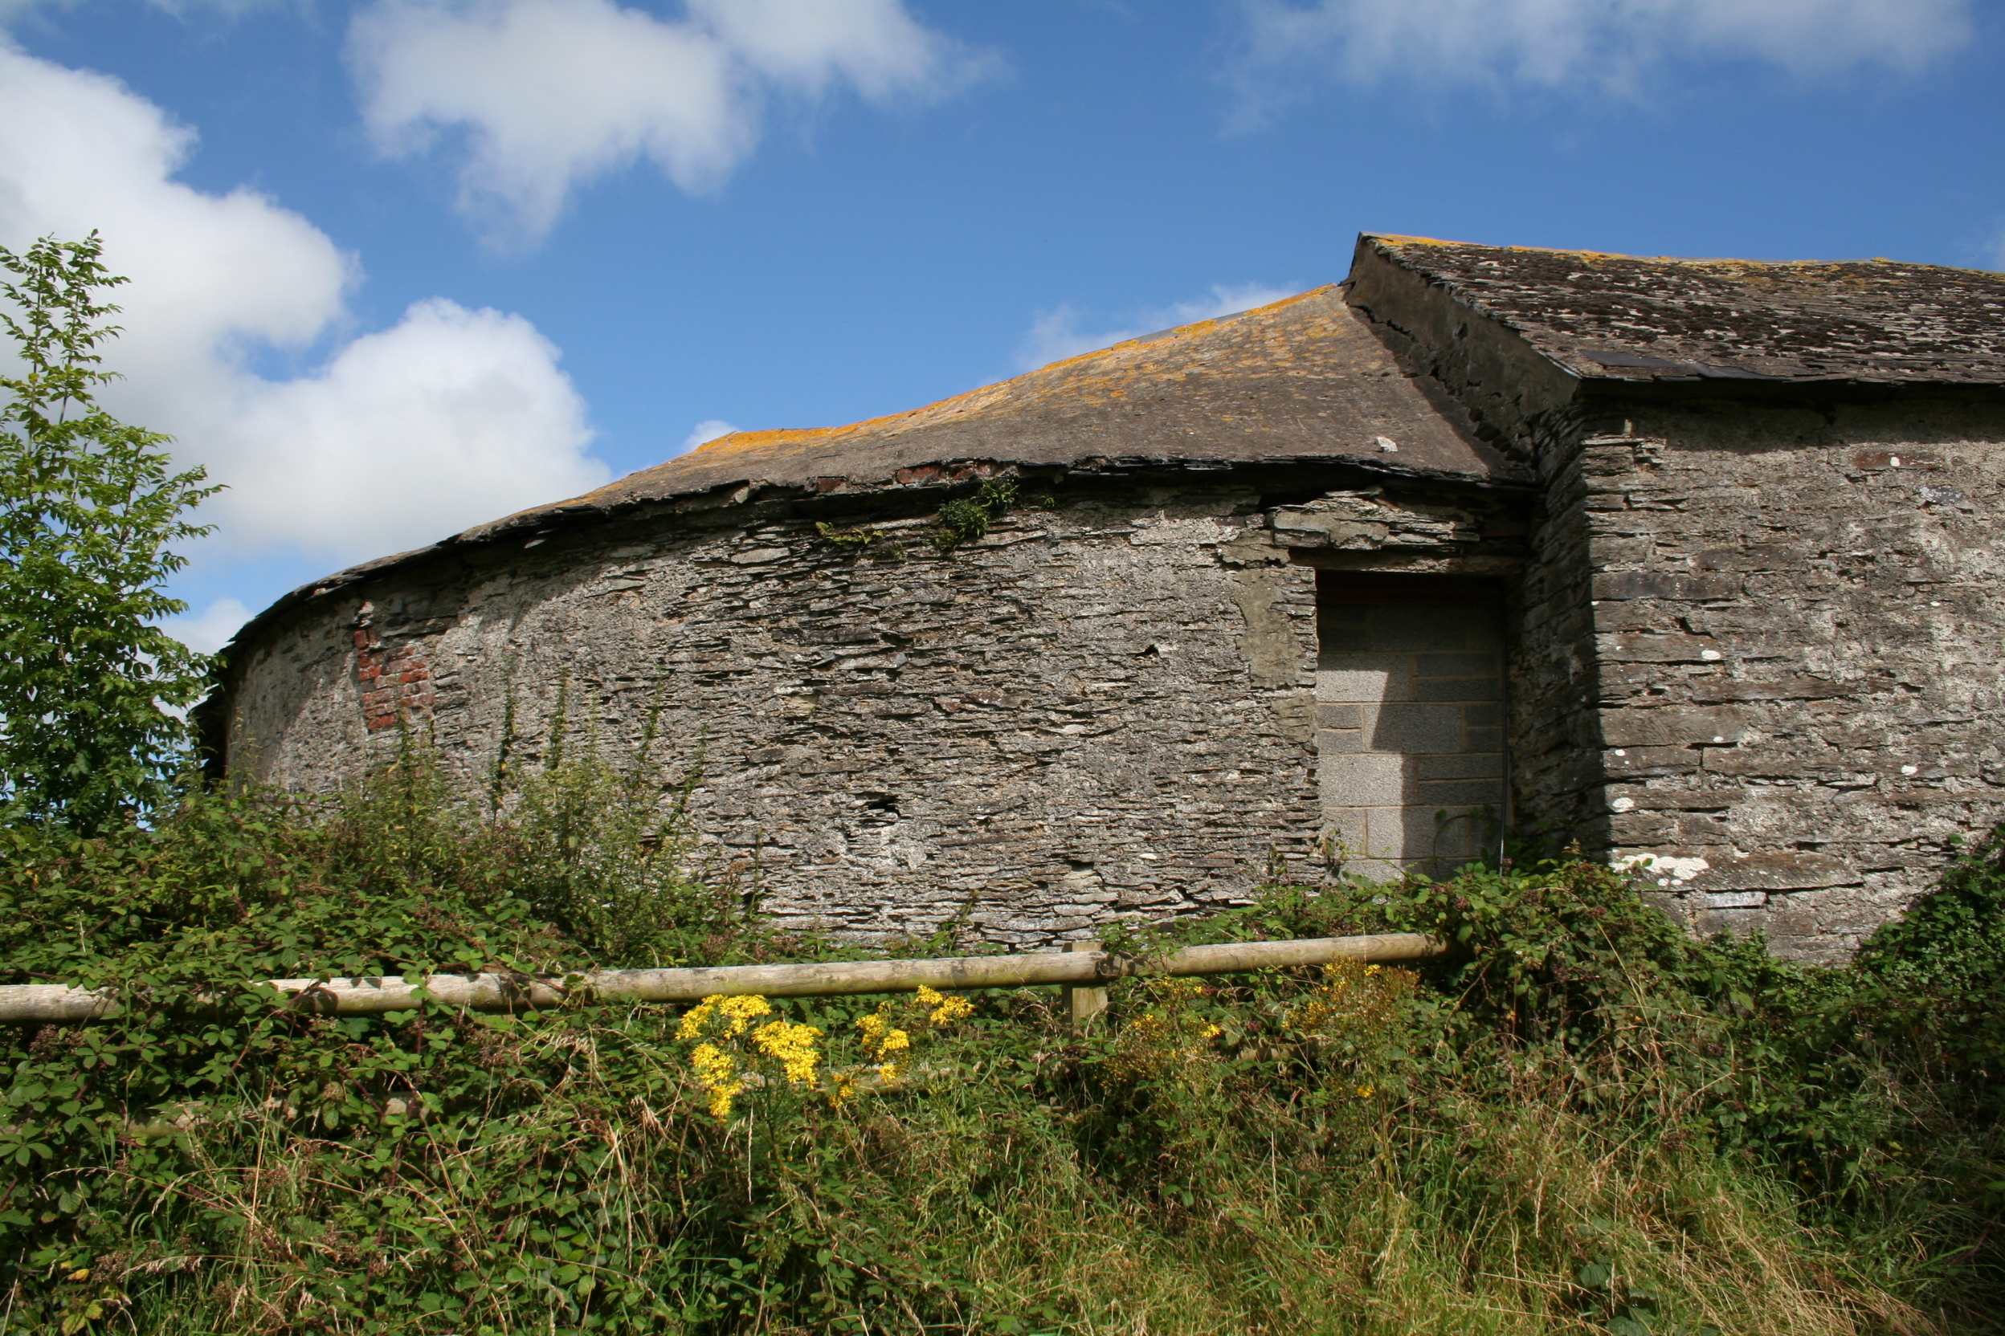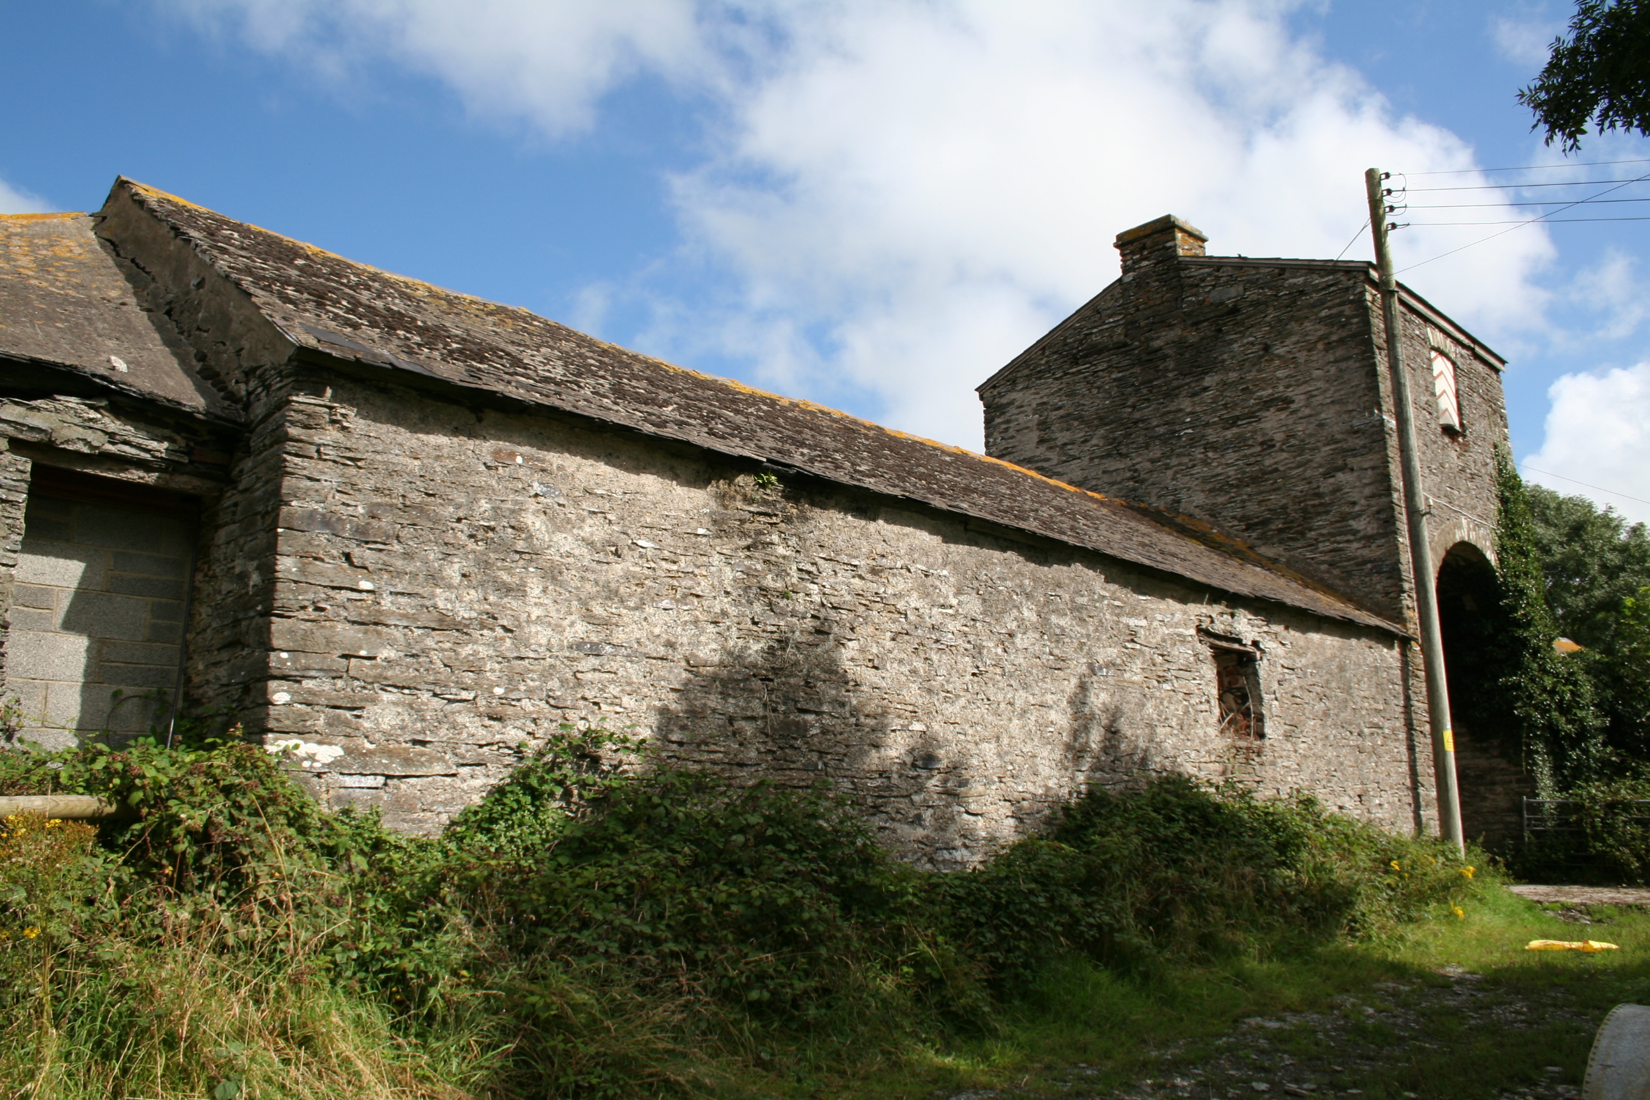

Exterior of semi-circular west cattle shelter and south arched entrance

Comment
Allthough a practical working farm, it would also have been part of an estate tour, with its north entrance of rusticated ashlar making a grand statement leading to the symmetrical cresent shaped shelter-sheds flanking the track, where prize animals could be displayed. The farm animals and processes could be viewed all at once as you passed by and beyond through the south gate-house and past the farmhouse, towards the ‘U’ shaped walled gardens for a picnic.

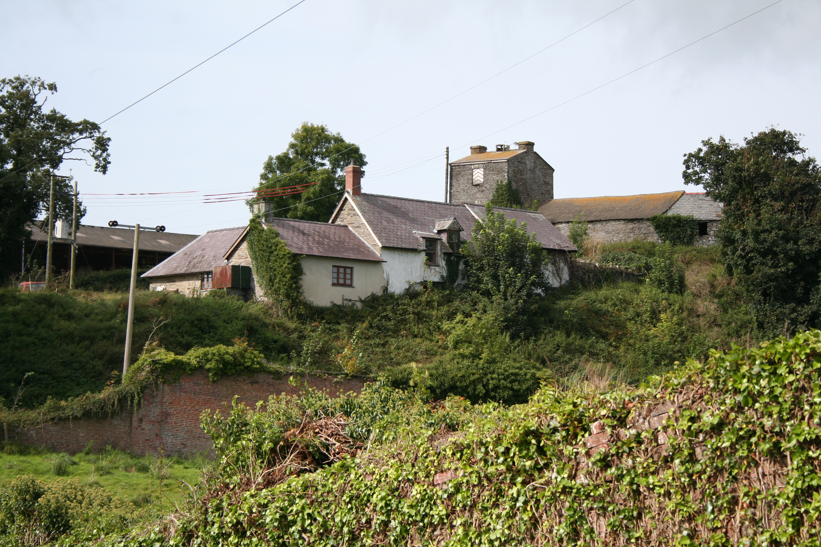

The Model Farm as viewed from the walled garden with the farmhouse in the foreground

The south arched entrance way may have been intended to give the impression of a castle gate-house, especially when viewed from the lower adjacent picturesque gardens with their brick walled garden, lake and fountains. The farm buildings appearance in the general scheme would have been of great importance at that time, when farming improvements were a priority to gentlemen owners and an example for others to follow.

Visited, Geoff Ward, 21/08/2007
Survey, GAW,SF & DPJ, 21/08/2007

